****

**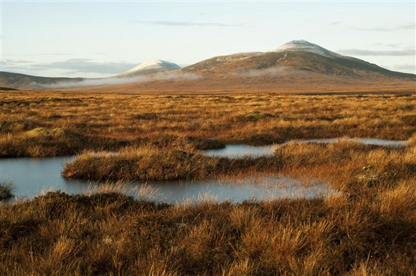**

Forsinard Flows. Photo: Eleanor Bentall – taken from RSPB website

**

**Discussion Work *Teacher Notes***

There are many issues surrounding the peat bog of the ‘Flow Country’. How this land and its resources should be used and managed are matters of ‘real-world’ controversy and debate.

Four discussion, debate and decision-making activities follow. These are progressive in terms of learner sophistication:

Activity 6 - Land use priorities

Activity 7 - Raising questions

Activity 8 - Promoting a land use choice

Activity 9 - Making a decision (role play)

The activities have been designed for collaborative group working, and to stimulate critical thinking, questioning and debate.

**Activity 6 How should we use peat bogs? *Teacher Notes***

**Context**

Peat bogs are wild habitats, however they can be used in a variety of different ways for economic benefit, including forestry, fuel, agriculture and sustainable power supply (wind farms).

**Aim**

The aim of this activity is to enable pupils to explore land use conflict from the perspective of one of the following user groups:

* The Conservationists - ‘Save the peat’
* The Peat Sellers - ‘Dig up and sell the peat’
* The Forest Managers - ‘Drain the peat and plant trees’
* The Framers - ‘Drain the peat and plant crops’

In this activity pupils are asked to:

1. Work in groups to read the information provided on their user group
2. Sort the information and decide whether it strengthens their user group’s argument, or whether it undermines it
3. To work as a group to think creatively and propose any of their own arguments to support their user group

***Extension***

*Groups can then be asked to present their case to the class – sharing their knowledge. Peer assessment of the presentations can be used here.*

**Note:** The icons required for the activity are provided at the end of the notes.**Activity 6 Discussion: How Should we use Peat Bogs? *Pupil Guide***

# Group 1: The Forest Managers

Peat bogs like the ones in the Flow Country cover large areas of land. The land is not used for much. Some people say the peat bogs should be drained and trees planted instead as there is a lot of money to be made from planting trees. Other people disagree.

**Task:** Your group are the Forest Managers. It will be your job to convince the other groups that planting forests on peat bogs is the best use of the land.

1. Read the Forest Managers Resource Sheet
2. Using the picture cards provided:
   * + Place cartoon TREE next to the arguments you think support the case for planting trees.
     + Place the cartoon ‘X’ next to the ones you think undermine the case for planting trees.
     + Put a “?” next to the ones you are not sure about
3. Together, add to the list any extra ideas you can think of that SUPPORT or UNDERMINE the idea of draining the peat bog and planting trees

**Activity 6 Forest Managers**

|  |  |
| --- | --- |
| A lot of trees are planted and cut down for timber in Scotland |  |
| The timber industry brings money and jobs |  |
| Fast growing tree types can survive on peat soils |  |
| The peat bog may have started as a forest, before humans cut them down over thousands of years |  |
| Sphagnum moss can be grown between the trees and sold to garden centres |  |
| Some garden centres sell sphagnum moss from New Zealand |  |
| Trees store carbon. In the short-term (300 years) a forest will store more carbon than a peat bog |  |
| On timescales over 300 years a peat bog will store more carbon than trees |  |
| Planting trees will change the wildlife living in the area |  |
| Tourists who want to see peat bog wildlife will no longer visit |  |
| Forest tracks are good for walking and  Biking |  |

**Activity 6 How Should We Use Peat Bogs? *Pupil Guide***

**Forest Managers Resource Sheet**

Planting trees, cutting them down and selling the wood is very important in Scotland. It adds £500 million a year to the Scottish economy. Altogether, forest activities employ 40,000 people in Scotland. The peat bogs of Scotland probably used to be forests until the trees were cut down when man needed more fuel 5,000 years ago. It is possible to grow fast growing tree types like sitka spruce on the soil, so they can be sold quickly. Sphagnum moss can be grown on the forest floor between the trees and can be dug up and sold to gardeners. As well as making money, this saves getting moss from as far away as New Zealand.

In the short-term forests on peat store MORE carbon than just peat bogs. After all, trees store carbon too. But the trees are eventually chopped down. They can be used as fuel and for building and paper. Burning trees as fuel releases carbon dioxide into the atmosphere. But trees are better than fossil fuels like coal because they take up carbon dioxide when they grow. We call trees a carbon neutral fuel.

Changing the peat bogs into forest means that the habitat and wildlife will change. Some rare wildlife may be lost, but wildlife that lives in forests will replace it. The best trees to make money are not indigenous Scottish trees. Some tourists may not visit, because they want to see wildlife that lives in peat bogs. Other tourists may still come to see the forests and forest wildlife, or walk or ride bikes on forest tracks.

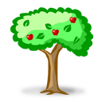

# Group 2: Peat Sellers

Peat bogs like the ones in the Flow Country cover large areas of land. The land is not used for much. Some people say the peat bogs should be drained and the peat dug up and sold. Other people disagree.

**Task:** Your group are the peat sellers. It will be your job to convince the other groups that selling peat is the best use of the land.

1. Read the Forest Managers Resource Sheet

2. Using the picture cards provided:

* + - Place cartoon POUND SIGN next to the arguments you think support the case for selling the peat.
    - Place the cartoon ‘X’ next to the ones you think undermine the case for selling the peat.
    - Put a “?” next to the ones you are not sure about

1. Together, make a list any extra ideas you can think of that SUPPORT or UNDERMINE the idea of draining the peat bog and selling the peat

**Peat Sellers Resource Sheet**

Peat is a really good fuel. This is because the plants in it have not completely broken down (decomposed). Gardeners also use peat to make their plants grow better. Peat has been dug up and burned to heat houses in Scotland for hundreds of years. Ireland uses peat to make electricity – six of its power stations use peat. In Ireland digging up the peat is important for jobs in the Irish midlands because there is little other work there. If you dig up and sell peat as a fuel and to garden centres you can make a lot of money.

Digging up peat releases carbon dioxide into the atmosphere. How much escapes depends on the way the peat is taken out. Today, looking at the whole world, peat bogs soak up more carbon than they release. On the other hand using peat fuel is better for the environment than coal. Peat releases less carbon dioxide and less nasty gases containing sulphur and mercury. Also, finding coal, oil and gas and bringing it to Scotland costs time and money. We have already found the peat and it is in Scotland. When all the peat has been dug up, the peat bog can be slowly grown again. This means that the area will start to soak up carbon again. This means it will become a carbon sink.

Peat can take thousands of years to build up. We can dig up peat much faster that it is made. Digging up the peat also destroys wildlife habitats and will affect biodiversity. Less wildlife tourists may want to visit the area.

If lots of peat is dug up and sold or used to make electricity, then more workers, houses and roads will be needed in the local area.



**Activity 6 Peat Sellers**

|  |  |
| --- | --- |
| Peat can be used to heat homes and make electricity |  |
| Gardeners buy peat to help their plants grow |  |
| Digging up peat provides jobs and makes money |  |
| Carbon dioxide is released when peat is dug up |  |
| Peat is a less damaging fuel than coal to the environment |  |
| Once the peat has been removed it can grow back, which will soak up carbon dioxide |  |
| Peat takes thousands of years to grow |  |
| Digging up the peat will change the wildlife and biodiversity in the local area |  |
| Tourists who want to see peat bog wildlife and unspoilt wilderness may not visit |  |
| More houses and roads will be needed in the local area |  |

**Activity 6 How Should We Use Peat Bogs? *Pupil Guide***

**Group 3: Farmers**

Peat bogs like the ones in the Flow Country cover large areas of land. The land is not used for much. Some people say the peat bogs should be drained and crops planted instead. Other people disagree.

**Task:** Your group are the peat sellers. It will be your job to convince the other groups that selling peat is the best use of the land.

1. Read the Forest Managers Resource Sheet

2. Using the picture cards provided:

* + - Place cartoon Tractor next to the arguments you think support the case for planting crops.
    - Place the cartoon ‘X’ next to the ones you think undermine the case for planting crops.
    - Put a “?” next to the ones you are not sure about

1. Together, make a list of any extra ideas you can think of that SUPPORT or UNDERMINE the idea of draining the peat bog and selling the peat

**The Farmers Resource Sheet**

Peat is very fertile (good for growing plants in) because it contains a lot of plants that have not completely broken down or decomposed. Peat is also very acidic and doesn’t have much oxygen in it, which is not very good for plants. Peat soils are also under water, which stops many plants growing properly. Farmers who want to grow things in peat have to make it less acidic, drain away the water and get oxygen into the soil. They do this by digging trenches and adding lime (an alkali) to the soil. These things take time and money.

The things that the farmers will need to do to the peat to grow things on it, make the amount of peat shrink. This can happen at 2cms per year and up to 20cms per year when the changes are first made. This means that 2m of peat could be gone in about 90 years. It takes much longer than 90 years to build 2m of peat.

What could be grown on this peat farmland? It could be used to grow crops to feed people. This means less food has to be transported around the country. The land could also be used to grow bio-fuel crops – meaning that Scotland would need to use less fossil fuel to power its cars. Selling food or bio-fuel crops would make money and there would be more jobs. The local villages and towns would have to build more homes and roads to support this.

If the peat bog is changed to farmland, some rare habitats will be lost. This means that some of the wildlife would no longer have a home and the biodiversity would be affected. This may also mean that less tourists come to visit the area as there will be less wildlife to see and the area will no longer be wild and natural.

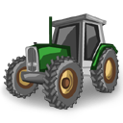

**Activity 6 Farmers**

|  |  |
| --- | --- |
| Peat is very good for growing plants, it is very fertile |  |
| Peat soils are very wet and acidic, farmers have to change the soil properties to make plants grow |  |
| Changing the soil takes time and money |  |
| Peat is damaged by having crops grown on it, it shrinks |  |
| Food crops could be grown on the land and sold |  |
| Bio-fuel crops could be grown – less fossil fuels would be needed to power cars |  |
| Habitats would be lost and wildlife and biodiversity would be affected |  |
| More jobs would be created in farming |  |
| More houses and businesses would be needed for farm workers |  |

**Activity 6 How Should We Use Peat Bogs? *Pupil Guide***

**Group 4: The Conservationists**

Peat bogs like the ones in the Flow Country cover large areas of land. The land is home to many rare plants and animals and stores lots of carbon. Some people say the peat bogs should be protected and preserved. Other people disagree.

**Task:** Your group are the peat sellers. It will be your job to convince the other groups that saving the peat is the best use of the land.

1. Read the Forest Managers Resource Sheet

2. Using the picture cards provided:

* + - Place cartoon BIRD next to the arguments you think support the case for saving the peat.
    - Place the cartoon ‘X’ next to the ones you think undermine the case for saving the peat.
    - Put a “?” next to the ones you are not sure about

1. Together, make a list of any extra ideas you can think of that SUPPORT or UNDERMINE the idea of draining the peat bog and selling the peat

**The Conservationists Resource Sheet**

The peatlands contain many moss species, like sphagnum moss. These mosses are very important in creating peat. The current areas of peatland can be up several metres deep. But they were slow to build up. It took as much as 8,000 years (since the end of the last ice age).

Many bird species need the peat bogs to breed and feed, including the red throated diver. Peat bogs are also important for the Atlantic salmon and otters. This is because material from the peat bogs gets into the local streams. This material helps to feed things which salmon and otters feed on.

Peat bogs can be good for tourists. They are pleasant outdoor surroundings. Tourists can also see the wildlife on peat bogs. But tourists can damage the peat if they walk or drive on it. Tourists also need roads, hotels, restaurants and shops.

Land owners would be prevented from creating more jobs and money by using the land in a different way. Tree plantations were planted on many areas of peatland in the 1970's. This damaged the peat but was good for the economy. Many tourists prefer the forests to the peat.

Keeping the peat bogs in good condition needs experts and money. The water drainage needs to be checked. Local people will need information about what they should do to help the peat bogs and the wildlife living in them.

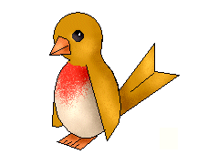

**Activity 6 Conservationists**

|  |  |
| --- | --- |
| Peat bogs are home to some very important and rare plants and animals |  |
| Peat bogs support life in streams which feed otters and Atlantic salmon |  |
| Carbon is stored in peat bogs, but only if they are well cared for |  |
| It took thousands of years to build up the layers of peat we have now |  |
| Keeping the peat bogs healthy needs people, time and money |  |
| Tourists like to visit peat bogs to see the wildlife |  |
| Hotels, roads and restaurants are needed to keep the tourists happy |  |
| Some parts of the peat bog have trees on them, these would need to be cut down |  |
| Any trees cut down could be sold |  |
| Any wildlife living in forests would also have to move |  |
| Landowners and businesses could create more jobs and money using the land for something else |  |

**Activity 7 Land use Priorities *Pupil Guide***

Land can be used for many things. But not all of these can be done at the same time on the same land. For example, a piece of land cannot have both a peat bog and a forest on it at the same time. Some land uses mix better than others. For example, forestry can also be used for cycling and walking on forest tracks. But cycling on a peat bog is not so easy.

People disagree about what is important. What kinds of things do you think are more important than others?

In groups:

1. Cut out the statements on the next page.
2. Discuss each one and try to arrange them in a Diamond Nine shape (see below). Nearer the top of the diamond you put things that are more important. Nearer the bottom go things that you thing are less important. It’s up to you to agree.
3. There are ten statements so leave out the one you are least able to agree on.
4. If you think there is something really important missing, fill in one of your own and see if you can agree where to put it on the diamond. You will have to take another one out to fit it in though.

What things are more important than others when deciding how to use land?



Most important things

Least important things

Things on the same row are roughly equal importance

the historical or traditional land use

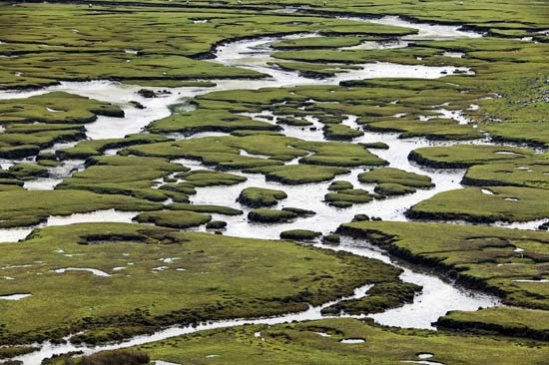

www.britannica.com

what business people say they want



www.britannica.com

the effects on climate change



www.britannica.com



www.britannica.com



www.britannica.com

what the land owner says he or she wants



www.britannica.com

biodiversity and wildlife



www.britannica.com

how much time and money is needed



www.britannica.com

what tourists say they want



www.britannica.com



what birdwatchers say they want

www.britannica.com

Cut out the statements below and discuss where you would put them on the diamond nine: which do you think are most important? Some have been left blank for you to add your own statements.



how much money can be added to the economy

www.britannica.com



the views of people living on the land

www.britannica.com

|  |  |  |  |  |
| --- | --- | --- | --- | --- |
| finished-bird | finished-bird | finished-bird | finished-bird | finished-bird |
| finished-bird | finished-bird | finished-bird | finished-bird | finished-bird |
| pound_sign | pound_sign | pound_sign | pound_sign | pound_sign |
| pound_sign | pound_sign | pound_sign | pound_sign | pound_sign |
| tractor | tractor | tractor | tractor | tractor |
| tractor | tractor | tractor | tractor | tractor |
| Burn icon | Burn icon | Burn icon | Burn icon | Burn icon |
| Burn icon | Burn icon | Burn icon | Burn icon | Burn icon |
|  |  |  |  |  |
|  |  |  |  |  |
|  |  |  |  |  |
|  |  |  |  |  |
|  |  |  |  |  |
|  |  |  |  |  |
|  |  |  |  |  |
|  |  |  |  |  |
|  |  |  |  |  |

**Activity 7 Raising Questions *Teacher Notes***

**Context**

Peat bogs are wild habitats, however they can be used in a variety of different ways for economic benefit, including forestry, fuel, agriculture and sustainable power supply (wind farms).

**Aim**

The aim of this activity is to enable pupils to explore land use conflict by considering all of the issues surrounding the land use of peat bogs considering the social, economic, environmental and political factors. In this activity pupils are asked to:

1. Work in groups to compile a list of important considerations
2. Sort these considerations into social, economic, environmental and political
3. Work in pairs to investigate the answers

.

# **Activity 7 Raising Questions *Pupil Guide***

What should we do with the land that is now the peat bogs of Scotland and the Flow Country? There are lots of options. But what do we need to find out before we can decide? What questions should we ask?

There are lots of questions. The compass rose is a way of organizing them.

In groups:

1. Write down a neat list of the things you would need to find out about if you were going to decide what to do with the land. LEAVE SPACE so you can cut out each question on your list.
2. Cut out each question on your list
3. Once you have your questions, see if you can organize them onto the ‘compass rose’ on the next page. Some of the questions might go on the points of the star. Some might go in between points. Some might go right in the middle.
4. If you think up new questions, add them too.
5. Now that your questions are organized, you can divide them amongst yourselves and choose which sets of questions you will each try to find out about.

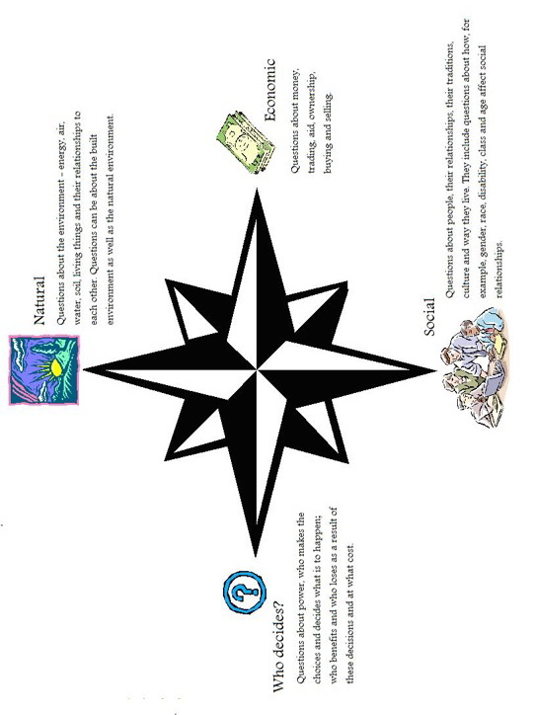

**Activity 8 Promoting Land use Choice *Teacher Notes***

**Context**

Peat bogs are wild habitats, however they can be used in a variety of different ways for economic benefit, including forestry, fuel, agriculture and sustainable power supply (wind farms).

**Aim**

The aim of this activity is to promote the use of critical thinking skills, encouraging pupils to use all of the information they have investigated and analysed to make a decision on what should be done with the land. This activity also encourages pupils to think creatively and collaboratively to produce a piece of work that details their decision.

1. Discuss the advantages and disadvantages of each land use option
2. Decide on which option they wish to promote
3. Choose a method of promotion (poster/TV advert/ presentation) to promote their choice to the rest of the class

# **Activity 8 Promoting a Land Use Choice *Pupil Guide***

We now know that there are many things that could be done with the peat bogs in the north of Scotland. Four of these choices are:

* Save the peat
* Dig up and sell the peat
* Drain the peat and plant trees
* Drain the peat and plant crops

1. You may have looked at one of these. You should now get into a group where all of them have been investigated between you.
2. Discuss the advantages and disadvantages of each option.
3. Choose the option that your group wants to promote.
4. Plan to promote your choice to the rest of the class. You could do this in ONE of these ways:

* Giving a short presentation to the class about your preferred option. Try to think what questions they might ask and be ready with your answers.
* Designing a poster. Try to make it striking, visual and simple. But also give information about what people reading the poster can do if they agree with you.
* Writing a press release for a newspaper. This should be a bit like a newspaper article. You must think how to make it interesting. You should put your most important points first and your more detailed points later. The newspaper editor may CUT the length of your press release and will start cutting FROM THE BOTTOM. You should add a final section of notes that explain where the editor can get more information from and how he or she can contact your group.
* Writing the script of a TV documentary. List the different points you want to make. Create a ‘scene’ (or segment) for each one. Think about what you will see on the screen. Think about who you will show, what they will be doing, and what they will say or be asked.

**Activity 9 Making a Decision *Teacher Notes***

**Context**

Peat bogs can be used in a variety of different ways for economic benefit. However deciding what should be done with the land can be complex, especially when there are several different user’s viewpoints to take into consideration

**Aim**

The aim of this activity is to encourage pupils to make informed choices based on critical assessment of facts and information. Pupils are given a scenario and asked to make a decision based on a role play type activity. Pupils are asked to:

* 1. Based on a scenario, imagine a proposed development
  2. In groups (of different land users) hold a council meeting to discuss the proposed development
  3. Decide and vote on whether to grant the planning or refuse it, or whether to grant it with conditions

# **Activity 9 Making a Decision *Pupil Guide***

A local land owner has asked for planning permission to change the use of the peat bog she owns. Before it decides whether to allow this, the Local Authority must hold a planning enquiry. Anyone can come to several meetings around the area and try to influence the decision.

Task 1: Read what the land owner has to say below

*I would like permission to drain 50 hectares of the peat bog I own. I would like to use some of the land to start a forestry business and sell timber products throughout Europe. I’d build forest tracks to allow other people, like tourists to enjoy the area. With the rest of the land I’d use wind turbines to create green electricity to sell to power companies. I think the planning board should give me permission. I understand that some of the local water supplies run through the bog, but it is my land after all!*

The meetings will make RECOMMENDATIONS to the elected councillors. The meetings can recommend either:

* “Yes”, the landowner should be granted permission to do al this
* “No”, the landowner must leave the peat bog as it is
* “Yes but…”, the landowner should be granted permission to do all or some of it, but must agree to some conditions.

Several different kinds of people intend to go to the meetings:

* Local bed & breakfast owners
* Conservation promoters
* Scientists
* Water company executives
* A member of the local school’s pupil council
* A planning officer who will chair the meeting

# **Activity 9 Making a Decision *Pupil Guide***

You will play the role of one of these kinds of people. To prepare for the role:

1. Get into a group with your classmates who are playing the same role as you.
2. Discuss in your group whether you would already have a view about what decision you would like the council to make (“Yes”, “No”, or “Yes, but...”)
3. If you have a preferred decision, write down the arguments you will use to persuade the Council.
4. If you do not have a preferred decision, write down what kinds of questions you will want to ask at the meeting. Write down why you are asking these questions.
5. If you are the planning officer, write down how you think you should organise the meeting. Who should speak first and in what order? When should questions be asked? Are interruptions allowed? How will you make sure everyone gets to speak?

When everyone is ready, reorganize into several planning meetings. Each meeting must have a chair and a mix of other roles.

To hold the meeting:

1. The chair should say: “Welcome to the meeting. We are here to consider whether 50 hectares of peat bog should be used for timber production with public access routes in the forest. At the end of the meeting I will recommend to the Council whether it should say “no” or “yes”. And if I recommend “yes”, whether any conditions should be attached and what those conditions are.
2. The chair should then chair the meeting for the allotted time.
3. The chair should then say what recommendation he/she is going to make to the Council.