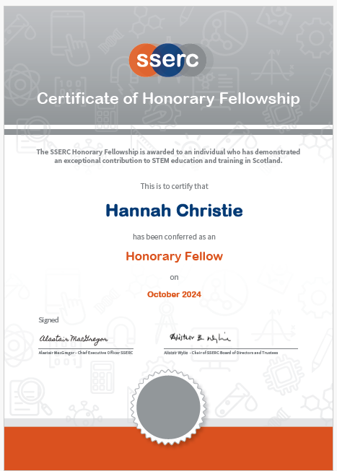
Honorary Fellowship 2024

Hannah’s extensive contributions to STEM education in Scotland make her an exceptional candidate for the SSERC Honorary Fellowship Award. As Principal Teacher of Pastoral Care, her previous leadership roles in Design and Technology have laid a solid foundation for her impact in education.
During her tenure as STEM Development Officer for Glasgow City Council (2017-2021), she spearheaded initiatives that spanned early years to secondary education, effectively promoting STEM learning across the council. Her representation of Glasgow at national STEM Learning network meetings allowed her to both share successful practices and bring back innovative ideas to enhance local programs, particularly in collaboration with SSERC.
Hannah’s partnerships with national organisations such as Education Scotland, SQA, and Skills Development Scotland have led to significant advancements in curriculum and policy development. Her involvement in the Primary Cluster Programme and the Leadership in STEM professional development course exemplifies her dedication; the measurable impact of these programs underscores her value as a leader in the field.
The recognition of her work through the GTCS Excellence in Professional Learning Award for developing the Primary STEM Leaders programme highlights her success in building capacity within schools. Her collaboration on national initiatives, including the SSERC Leadership in STEM programme and BBC Bitesize National 5 resources, has reached thousands of educators, further amplifying her influence.
Additionally, her organisation of national STEM TeachMeets has fostered valuable connections among teachers across Scotland, enhancing the collaborative spirit of STEM education.
In summary, Hannah's leadership and commitment have significantly advanced STEM education at both city and national levels. Her achievements through SSERC and beyond illustrate a profound dedication to strengthening STEM teaching and learning in Scotland. Her outstanding service truly merits the recognition of the SSERC Honorary Fellowship Award in 2024.
