|  |
| --- |
| Chemical Demonstrations |
| Diffusion of Liquids and Gases |

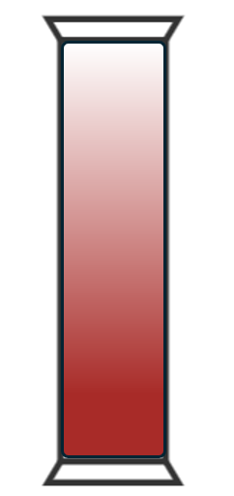

This reaction can be applied to curriculum for excellence.

*By contributing to experiments and investigations, I can develop my understanding of models of matter and can apply this to changes of state and the energy involved as they occur in nature.*

SCN 3-05a

*I have developed my understanding of the kinetic model of a gas. I can describe the qualitative relationships between pressure, volume and temperature of gases.*

SCN 4-05a

## Introduction

Diffusion is the movement of particles a substance from an area of high concentration to an area of lower concentration. It occurs in liquids and gases when these particles collide randomly and spread out.

It is not the easiest phenomenon to demonstrate in the laboratory. Diffusion in liquids is very slow and while it is faster in gases, most gases are colourless. And the only gases coloured enough to make the experiment viable have significant health and safety risks.

The two alternatives are:

1. Bromine, whichhas been responsible for a number of accidents to both teachers and technicians, due to its corrosive and toxic fumes. It should **only** be used by an experienced chemist. And
2. Nitrogen dioxide, whichis a **slightly** safer alternative. Although exposure to the fumes can also cause significant health effects often delated for several days.

This is the ‘traditional’ method using nitrogen dioxide.

A safer alternative is a microscale version that can be carried out by learners.

## Diffusion in liquids

This can be shown simply by adding a crystal of a coloured, soluble solid to a beaker of water. Potassium manganate VII is a good choice as it has an intense colour but it generally comes as a powder and so the staining can partially obscure the effect. Chromium potassium sulphate is a very dark purple and comes in larger pieces, as does copper sulphate. Though these two are both slower to show the effect.

### You will need

|  |  |
| --- | --- |
| Beaker | Water |
| Crystal of a soluble solid |  |

### To Do

1. Fill your beaker with water and leave for a minute or two so any swirling currents have died down and the liquid is entirely still.
2. Place your crystal as carefully as possible in the bottom of the beaker.
3. Wait and see what happens.

## Diffusion in gases

### You will need

|  |  |
| --- | --- |
| Copper turning or foil | Concentrated nitric acid |
| 2 gas jars and lids | Small measuring cylinder or Pasteur popette to dispense the nitric acid. |

### Preparation

Determine the volume of the gas jar to establish the amount of gas you are going to generate.

* We are adding concentrated nitric acid to excess copper turnings and so the volume of NO2 is determined by the volume off acid you add.
* 8 cm3 of HNO3 produces 1,000 cm3 of NO2. So scale that down for your particular gas jar.

Wear eye protection (BS EN166 3) and gloves and carry out this stage in a fume cupboard.

1. Place between 1 and 2 g (max) of copper turnings in the gas jar
2. Add 1 cm3 less than your determined, measured amount of HNO3 to the copper turnings. (This ensures the metal is in excess).
3. Place the lid on top of the jar and wait for the reaction to die down. This should leave you with a gas jar full of brown NO2 fumes.

### The demonstration

1. 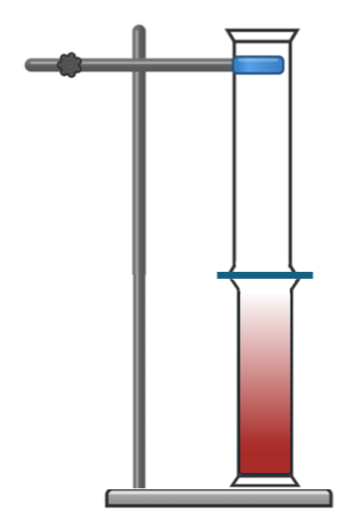Place the gas jar, with its lid still on, on the bench. If possible keep it in the fume cupboard but if the visibility is poor this stage can be carried out in the open lab.
2. Use a clamp to hold another gas jar upside down on top of the first jar. Firmly enough to stop it falling over but loosely enough that in can be slid up and down.
3. At this stage, you have two gas jars with a single lid between them.
4. Remove the lid and make sure the top gas jar slides down to seal the gap between the two jars.
5. Over the next 20 minutes or so, the brown NO2 will diffuse upwards to fill the upper jar as well.

**Disposal**

Seal the two jars with Sellotape (or any other type of tape) and carefully remove them, still joined together to a fume cupboard. (If the fume cupboard is in the same room you can forego the taping up).

Now you can separate them. Add some water to each gas jar, swirl around and wash the contents to waste with more fresh running water.