Hydrogels & Bioplastics
This session involves 3 parts. In the first, you will prepare edible water bottles using food-grade materials. In the second activity, three basic bioplastics will be made and evaluated. In the final activity, the benefits of hydrogels in farming will be investigated by considering how their use could support water retention in soils to promote crop growth.

Part 1: Making edible water bottles
Materials for session (groups of 4):
The sodium alginate and calcium lactate were prepared the day before the session. The following materials were required:
- 1 g food-grade sodium alginate
- 5 g food-grade calcium lactate
- Food dye
- 1.25 cm³ drinking water
- 1L jug
- 2x glass bowls
- Hand mixer
- Spoon
The following steps were taken to prepare for the session:
- In a bowl, combine 1 g sodium alginate with 250 cm³ water using a hand mixer. This will take some time. Food dye can be added at this stage. The mixture can be left in the fridge overnight, if preferred.
- In the second bowl, combine 5 g calcium lactate with 1 L drinking water. Stir to dissolve. This can be prepared the day before and stored in the fridge, if preferred.

1x bowl of 0.5% calcium lactate | Selection of measuring spoons
1x cup of 0.4% sodium alginate | 1x tea strainer
1x party bowl

Method:
- Use a measuring spoon, or any suitable alternative (e.g. a plastic bottle cap), to scoop up some sodium alginate.

- Gently drop the sodium alginate into the bowl of calcium lactate solution. It will immediately form a “bead”. Let the beads sit in the calcium lactate solution for about 3 minutes.
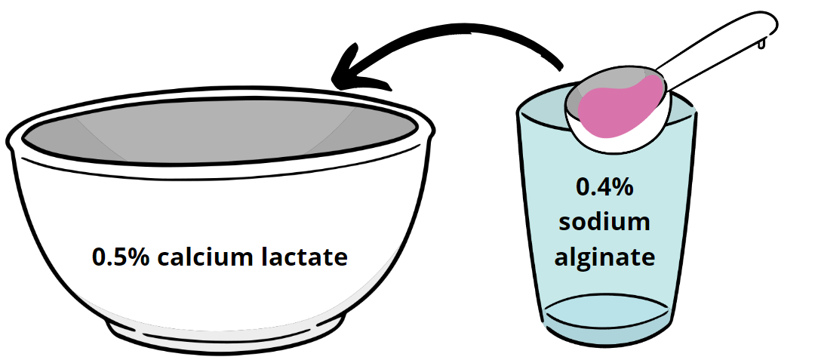
- Use the tea strainer to transfer the bead to the bowl. You can now try your edible water bottle.

Part 2: Making a bioplastic
Aim: To compare three recipes for a simple bioplastic.

Materials for session (per pair):
Measuring spoons | 10 g glycerol
50 g cornstarch | Paper cup
Access to water | Lollypop stick (as stirring rod)
10 g baking powder | Access to microwave
Method:
Each pair will make one of the bioplastics
Fluffy bioplastic
In the paper cup, combine:
- 1 tablespoon of cornstarch
- 1 tablespoon of water.
Mix to combine, using the lollypop stick. Microwave for 30 s.

Fluffier bioplastic
In the paper cup, combine:
- 1 tablespoon of cornstarch
- ¼ teaspoon baking powder
- 1 tablespoon of water.
Mix to combine, using the lollypop stick. Microwave for 30 s.

Fluffiest bioplastic
In the paper cup, combine:
- 1 tablespoon of cornstarch
- ¼ teaspoon baking powder
- 1 teaspoon of glycerol
- 2 teaspoons of water.
Mix to combine, using the lollypop stick. Microwave for 30 s.
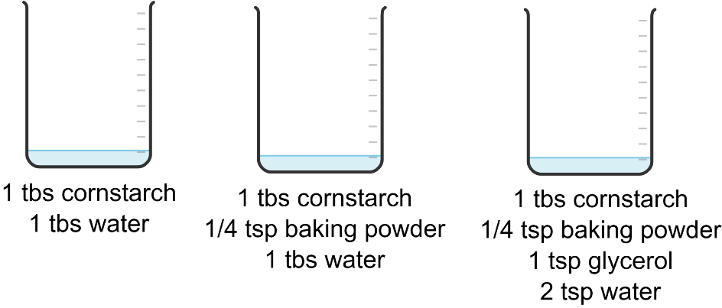
Compare the consistencies of the different bioplastics. As a suitable follow-up activity, learners might test the performance of their bioplastics by:
- Testing the solubility of their bioplastic

- Testing how effectively the bioplastic can protect an item, e.g. an egg. This could be conducted by carrying out an egg drop test to test whether the bioplastic could protect the egg upon impact. Allow the bioplastic to cool completely. The bioplastics can be stored in Ziploc bags at room temperature for about 4 days before they harden and begin to develop mould.

Part 3: Testing hydrogels
Activity 1 – Make a hydrogel

Materials for session (per pair):
2 x 100 cm³ beaker | 1x magnetic stirrer
Stirring rod | 50 – 100 cm³ measuring cylinder
0.5 g sodium alginate | 2 g calcium chloride

Method
- Combine 0.5 g sodium alginate with 30 cm³ water in Beaker 1. Add a magnetic flea and stir using the magnetic stirrer.

- Combine 2 g calcium chloride with 30 cm³ water in Beaker 2. Use the stirring rod to mix.

- Use a spatula to remove any large lumps of sodium alginate that have not dissolved.

- Pour the calcium chloride solution into the sodium alginate and stir with the stirring rod. A thick gel will form.
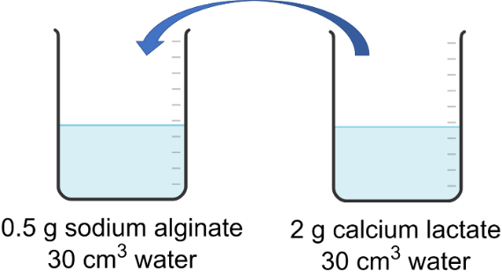

Activity 2 – Properties of hydrogels
Materials for session (per pair):
1x petri dish | 1x sample of hair gel
salt | Sugar
spatula

Method
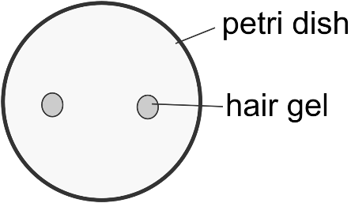
- Use the spatula to add 2 blobs of hair gel to opposite sides of the petri dish.

- Sprinkle some sugar on one blob.

- Sprinkle some salt on the other blob.

- Leave for a few minutes.

- Observe any changes.

Activity 3 – Hydrogels in action – disposable nappies
Aim: To investigate the use of hydrogels in water retention.

Background
With an increasing population, agriculture is facing many challenges, including climate change, urbanisation, the use of natural resources, run-off losses, and accumulation of agrochemicals. Global water shortage affects agriculture – drought is a natural disaster that affects farmers and a country’s social, economic and environmental status. Agronomic strategies can reduce drought stress in crops. This includes superabsorbent polymers that improve soil health by increasing water holding capacity for crops to grow (Malik, S., 2023).

References: Malik, S. (2023), Superabsorbent polymers as a soil amendment for increasing agriculture production with reducing water losses under water stress conditions, Polymers, 29,15(1):161.

Materials for session (per pair):
A disposable nappy | Scissors
A large ice cream tub or similar | Distilled water
salt | Dessert spoon or similar
Stirring rod | 1000 cm³ beaker
100 cm³ measuring cylinder | Gloves if you have sensitive skin
Large sieve | Basins
10 cm³ measuring cylinder

Method
- Cut the middle section out of a nappy.

- Transfer the small white grains from the nappy into a dry container. Dispose of fluff.

- Transfer 5 cm³ grains to the 10 cm³ measuring cylinder. This is your starting volume.

- Transfer the grains to the beaker with 100 cm³ water. Stir to combine. Continue adding water in 100 cm³ increments, mixing each time, until no more can be absorbed (i.e. the stirring rod no longer stands up unsupported). Record the volume of water added.

- Pour the hydrogel suspension through a sieve, positioned over a basin. Drain excess water. Measure the volume of the drained water and subtract this from the value in Step 4. This is your final volume of hydrogel.

- Dispose of hydrogel in the bin bag – do not pour down the sink.

Brand of nappy | Final volume of hydrogel (cm³)
 | 1 | 2 | 3 | Average

