**Lichen Abundance in Deciduous Native Woodland**

**Aim**: To investigate the effect of aspect on lichen abundance in native deciduous woodland.

**Materials required (per pair):**

|  |  |
| --- | --- |
| Number markers | OS Locate app |
| Random number generator (phone) | 100-circle grid transparency |
| Chalk | Tape measure |

**Method**

1. Identify a suitable area, ideally with trees of the same species. This should be an accessible area, with at least 15 trees within the site.
2. Number each tree in the area by placing the number markers on the ground in front of the tree.
3. Use a random number generator to select which tree to sample.
4. Place the 100-circle grid 1.4 m high up on the trunk from the ground. Use a compass to determine the aspect of the tree. The lower edge of the grid should touch the 1.4 m mark. This can be marked with chalk.
5. Count how many of the circles (out of 100) contain lichen. Record this as a number in the results table.
6. Repeat this process at each aspect of the tree.
7. Use the random number generator to select a further 4 trees to sample.

With more time allowed, this would be repeated at several comparable sites.

Bark pH can affect lichen growth. Typically, more alkaline bark will favour lichen growth, including ash, elm or sycamore.

<https://www.pathfinderscience.net/so2/media/100_circles.pdf>

**Results:**

|  |  |  |  |  |  |
| --- | --- | --- | --- | --- | --- |
| **Tree** | **Tree ID** | **Number of circles (/100) containing lichen on each trunk aspect** | | | |
| **North** | **East** | **South** | **West** |
| 1 | Beech | 6 | 20 | 32 | 4 |
| 2 | Beech | 10 | 14 | 65 | 2 |
| 3 | Beech | 2 | 15 | 70 | 15 |
| 4 | Beech | 8 | 30 | 55 | 10 |
| 5 | Beech | 11 | 32 | 46 | 15 |
| ***Mean number of circles containing lichen on each tree aspect*** | | 7 | 22 | 54 | 9 |

**Examining the variation in data**

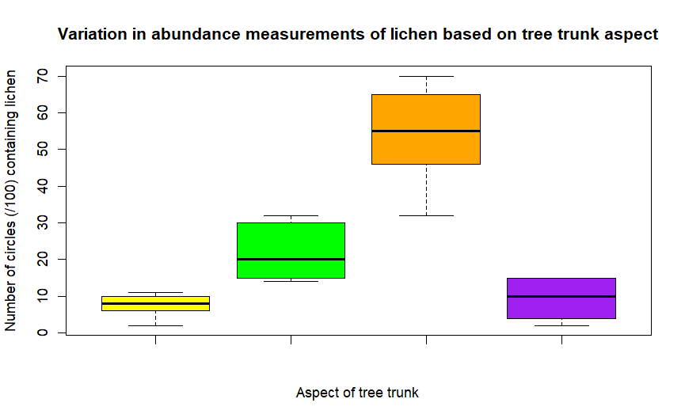

*Produced in R Studio*

**Processed data:**

|  |  |
| --- | --- |
| **Aspect of tree trunk** | **Abundance of lichen (%)** |
| N | 7 |
| E | 22 |
| S | 54 |
| W | 9 |

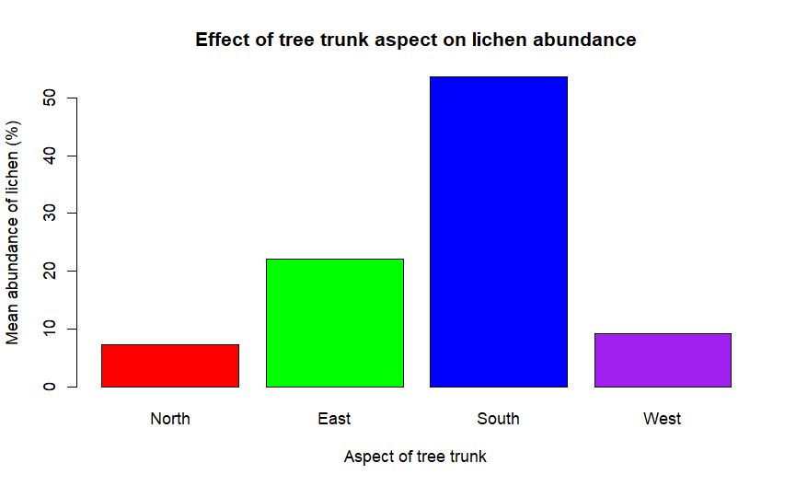*Produced in R Studio*

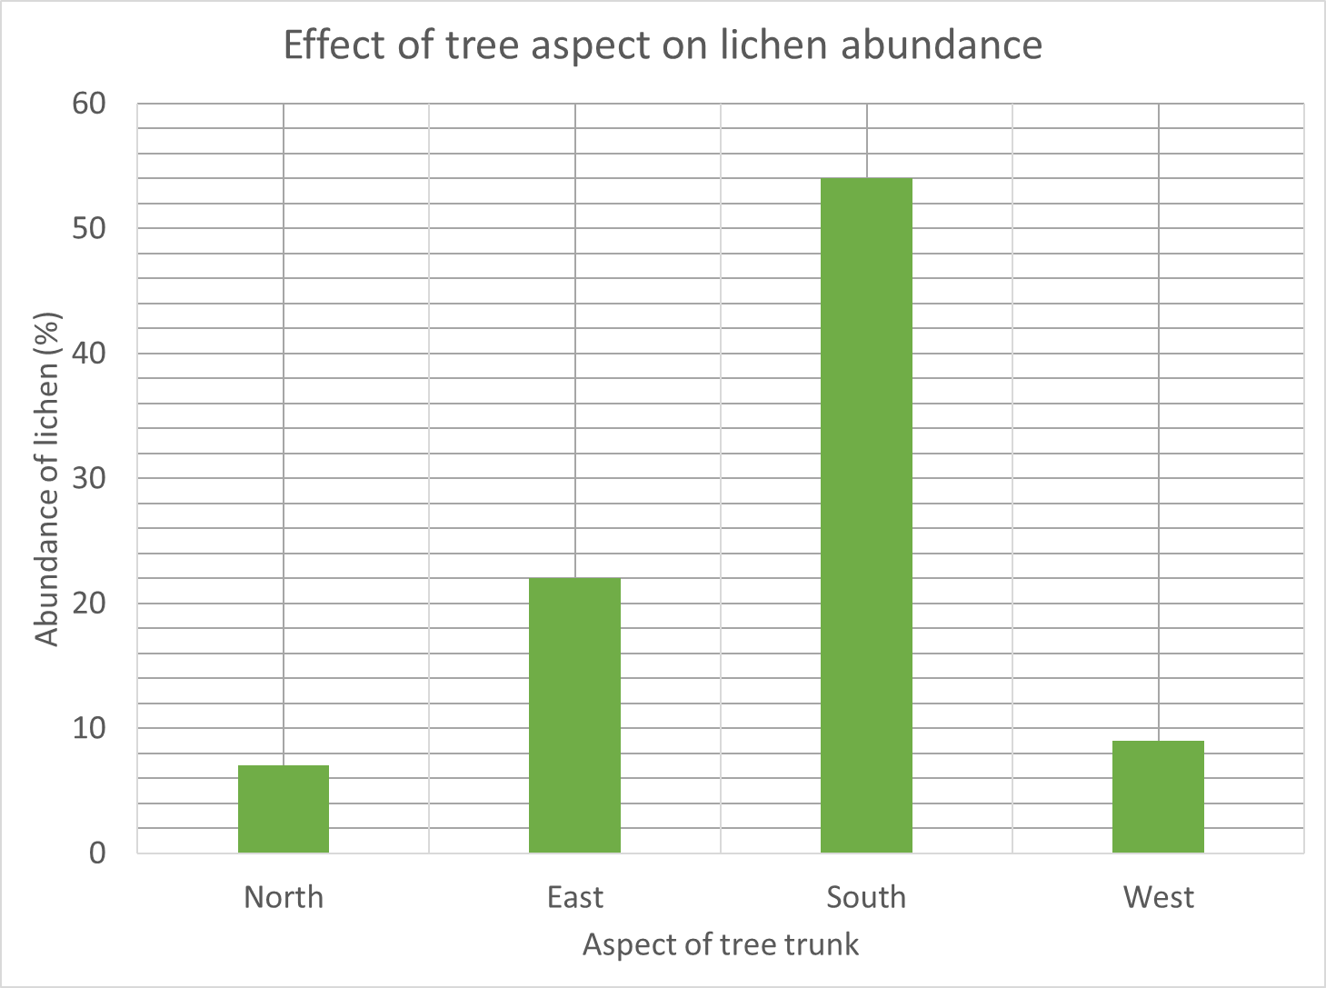

*Produced in Excel*

**Conclusion:**

Lichen is most abundant on the south-facing side of a tree, followed by east, then west. There is least lichen present on the north-facing side of a tree.