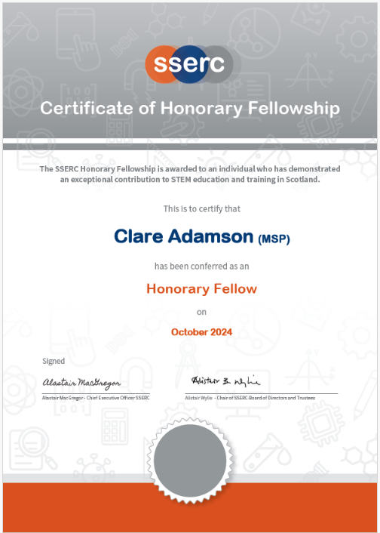**Honorary Fellowship 2024**

Clare was a member of the SSERC Board since 2015, assuming the role of Vice Chair (VC) in 2017 and also chairing the Audit and Risk Management Committee during her time as VC. During her time on the Board, Clare gave 100% effort, dedication and time to the role. In addition, Clare was a strong Ambassador for the organisation both within and outside the Scottish Parliament. Several useful and professional individual and organisational partnerships have been developed to benefit SSERC via Clare.

As well as acting as an Ambassador for SSERC within the Parliament, Clare convenes two Cross Party Groups of which SSERC are members (Science and Technology and Accident Prevention and Safety Awareness) and opportunities have been given to promote the work of SSERC at these events. As Convenore of the Education and Skills Committee, Clare again provided a platform for SSERC when appropriate.

Whilst Clare is no longer a member of the Board, she continues to be a strong and active Ambasssaador for the organisation eg facilitating the presentation of the 2023 Hon Fellowship in the Scottish Parliament (Nov 23) and profiling the work of SSERC at the Science in the Parliament event (Nov 23).

Clare has continued to engage with the organisation many times after she left the Board, and her commitment to continue to act as an Ambassador for the organisaiton has not diminished.

