BeeSpiV experiments
Experiment 1 – velocity down a slope - variation of v with s
You will need:
BeeSpiV
Toy car
3 or 4 sections of track
Metre stick
Ramp
Block of wood to support one end of ramp
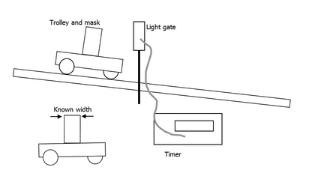
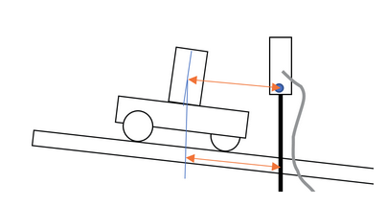

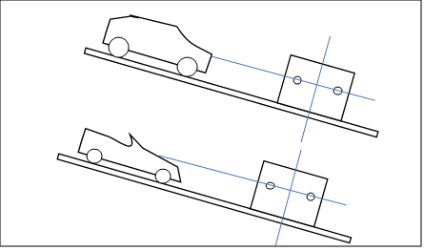
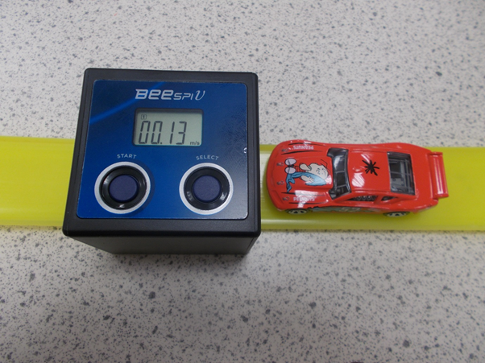

What to measure
We measured speed after s = 5 cm to s = 30cm in 5 cm intervals.
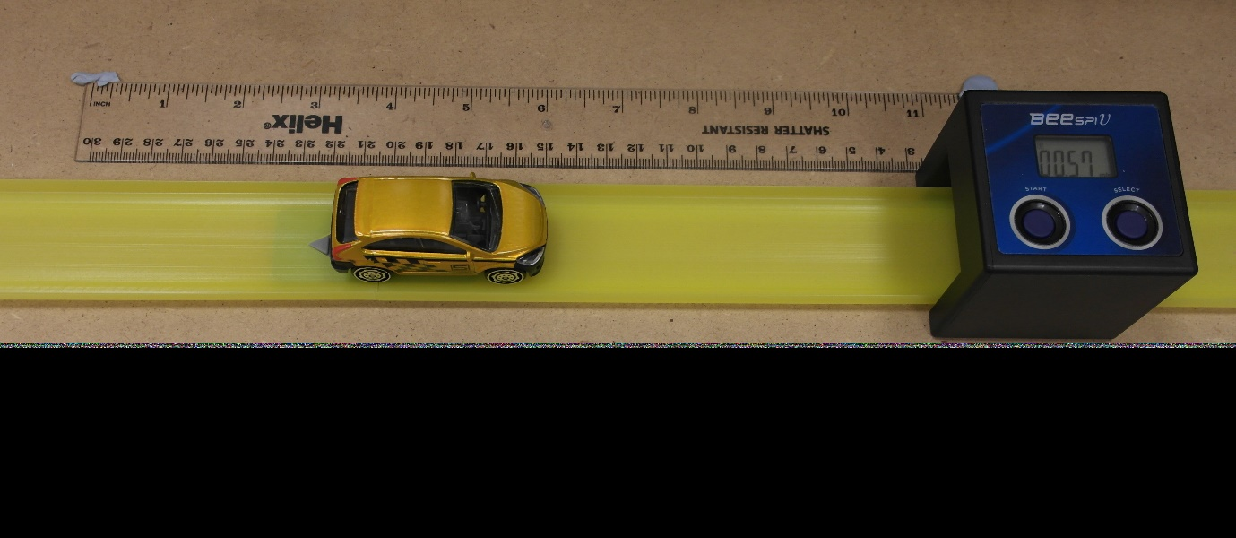
Beware track joints and cars rubbing against the sides of the track...

Theory
Since v² – u² = 2as,
If the trolley is released from rest, u² = 0, so v² = 2as
Graph of v² versus s should therefore be a straight line through the origin, with gradient 2a.
a, the acceleration, should be equal to gsinϴ where ϴ is the angle between the slope and the horizontal and g is the gravitational field strength.
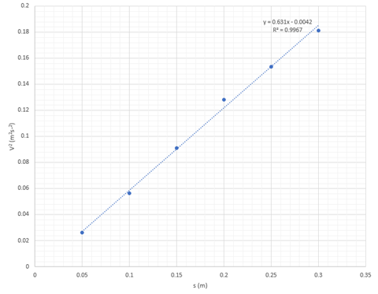
Experiment 2 – variation of range with horizontal speed
You will need:
BeeSpiV
Ball bearing
3 or 4 sections of track or a curtain rail
Metre stick
Clamp stand
Piece of carbon paper
Piece of white paper

Set up the apparatus as in the photo below.

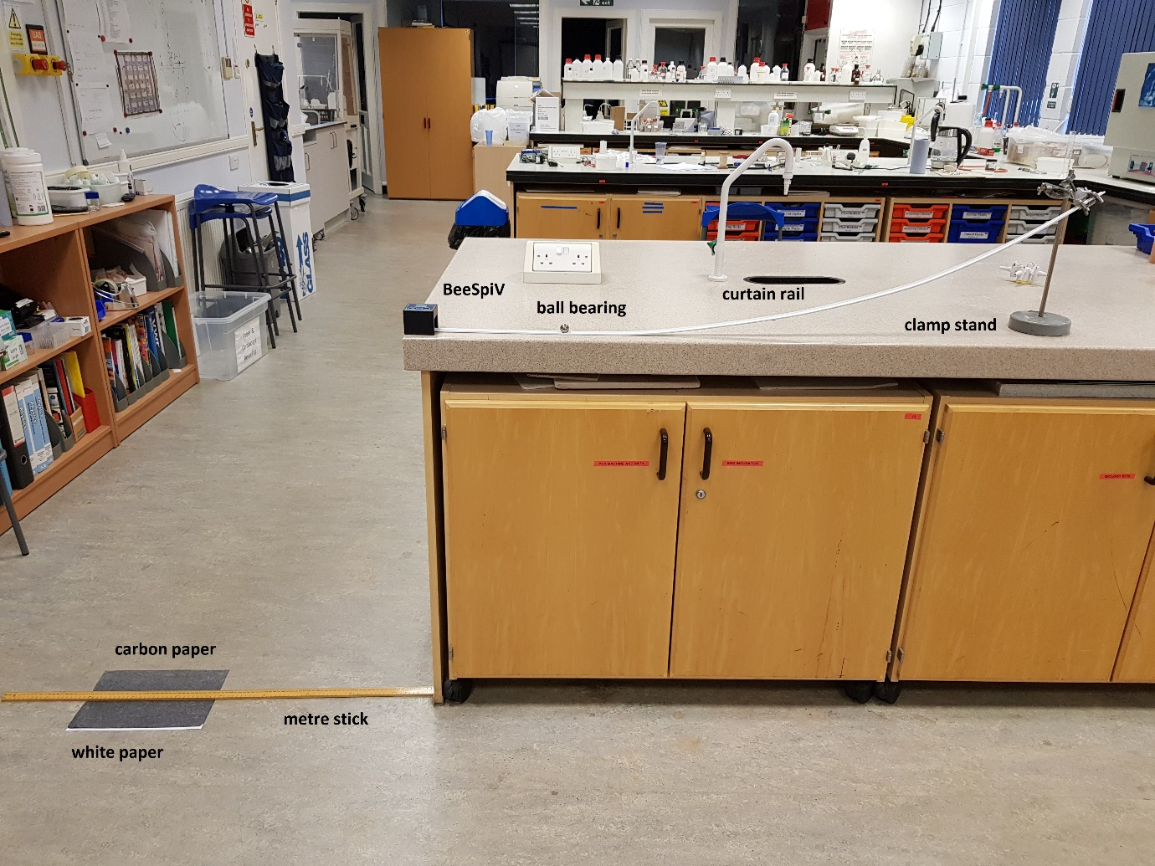
Run the ball bearing down the slope to establish a typical ‘landing site’. Use a small piece of adhesive tape to temporarily fasten the white paper to the floor at this point.
Place the piece of carbon paper ‘dark side’ down on top of the white paper. The ball bearing will now leave a mark on hitting the carbon paper.
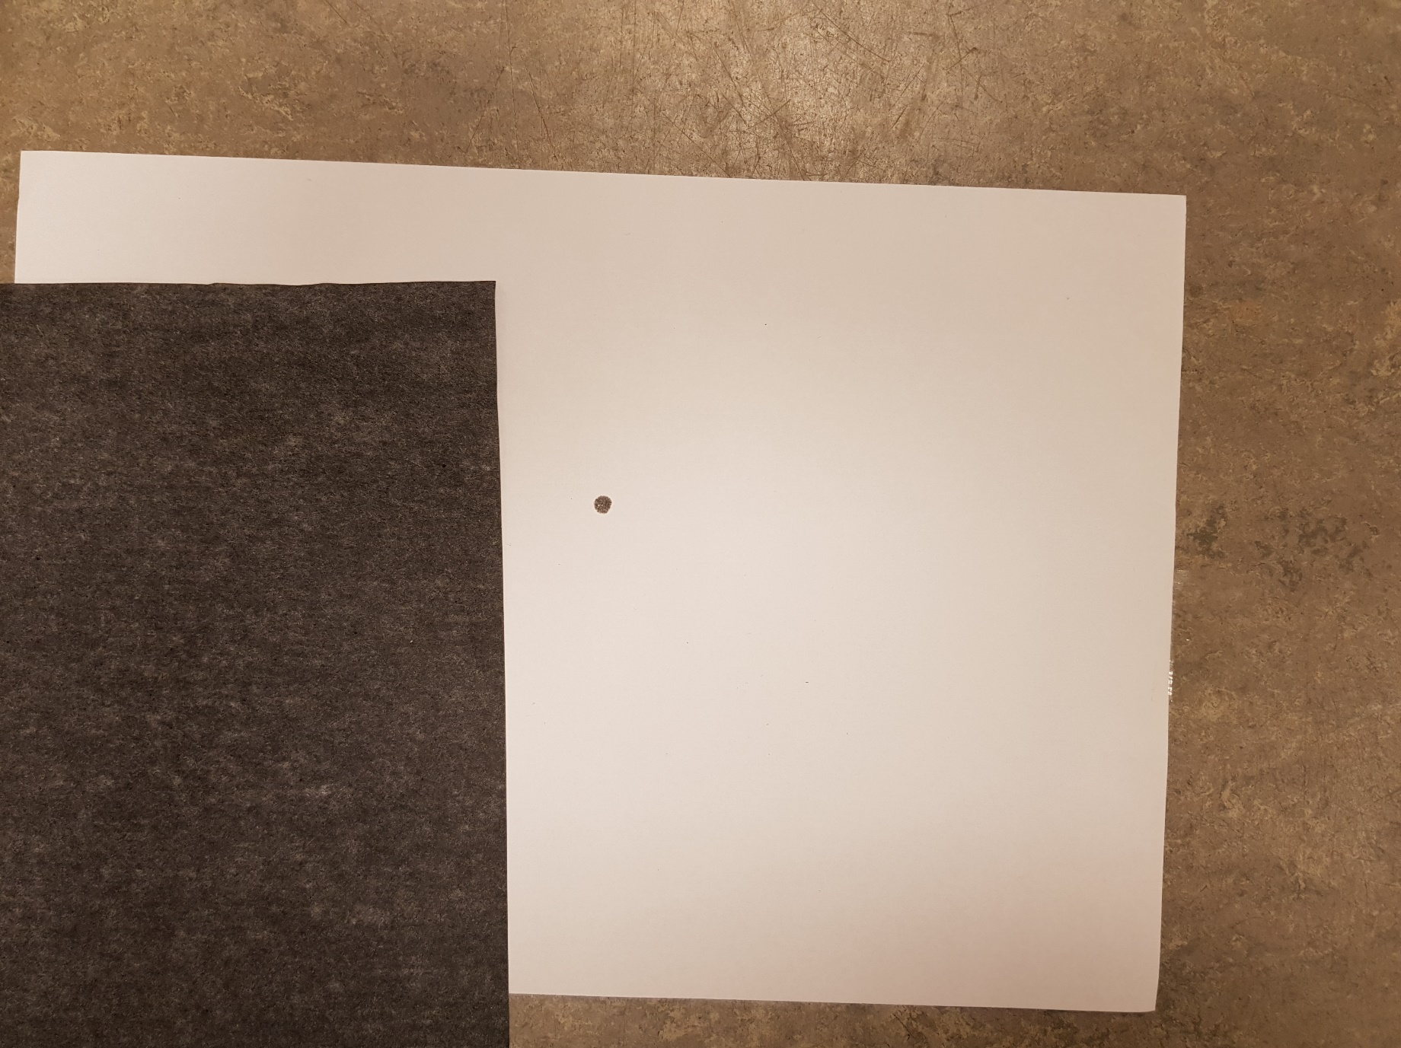
Measurements
Allow the ball bearing to run down the slope and record the horizontal velocity from the BeeSpiV and the range – the horizontal distance measured from directly below the end of the curtain rail.
Cross out or otherwise mark the impression to prevent confusion in future measurements. After several measurements you will have recorded a range of horizontal velocities and corresponding ranges.
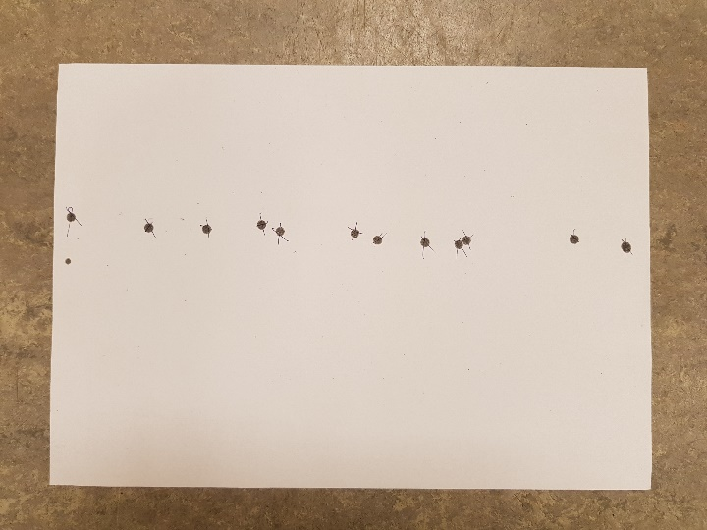

Theory
Distance = speed x time so range = horizontal velocity x time of flight
If the vertical height is constant the time of flight is constant and range is directly proportional to horizontal speed. Typical results are shown below. If the height is known g can be calculated using the gradient of this graph.

Experiment 3 – variation of range with height
You will need:
BeeSpiV
Ball bearing
3 or 4 sections of track or a curtain rail
Metre stick
2 x Clamp stands
Piece of carbon paper
Piece of white paper
Several gratnell trays

This experiment uses much the same equipment as the previous experiment.
In this experiment however we keep the horizontal velocity constant by using a second clamp stand as a stop to ensure we release the ball bearing from the same point on the track and we adjust the height by ‘raising the floor’ using gratnell trays. (see photos below).
In this experiment we measure the horizontal range (as before) and the vertical height from the end of the curtain rail to the surface of the top tray with the carbon paper.

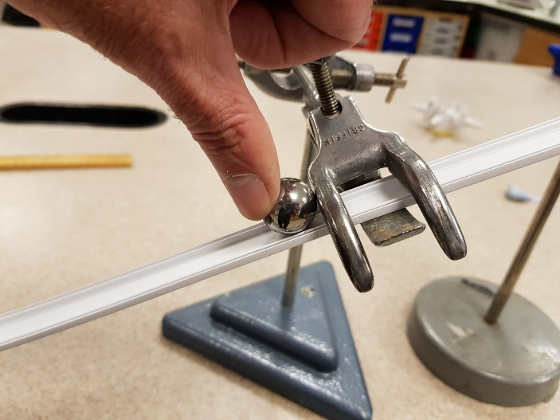
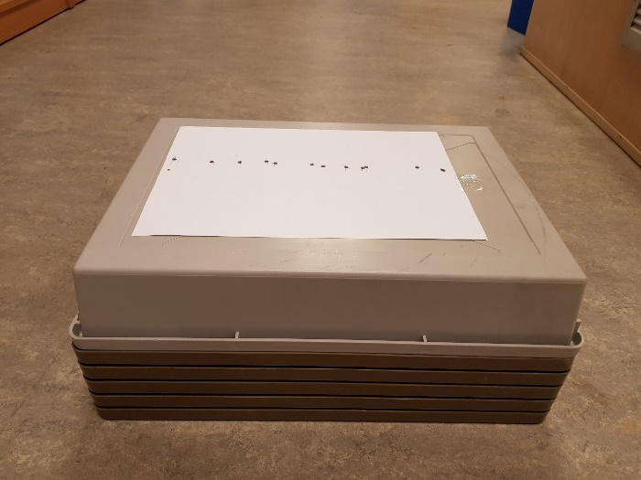

Theory
From s = ut + ½ at² if u =0, s=h and a =g we have h = ½ g t²
$t= \sqrt{\frac{2h}{g}}$ from experiment 2 we have range(R) = horizontal velocity(v_{h}) x time of flight(t)
So range R = v_{h} $\sqrt{\frac{2h}{g}}$ if v_{h} is constant then R α $\sqrt{\frac{2h}{g}}$ and plotting R v $\sqrt{h}$ gives a gradient m of value v_{h} $\sqrt{\frac{2}{g}}$ a straight line through the origin.
A typical graph of results is shown below.

