|  |
| --- |
| Chemistry Skills |
| Determining the melting point of Benzoic Acid |
| Teacher Guide |

## Introduction

Determining the melting point of a compound is one way to test if the substance is pure and is often used to test samples made from organic synthesis (eg of aspirin or paracetomol) as often have low melting points (below 300°C) which can be conveniently measured.

Pure samples usually have sharp melting points, for example 149.5-150°C or 189-190°C; impure samples of the same compounds melt at lower temperatures and over a wider range, for example 145-148°C or 186-189°C.

So if your sample has a melting point at the temperature you expect, it is probably what you think it is. Though be warned, there are some substances that have the same melting point. If the melting point is quite sharp, then it is likely to be pure. If a pure sample of a compound melts at 110 to 111°C, adding substantial amounts of another compound might result in a new melting point range from, say 88 to 100°C. Not just different but a wide range.

A sharp melting point at another temperature that then one you want probably means you have a fairly pure sample of something else.

The general method is to heat a sample indirectly by placing the prepared sample (usually packed in a glass capillary tube) in or on a heated medium and observing it, and the temperature, closely until melting is complete.

## Melting point of benzoic acid

## Preparation

1. For both versions given here, you need to prepare the sample in the same way.
2. Pour a small amount of your solid (benzoic acid in this case) onto a watch glass.
3. A needle dropping a substance into a glass dish

   Description automatically generatedTake a glass capillary melting point tube, which has one end sealed and the other end open.
4. Jab the open end of the tube into a pile of the solid.

*(If the solid is granular, grind it a little before trying to get it into the melting point tube – or it won’t fit).*

1. Turn the capillary tube the right way up and gently tap it on the benchtop to cause the solid to fall down to to the closed end
2. Then, drop the capillary tube closed side down several times through a long narrow tube (glass tube or cut PVC pipe,).

*The capillary tube will bounce as it hits the benchtop, (the glass/PVC tube is to stop it falling off the bench). The impact should pack the solid into the bottom of the tube. Failure to pack the solid well may cause it to shrink when heating, which can cause confusion as to the correct melting temperature*.

1. A close-up of a needle

   Description automatically generatedIf needed, repeat the previous steps to load sample until it is a height of 2-3mm in the tube.

*It is important that the sample be no higher than ~3mm or the melting range will be too broad.*

## Method 1 – melting point apparatus.

There is a wide range of different melting point apparatus out there. They all work in fundamentally the same way.

1. You put your prepared sample tube into a hole in an aluminium block

*Depending on the age of the machine, you may need to insert a thermometer into another hole in the block*

1. You turn the heat on high at first

*Different machines have different methods. Some simply have a manual control and you will need to watch the temperature and slow down as you get close, others allow you to set a target temperature that it will hurry up to and slowly increase from there.*

*The melting point of benzoic acid is 122.3°C*

1. When you are close, slow down the heating rate.

*If this has not been done automatically. In this case, close probably means around 110 – 115°C but if your apparatus is responsive you can get closer before slowing down.*

*The heating rate should be slow, usually around 1–2°C per minute.*

1. Watch the sample carefully.

*Most machines have a magnifying device and a light but you may find it easier to use a brighter light and/or a separate viewing device.*

1. When you see the first sign of melting, record the temperature.
2. Keep heating very slowly. Once all of your sample has been melted, record the second temperature.
3. These two temperatures are your melting point range.
4. Repeat to make sure you get similar results.

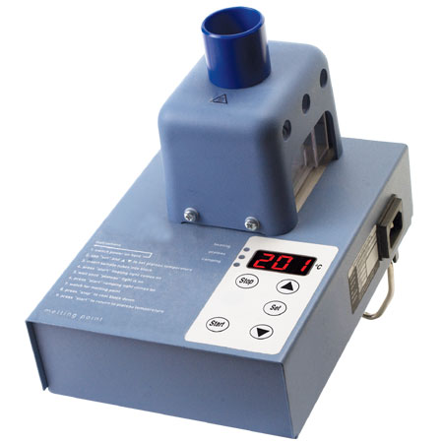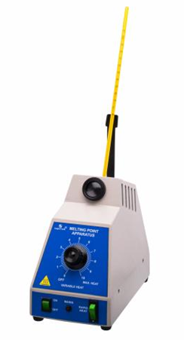

## Method 2 - Thiele tube

**You will need**

|  |  |
| --- | --- |
| Thiele tube | oil |
| Melting point tube(s) | Benzoic acid |
| Thermometer and bung | Spirit burner* |
| ‘fixing loop” |  |

* We have found that using a Bunsen burner means that the temperature rises too fast and it is much harder to get accurate results.

**Method**

1. A diagram of a chemical experiment

   Description automatically generatedFill the Thiele tube with oil* – to just above the loop and hold it in a clamp.
2. Take your melting point tube containing benzoic acid and fix it to a thermometer, such that the sample is adjacent to the bulb of the thermometer
3. Light your spirit burner and start heating the side arm of the Thiele tube.

*The melting point of benzoic acid is 122.3°C*

1. Once you get up to 100°C, take the burner away and then proceed slowly.

*The temperature on the thermometer will continue to rise for 2-3 minutes after you stop heating so be careful.*

1. When you are close to the target temperature, watch the sample very closely – using a magnifying glass (or your phone camera) can help. When you see it beginning to melt, record the temperature.
2. Keep heating very gently until it is all molten – record this temperature too.
3. Then carry out at least two further careful determinations (by heating more gently, i.e. temperature changing only about 2 °C/min) until you obtain two consistent values.

Note that unlike boiling point, the melting point is relatively insensitive to pressure and no pressure correction needs to be made.

*\* ethan1,2-diol can be used for temperatures up to about 140 °C. This has the advantage of being water soluble so cleaning is easier. Alternatively liquid paraffin can be used up to around 220 °C. Though a cheaper option (which we are using here, is just to use cooking oil.*

## Tips

* Particularly when using the Thiele tube method, go slowly.
* For your second melting point test, you need a fresh sample. You might be tempted to re-test the first sample once it has solidified but don’t. Differences in crystal structure between the original solid and the previously melted solid could lead to different melting ranges.
* If another melting point test is being carried out directly after the first, the metal block should be cooled to at least 20°C below the melting point of the next sample. You can just leave it to cool naturally but if you are in a hurry, you can speed up the process by touching it with wet paper towels or cooling it with a jet of cool air from a fan or hairdryer.
* If the sample begins to darken, this indicates that it is starting to decompose before tit reaches its melting point. Take note of the decomposition temperature, as it is sometimes as reliable a reference point as a compound's melting point. Use the letter "d" after a melting point to indicate decomposition (e.g. 155°C d).
* Some substances may sublime instead of melting, caffeine for instance. You will recognise this by a ring of solid appearing above where the sample is heated. The solid has sublimed and the vapours desublime into the solid again when it reaches a cooler area.

*Sometimes sealing the capillary at the top with a flame can prevent further decomposition or sublimation*

* The solid must be dry or the results will be affected as solvent can act as an impurity and affect the melting range.
* The sample should also be a fine powder. If it is not, grind it in a pestle and mortar.
* If your substance is hydroscopic (absorbs water from the atmosphere) then this might affect the accuracy of the result – especially if the sample is prepared in advance. Sealing the capillary with a flame will prevent this being an issue.
* Checking your conclusion. If your melting point analysis suggests that your unknown solid is a certain known compound, it is quite simple task to prove or disprove it. Mix your unknown sample with a roughly equal quantity of the purse substance. (eg mix your synthesised aspirin with aspirin from the chemical store).

A 50:50 mixture will either be a pure sample of the known compound, in which case the melting point will be pretty much the same as it was before or it will be a highly impure sample of the known compound. In the latter case the melting point will be lower and lowered and much broader. This identification/confirmation procedure is referred to as the determination of a "mixed" melting point.

## Some possible alternatives to Benzoic acid

|  |  |
| --- | --- |
| Aspirin 136°C | Paracetamol 169°C |
| Sorbitol 95°C | Vanillin 82°C |
| Resorcinol 110°C | Urea 133°C |
| Maleic Acid 138°C | Citric Acid 153°C |
| Tartaric Acid 169°C | Ascorbic Acid 191°C |