# Handling chemicals

Despite the word, handling chemicals should not involve contact with your hands. While many chemicals are harmless, some can be extremely harmful in contact with the skin.

## Preparation

### PPE

**Gloves**

At SSERC we generally recommend to avoid the use of gloves for most purposes.

* Gloves, even thin ones, reduce manual dexterity and sensitivity and so can make a spill more likely.
* They can lead to wider contamination. If you don’t realise you have a chemical on your gloves, you may wipe your eyes or transfer it to another surface. Etc.
* They are, if used frequently, an expense for the school and as they are disposable there are environmental issues to consider as well.

However, there are some circumstances in which they should be used:

1. If there are cuts, blisters etc which cannot be covered adequately by plasters
2. When using one of the small small number of chemicals which are corrosive but do not immediately produce a sensation of burning, eg phenol.
3. When handling substances that are significantly toxic by skin contact eg liquid bromine.

**Eye protection**

SSERC recommends the use of eye protection in the same way as you would in any other use of a chemical. If it is corrosive, splash resistant goggles if irritant safety spectacles.

There is, however, room for some common sense. If you are carrying out microscale chemistry and the likelihood of a spillage resulting in contact with your skin or eyes is very low, the risk assessment may suggest that eye protection is not needed. You should, however, always err on the side of caution.

## Handling

### Solids

The main risk here is of spilling a hazardous solid.

The correct tool for transferring solids from one container to another is a spatula. These are usually made of stainless steel (sometimes nickel) and come in various designs as shown below.

Always check that the spatula is clean and do not use the same spatula for different solids, unless cleaned and dried between uses. That way you will avoid contamination of your reagents.

There are various types of spatula you may encounter:

|  |  |
| --- | --- |
| **Nuffield spatula**  This is the most common spatula used in schools. The ‘curved’ end is the most suitable to use unless you only want a few grains. |  |
| **Chattaway spatula**  This is available in different sizes. There are also micro-sized versions. |  |
| **Spoon Spatula and Trulla spatula (trowel spatula)**  These are usually only used by technicians or teachers for transferring larger quantities of solids. |  |
| **DIY spatula**  A wooden splint can be used to transfer solid chemicals. The end can then be cut off with scissors and another chemical can be transferred with the same splint. The splint can be cut to a point to transfer tiny amounts of solids. |  |

### Mixing solids

For many substances, it is possible to simply stir them in whichever container they are in but this can be problematic.

Some mixtures which might explode if stirred with a metal spatula (or at all). In tis case, the solids to be mixed should each be placed on separate pieces of paper (or in plastic weighing boats) and then poured gently from one onto the other, back and forth. Repeat this pouring action about 10 times so that there is thorough mixing.

This is the only safe way of preparing explosive mixtures and is good practice for all solid mixtures.

## Liquids

The main risk here is of spilling or splashing a hazardous liquid or solution.

**Pouring**

* Spills can occur in various situations:
* When attempting to pour liquids from a large container (bottle) into a small container such as a test tube.
* When pouring too fast into a funnel, so the air has no chance to escape.
* When dribbling down the side of the bottle or measuring cylinders. (this can damage labels, make the bottle unsafe to pick up, or produce fumes as the liquid evaporates.

If your liquid is in a large bottle, it is safer to pour some into a beaker first.

Pouring from bottles, measuring cylinders and beakers

One way of avoiding dribbles is to pour down a glass rod into a container via a funnel.

**Small quantities**

It is difficult to pour small quantities so in this case using Pasteur pipettes or dropping bottles is a better option.

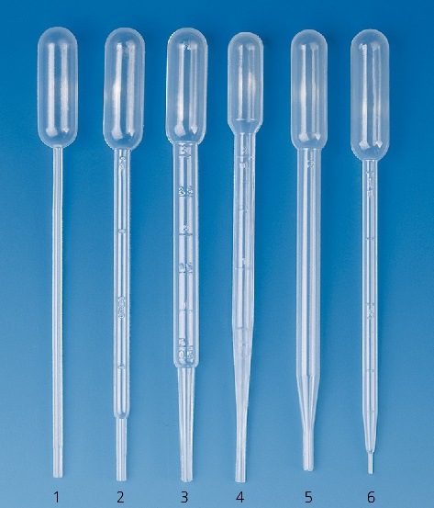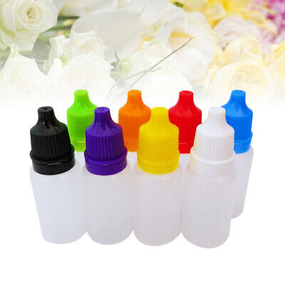

### Mixing liquids

Sometimes, the mere action of pouring one liquid into another will mix them adequately but if not the mixture will need to be stirred.

Spatulas should not be used for stirring.

Stirring rods made of glass or plastic should be used.

Stirring too vigorously can break your beaker or other container or cause the liquid to splash.

In a prep room there will probably be magnetic stirrers but as most liquids mix fairly easily it is rarely worth the effort of getting these out for this purpose.

**Filling test tubes**

If using a test tube, do not fill it more than 20 – 25% full (a quarter).

To mix the contents, hold the tube at the top (near the open end) and agitate (waggle) the test tube from side to side.

Do not generally shake it up and down. To stop it spilling out you will need to put your thumb over the end and this is not a good idea as both you and the solution will get contaminated. If more thorough shaking is needed, use a well-fitting rubber bung and hold it in with a finger or thumb while shaking.