

Chemical Experiments
TLC of Plant pigments

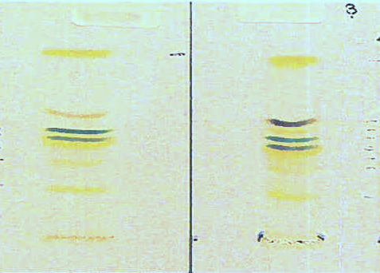
CfE Higher – Chemistry in Society
Chemical analysis
(and various points in the Biology curriculum

Introduction
Thin layer chromatography (TLC) like other forms of chromatography separates substances according to their solubilities and how they react with the material the plate is made of (usually silica or alumina). TLC uses a thin layer of silica or alumina (hence the name, on a plastic backing. The advantage of TLC over other forms of chromatography is that it can be carried out quite quickly and gives good separation.
This particular experiment uses the technique to look at the different pigments found in plant leaves.

You will need
Pestle and mortar | Some leaf material (e.g. basil plant)
Sample tube containing propanone (750 μl) | Ruler and pencil
Pasteur pipette or glass capillary tube | Beaker (250 cm³)
Solvent mixture

Preparation
Prepare your solvent mixture
5 parts cyclohexane
3 parts propanone
2 parts petroleum ether (40-60°C boiling point range)
The amount you will need depends on the size of your plate and container. For microscale n a Universal bottle, no more than 1 cm³ should be fine. For this version, in a 250 cm³ beaker, 5 cm3 should suffice but if using a 600 cm³ beaker (with 2 plates in per beaker, you will need 15-20 cm³ of the solvent)
Prepare your capillary tube
This is especially important if you are working on a microscale. The larger the drop. the less clear the separation and even a capillary tube can give quite a large size drop.
Holding the ends of your capillary tube in both hands, heat the centre of it briefly in a Bunsen or other burner flame foe a second or so and then pull apart to produce an even thinner capillary section in the centre. Let it cool and snap the middle to leave you 2 capillaries with extra fine tips.

Method
- Tear off approximately 1 cm² of the leaf material and grind it using the pestle and mortar.
We have found that basil leaves work well and are soft enough to grind easily. You can use any green plant material. If it is tougher, you can use a small amount of fine silver sand to help grind it.
- Add propanone (750 μl) and mix to form a green liquid.
- Pour this liquid back into the sample tube (try to avoid transfer of too much solid material at this stage) and re-cap the tube.

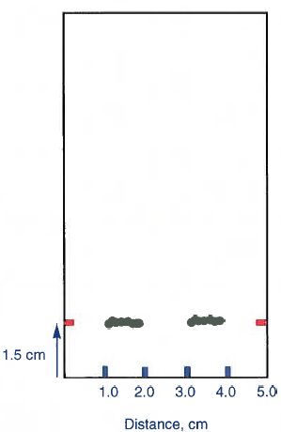
- Prepare your plate
If this is being done on a microscale, you will need to cut your TLC plates to size with a pair of sharp scissors.
The details below are for a full-size plate but the principle is the same for any.
Place the plate on a flat surface and using a pencil make a faint mark at either edge of the plate 1 .5 cm from the bottom of the plate (corresponding to the two red lines in the schematic shown).

- Load the plate
You may want to practise this application step before running the sample.
  - Dip the end of your prepared capillary into the sample liquid you prepared earlier. A small amount will be drawn up into the tip of the tube.
  - Dab the end at a suitable position on the plate and allow a small drop to run out onto the plate. Depending on the plate size, this will be either a single drop or a line of them.
  - Several applications may have to be made to produce a dark green strip.
Avoid any drops being larger than 0.5 cm diameter (on a full-size plate) 2-3mm is preferable for a smaller one.
Avoid digging the pipette tip into the plate.
- Place the thin layer plate into the beaker (or other container) and cover.
Aluminium foil is fine if there is no suitable lid. The reason is to keep the air in there saturated with solvent vapour to prevent it evaporating too much as it goes up the plate.
- When the solvent front gets near the top, remove the plate and immediately mark the position of the solvent front with a pencil mark on the edge of the plate.
- Mark the position of the pigments as soon as the solvent has dried (they fade with time, especially in the light). Use the UV lamp to see if further bands can be identified.
A good option is to place a ruler next to the plate and take a photograph.

Results
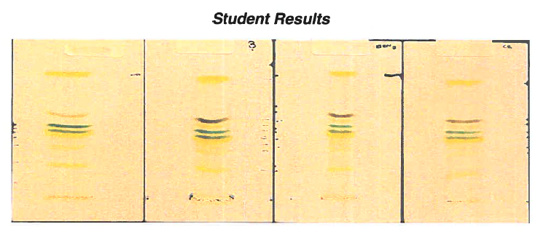

Pigment | Colour | RF value
Carotene | Yellow-orange | 0.91
Pheophytin | Grey | 0.75
Pheophytin | Light-grey | 0.63 - 0.75
Chlorophyll a | Blue-green | 0.63
Chlorophyll b | Green | 0.58
Xanthophylls | Yellow | 0.53
Xanthophylls | Yellow | 0.47
Xanthophylls | Yellow | 0.32

Note
Thin layer chromatography (TLC) of photosynthetic pigments is one of the practicals suggested in the learning activities section of Cf E Higher Biology.
The theory of thin layer chromatography as a separation technique is also included under the mandatory course key area ‘Laboratory techniques for biologists’ in the ‘Cells and Protein’ Unit of Advanced Higher Biology.
If appropriate, Advanced Higher students could use TLC as a technique in carrying out their Advanced Higher Investigation.

