|  |
| --- |
| Chemical Demonstrations |
| Burning magnesium in steam |

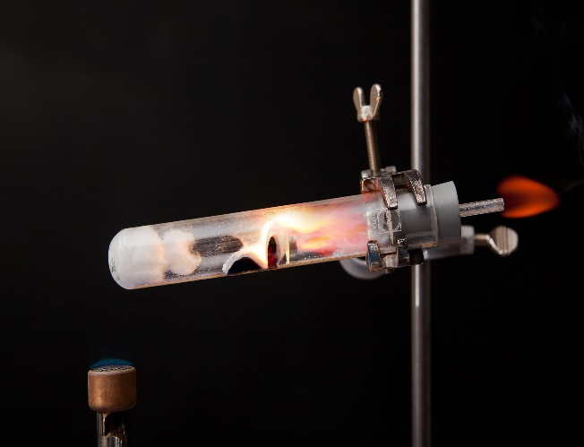

Image - RSC

This reaction can be applied to curriculum for excellence.

*Through experimentation, I can identify indicators of chemical reactions having occurred ...* SCN 3-19a

*Having carried out a range of experiments using different chemicals, I can place metals in an order of reactivity, and relate my findings to their everyday uses.* SCN 4-19b

**N4 –** Chemistry in Society

*The properties of Metals and Alloys*

**N5 –** Chemistry in Society

*Metals*

**Introduction**

When looking at the reactions of metal with water, we find out that magnesium does react but very slowly.

However, the reaction can be shown much more effectively if we heat it up and use steam instead.

**You will need**

|  |  |
| --- | --- |
| Magnesium ribbon ~6cm coiled | Bunsen burner |
| Borosilicate tube and bung with a glass tube in it. | **Mineral wool** |
| water |  |

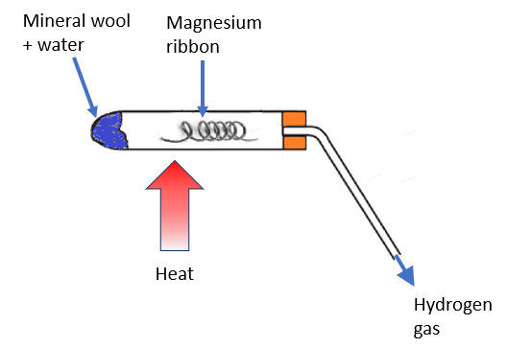**What you Do**

1. Set up the apparatus for this demonstration as shown in the diagram - right. (With the tube held in a clamp.
2. Heat the coil of magnesium ribbon coil until it **just** catches fire
3. Move the Bunsen flame so as to heat the water-soaked mineral wool.

*This produces steam that passes over the burning magnesium*

1. The hydrogen gas formed can be ignited as it comes out of the end of the glass tube.

*Alternatively a longer tube can be used to collect the gas for testing later. In this case be very watchful of potential suck-back.*

**Safety**

Wear eye protection

Do not use magnesium powder.

Learners should be at least 2 m back.

**Notes**

Magnesium burns in steam to produce hydrogen gas and white magnesium oxide.

Mg(s)+H2O(g) MgO(s)+H2(g)

The oxide is produced rather than the hydroxide formed when reacting with water is because the metal hydroxide thermally decomposes to the oxide and water.

Some magnesium silicide is formed with the glass apparatus; this weakens the glass and it can easily break. Even if it doesn’t break, the boiling tube is ruined by this experiment; do not attempt to clean it.

**Disposal**

Add used glassware to at least 500 cm3 of cold water; this destroys magnesium silicides.

The silanes that are formed are spontaneously flammable so you may see some small pops or flames. Don’t worry.

Once rinsed, the glass is disposed of in the glass bin.

**It is the responsibility of teachers doing this demonstration to carry out an appropriate risk assessment.**