Let’s Talk

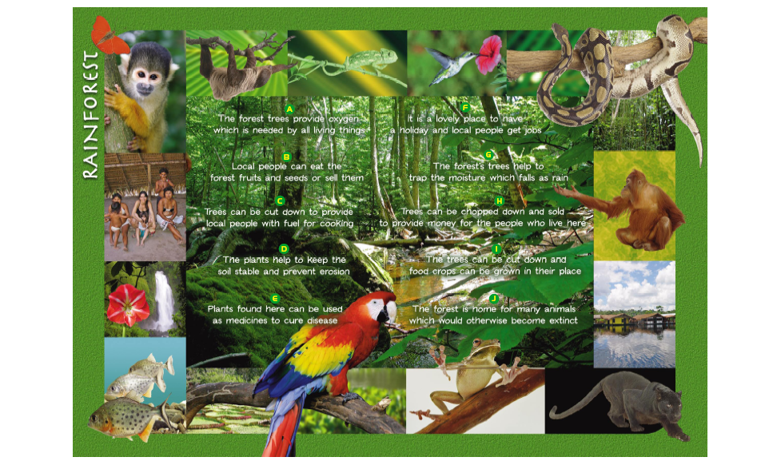

**Plants Matter**

Teacher Guide

This activity aims to provide primary teachers with a

resource which will help them to raise science-related

issues with their pupils.

This activity supports the following CfE outcomes:

* I have collaborated on investigations into the process of photosynthesis and I can demonstrate my understanding of why plants are vital to sustaining life on Earth. **SCN 3-02a**
* I understand how animal and plant species depend on each other and how living things are adapted for survival. I can predict the impact of population growth and natural hazards on biodiversity. **SCN 4-01a**

The activity also supports the **Life on Earth** units of National 3 and 4 Biology:

|  |
| --- |
| **National 3**  **Exemplification of key areas**  **Key areas** |
| Sampling and identifying living things from  Habitat is the place where an organism lives  The range of types of organisms, the biodiversity, varies greatly between habitats.  Different habitats support different organisms because the organisms are adapted to exist in the particular sets of conditions  different habitats to compare their biodiversity and suggest reasons for their distribution.  **National 4** |

**Key areas**

Investigate a variety of ecosystems/biomes eg rainforest, tundra, desert, arctic, temperate, local ecosystems

Animal and plants species depend on each

other

# Impact of population growth and natural

Investigate examples of human population growth and how these affect biodiversity. Investigate human influenced environmental disruptions on biodiversity

# hazards on biodiversity.

# Plants Matter

This activity could be used with pupils from age 9-11 when they are studying plants and perhaps at a point when they are learning about the importance of plants as foods, medicines, habitats for animals etc. The activity aims to encourage the pupils to discuss some of the issues and conflicts associated with preserving forests, providing habitats for wild animals within farmland, food transport issues etc. All the materials are on the enclosed CD.

The lesson could begin with a general discussion about the ways in which plants are important and the pupils are asked to imagine lovely ‘planty’ places. The teacher then reads out 12 words and the pupils write down the first plant-type word which comes into their head associated with the word the teacher has read out.

|  |  |  |
| --- | --- | --- |
| 1. forest | 5. seeds | 9. pollen |
| 2. green | 6. perfume | 10. buds |
| 3. carbon dioxide | 7. leaves | 11. photosynthesis |
| 4. flowers | 8. fruits | 12. habitat |

The teacher now put the class into groups of about 5 pupils and each group looks at the words to see if anyone in the group wrote down the same words.

The pupils then pick the 5 most popular words for their group and use them to make a short poem or a song or a sentence about why you feel plants matter.

This should set the scene and get the pupils thinking about plants.

Examples of poems from pupils aged 10

|  |  |
| --- | --- |
| **The trees are growing**  **The colours are glowing**  **The leaves are blowing**  **The plants are moving**  **But the green grass is swaying** | Cherry tree blowing in the wind Spring blossom with a wonderful smell  Leaves making oxygen to help us breathe With fruits and seeds to feed the animals |
| **In a field near me**  **There was a tree**  **Around it did fly**  **A buzzing bee**  **Under this tree**  **Ran many ants**  **From here to there**  **Carrying bits of plants**  **High in the air**  **Birds flapped their wings**  **Down on the farm**  **Animals ate like kings** | **Trees help us live**  **If it wasn’t for trees and their leaves**  **We would all be dead**  **Plants make the world beautiful**  **Green, red, brown, orange, purple and gold**  **All of these colours are beautiful**  **So is the world and we want to keep it that way** |

What matters most?

Then, still in groups, the pupils are given one of the plant environment pictures and asked to rate the importance of the statements. In each picture there are 10 statements the pupils have to give each statement an ‘importance mark’ out of 5 but they only have 35 points to give out. For example if a group was looking at

the farm and decided that the statement ‘Farms throughout the world provide almost all the food which we all need to survive’ was very important they would assign a score of 5 to box F on the pupil sheet. They need not use all their 35 points but must not use more than 35 points. They record their points in the tables provided for each environment.

Teachers might find it helpful to copy the list of statements, provided on the separate sheet, so that the pupils can keep track of which statements have been used.

The lesson ends with another discussion. The teacher could discuss the difficulties which exist in making the decisions about ‘what matters most’ and that there is no ‘correct’ answer. The teacher could ask the pupils who should make the decisions and then get them to vote to see who most pupils think should decide.

## Statements

|  |  |
| --- | --- |
| **Rainforest** |  |
| A  The forest trees provide oxygen  which is needed by all living things | B  Local people can eat the forest fruits  and seeds or sell them |
| C  Trees can be cut down to provide  local people with fuel for cooking | D  The plants help to keep the soil stable  and prevent erosion |
| E  Plants found here can be used as  medicines to cure disease | F  It is a lovely place to have a holiday  and local people get jobs |
| G  The forest’s trees help to trap the  moisture which falls as rain | H  Trees can be chopped down and sold to  provide money for the people who live here |
| I  The trees can be cut down and food  crops can be grown in their place | J  The forest is home for many animals  which would otherwise become extinct |

|  |  |
| --- | --- |
| **Farm** |  |
| A  Farmers throughout the world provide almost all the food which we all need to survive | B  Farmers spray crops to kill insects and other living things which are pests and would destroy the crops |
| C  People can have family holidays on farms and learn all about what happens there | D  Wild flowers grow on the farmland and insects and birds find places to live there |
| E  Farms provide work for local people and for all the people who transport and sell the food | F  Farmland gets sold and used to build houses for people |
| G  Farms are wonderful green areas full of plants which are giving beauty, food and oxygen | H  In some places the food grown on the farm is sent away to other countries and the land is not used to grow food for the local people |
| I  In some places farms are not looked after well and people do not get the food they need | J  In some places too much food is grown and it gets thrown away |

|  |  |
| --- | --- |
| **Seashore** |  |
| A  The sea and seashore are beautiful and we must preserve them | B  The plants in the marine environment help to stabilise our climate |
| C  When countries run out of fresh water they can use sea water to drink by taking the salt out of it | D  The seas are full of plants which provide oxygen for all marine life |
| E  Plants in the sea provide all the food for the animals | F  The seas are full of undiscovered plant and animal species which may be very important to humans |
| G  The seas and the seashore are great places for humans to relax and have holidays | H  If the marine plants are polluted many living things will become extinct |
| I  The seas provide a place for humans to get rid of their waste | J  Fish eat small marine creatures which eat marine plants and the fish provide jobs and food for people |