

|  |
| --- |
| Chemical Demonstrations |
| Methane Rocket |

This reaction can be applied to curriculum for excellence.

SCN 3-19a

*Through experimentation, I can identify indicators of chemical reactions having occurred ...*

National 4 – Chemical Change & Structure

*Energy changes of chemical reactions*

National 4 – Nature’s Chemistry

*Fuels, Hydrocarbons*

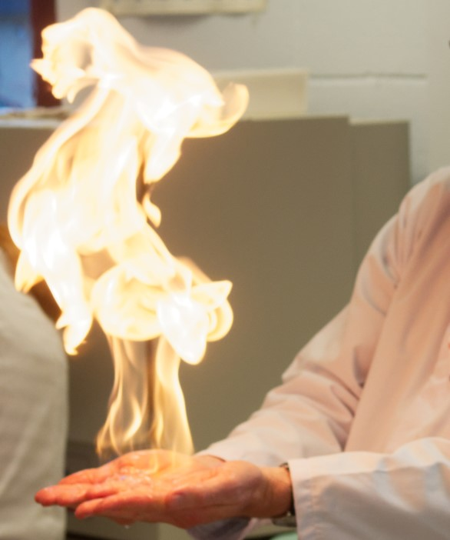

To show fossil fuels burn to give out energy.

A strong plastic bottle is filled with a 2 : 1 ratio of oxygen to methane and the mixture ignited. The mixture ignites with a loud bang and the bottle flies several metres

**What you will need**

|  |  |
| --- | --- |
| A carbonated soft drink bottle of between 300 cm3 and 500 cm3 capacity | A rubber bung to fit the bottle |
| A large trough or washing up bowl | Measuring cylinder, 500 cm3. |
| Rubber tubing to fit the gas tap | Access to an oxygen cylinder or other source of oxygen |

**Preparation**

1. Select a suitable place to carry out the demonstration. The bottle could easily fly the whole length of a laboratory so make sure that is nothing that it might hit – particularly anything fragile like glassware. A corridor might give more space but you would have to be careful about people getting in the line of fire.
2. You also need to prepare some sort of system to give it a bit of direction. One option is opening a book in a way that it forms V between the left hand and right hand pages and sitting the rocket in this. Or a couple of pieces of wood.
3. Find the volume of your bottle by filling it with water and pouring the water into a measuring cylinder to determine its total volume. It should be between 300 and 500 cm3 capacity

**What you do**

1. Add 1/3 of the bottle’s volume of water into the bottle and mark the level with a waterproof pen.
2. Next completely fill the bottle with water and invert it in a trough or washing-up bowl full of water.
3. Place the end of a rubber tube connected to the gas tap under the neck of the bottle. and fill the bottle to the marked level with methane (natural gas) from the gas tap. Remember to turn the tap on for a couple of seconds before putting under the neck of the bottle to allow air in the tube to be displaced first.
4. Now fill the rest of the bottle with oxygen from your cylinder (or other source) chosen source, again remembering to displace air in the delivery tube for a few seconds before starting to fill.
5. The bottle now contains a 2 : 1 mixture of oxygen and methane by volume: a stoichiometric mixture.
6. Place a rubber bung in the neck of the bottle and position it for launch. Check the aiming of the rocket and ensure than none of the audience is near the flight path.
7. Wear eye and ear protection and advise the audience to cover their ears.
8. Remove the bung and ignite the gas mixture by applying a lighted splint (or another suitable lighter) to the neck of the bottle.
9. The rocket will take off with a loud bang and fly for several metres.
10. If you are going to repeat this, use a new bottle.

**The Chemistry**

The reaction is

CH4(g) + 2O2(g) → CO2(g) + 2H2O(g) ΔH = -890 kJ mol-1

The gases react in a 2 : 1 ratio and the reaction is strongly exothermic.

Note that there are three moles of gas on both sides of the equation so all the force that propels the rocket comes from the expansion of the gases as they are heated by the energy given out by the reaction, rather than by the production of extra molecules of gas.

**Notes**

After firing, the rocket can be recovered and shown to the audience to point out that it is covered on the inside by condensation – droplets of water formed in the reaction

**Safety**



Wear eye protection



Care when igniting methane - flammable

It is important that a carbonated drink bottle is used; bottles used to contain still drinks may not be strong enough. Each bottle should be used for one demonstration only as it may be weakened by the explosion.

**It is the responsibility of teachers doing this demonstration to carry out an appropriate risk assessment.**