UV-Sensitive Yeast
Background:
Practical work involving the use of a mutated strain of Saccharomyces cerevisiae, which is sensitive to UV light, is suggested as a learning activity to support learning and teaching of CfE Highers in Biology and Human Biology. It has also been suggested, by the SQA, as a possible assignment topic at Higher level. The experimental work referred to in this document was initially adapted by Alison Rutherford from practical protocols produced by the Carolina Biological Supply Company (www.carolina.com). An article entitled ‘How much sun is too much?’ was published in SSERC Bulletin 228 and provides background to and description of the practical work [1]. This protocol has recently been investigated at SSERC by Sandy Norman, who has looked at ways to simplify the procedure and troubleshoot problems teachers and technicians were encountering.

Possible aims to investigate:
Aim 1: To investigate the effect of SPF on cell survival.
Aim 2: To investigate the effect of sunscreen brand on cell survival.
Aim 3: To investigate the effect of UV light exposure time on cell survival.

You will work in groups of 4.
- Each pair will carry out the serial dilution to prepare a 1000-fold dilution of the UV-sensitive yeast.
- In groups of 4, you will work on Aim 1.
- Each person in the group will plate out 100 µl of 10⁻³ culture dilution onto a sterile YGA plate, carry out their specific treatment, and then incubate their plate at 30 °C.
Anyone / Plate 1 | Person 1 / Plate 2 | Person 2 / Plate 3 | Person 3 / Plate 4 | Person 4 / Plate 5
No treatment | Moisturising cream | SPF X | SPF Y | SPF Z
Hypothesis: low cell count | Hypothesis: no protection; low cell count | Hypothesis: minimal protection; more colonies than plate 2 | Hypothesis: medium protection; more colonies than plate 3 | Hypothesis: high protection; more colonies than plate 4.

Materials that must be prepared before the session:
- YGA plates – 1L of this can be prepared as follows:
  - Add 20 g glucose and 10 g yeast extract to a beaker. Add distilled water to the 1 L mark. Stir thoroughly and adjust to pH 6 using 0.1 M sulphuric acid or 0.1 M sodium hydroxide. Add 20 g agar. Autoclave the media. Pour plates using the sterile media, once cooled to 55 ᴼC.
- YGA plates streak-inoculated with UV-sensitive yeast and incubated at room temperature for 2-3 days (wrapped in foil) to allow distinct colonies of a reasonable size to grow. Plates can be kept in the fridge, wrapped in foil, until required.

Materials available for each pair:
1x YGA-plate, streak-inoculated with UV-sensitive yeast (wrapped in foil) | 1x 10 cm³ sterile distilled water in universal container
3x 9 cm³ sterile distilled water in universal container | 1000 µl P1000 pipette + sterile tips
Marker pen | Glass spreader
Beaker of ethanol | Watch glass
Wire loop | Bunsen burner
Heat proof mat | 1% Virkon in discard jar
1% bleach (surface disinfectant) | Aluminium foil
Gas lighter / matches | Blue roll

Materials required per group of 4:
Access to UV lamp | Cling film
5x sterile YGA plates | Paper towels
Sunscreen (same brand) with various SPF | Spatula
E45 / moisturising cream (with no SPF) | Sellotape
Access to an incubator at 30 ᴼC

Method – Prepare a serial dilution – each pair will carry this out.
- Wash hands. Tie hair back. Disinfect work surface with 1% bleach.

- Label the bottles with the appropriate dilution.
  - Bottle of 10 cm³ – Starter
  - Remaining bottles, each with 9 cm³ water – 10⁻¹, 10⁻², 10⁻³.

- Using aseptic technique, transfer 1 isolated colony of UV-sensitive yeast from the stock streak plate to the bottle of 10 cm³ sterile water. Gently agitate to mix. Sterilise the loop.

- Flick the universal bottle to separate the clumps and ensure the cells are distributed through the liquid.

- Using aseptic technique and the P1000 pipette with a sterile tip, transfer 1 cm³ of the culture from the starter to the bottle marked 10⁻¹. Mix well.

- Repeat step 5 until you have a 10⁻³ suspension (1000-fold dilution).

- Wrap bottles in foil to prevent exposure to UV light.
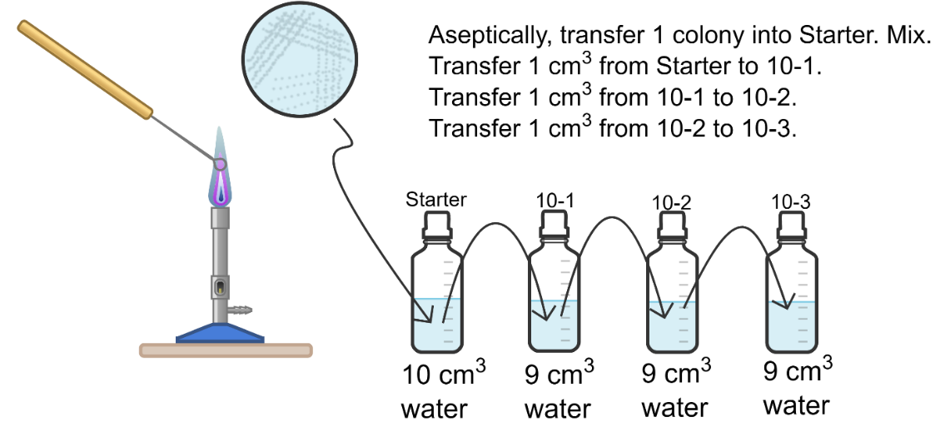

Method – working in groups of 4. Each person will be responsible for one plate. Whoever finishes first should do the negative control.

- Label a sterile YGA plate on the underside with date, your initials, UV-sensitive yeast dilution factor, and treatment (e.g. SPF6, SPF30).

- Using aseptic technique and the P1000 pipette with sterile tip, transfer 100 µl yeast culture (1000x dilution) onto the agar surface.

- Aseptically, spread the culture evenly over the surface using a glass spreader.

- Sellotape the petri dish closed with two small pieces of tape. Wrap the plate in foil.

- Repeat this for each plates.

- Plate 1 (negative control) will be fully exposed to light. Do not add anything to this petri dish.

- For the remaining plates: Apply sunscreen / E45 cream, to plates 2-5 by placing a pea-sized piece of sunscreen to a piece of clingfilm, spreading it with the spreader.

- When all pieces of clingfilm have been prepared, remove the foil from the plates.

  - Plate 1: remove the petri dish lid. Position the plate directly under the UV lamp.
  - Plate 2 – 5: remove the lid. Drape the clingfilm over the top of the petri dish, without touching the agar. Position the plate under the UV lamp.

- Irradiate all plates for one hour using a UV lamp.

- Remove the clingfilm, replace the lids, and cover plates in foil.

- Incubate plates for 2-3 days at 30 ᴼC.

- Count the number of distinct colonies on each plate.
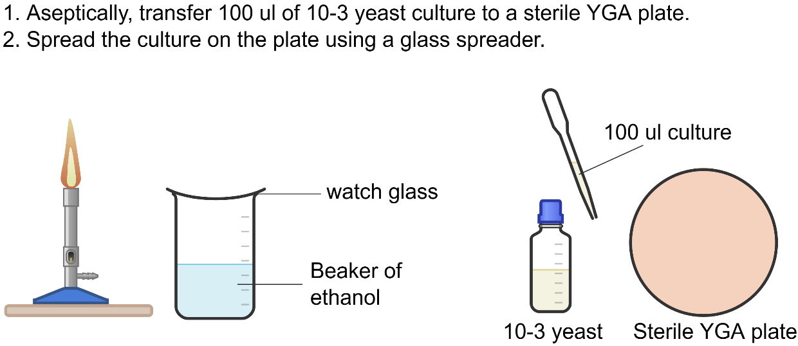
To allow you to obtain results during the course, we will provide some plates that were incubated 3 days ago. Count the number of colonies present under each treatment.

Results
Treatment | Number of yeast colonies growing on agar plate
No treatment
Moisturising cream
SPF
SPF
SPF

