Session 6: Catalase
Background:
Catalase is an enzyme found in nearly all aerobic cells (animals, plants, and microbes). The function of catalase is to protect the cell from the harmful effects of hydrogen peroxide generated as a by-product of cell metabolism. It does this by speeding up the breakdown of hydrogen peroxide into oxygen and water.

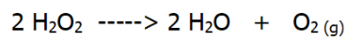

The following protocol demonstrates the above reaction. Oxygen is evolved when yeast is placed in hydrogen peroxide, containing a small volume of detergent. As oxygen is produced, foam is observed. The diameter of the foam circle produced on the activity board can be measured as an indicator of catalase activity.

Health & Safety: Working with 20 vol hydrogen peroxide can cause eye and skin irritation. Although the volumes used are small, eye protection should be worn throughout the protocol and care should be taken to minimise contact with skin. If 20 vol hydrogen peroxide does contact the skin, wash with copious running water.
In this session, we are going to investigate the effect of substrate concentration. However, the protocols in this session can be easily adapted for the standard enzyme IVs.

Investigation 1: Microscale catalase
Aim: To investigate the effect of substrate concentration on catalase activity.

Materials:

6 cm³ 2.5% yeast suspension | Ruler
6 cm³ 5 / 10 / 20 vol hydrogen peroxide | 6x 3 cm³ plastic pipettes
6 cm³ detergent | Stopwatch
6 cm³ distilled water | Activity board
Blue roll / paper towels

Method:
- Add 2 drops of detergent to the containers of hydrogen peroxide, using a clean pipette. In this session, the reaction will be carried out at room temperature.

- Use the table below to add the reagents to the circles on the activity board. Always add yeast last, as this is the source of the catalase enzyme.

Reagent | Drops of reagent to add to circle
 | 5 vol | 10 vol | 20 vol
H₂O₂ + detergent | 5 | 5 | 5
Water | 3 | 3 | 3
2.5% yeast | 2 | 2 | 2

- Leave the reaction for 3 minutes and then measure the diameter (in mm) of the foam circles using a ruler. Wipe the activity board clean and repeat the experiment a further two times.

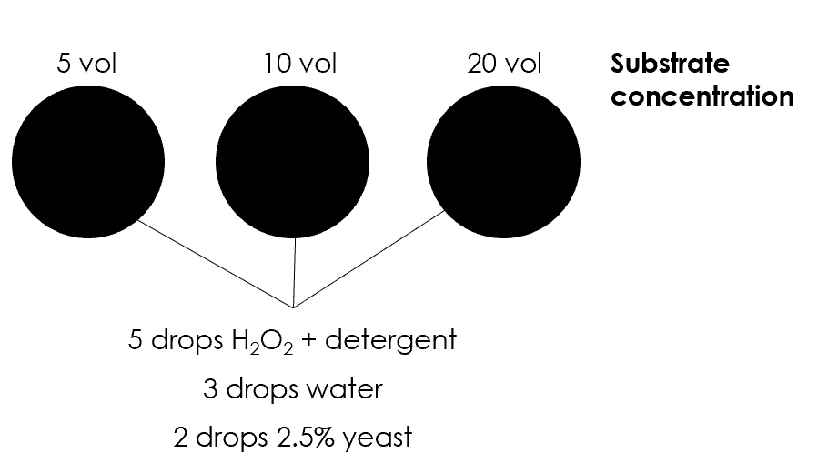

Results

Concentration of H₂O₂ (vol) | Diameter of foam (mm)
 | 1 | 2 | 3 | Average
5
10
20

Investigation 2: Immobilisation
In this section, we will look at effect of tissue type and substrate concentration on catalase activity.

Part 1: Preparing the tissues
Materials required (per pair):
Pestle & mortar | 2 g melon / cucumber (remove skin) / cress / bean sprouts
Plastic pipette | Distilled water
Balance | Weigh boat
Knife | 10 cm³ syringe (wash and re-use for Part 2)
Cotton wool | Forceps

Method - in pairs
- Choose a vegetable material – weigh 2 g of the tissue and add to the mortar. Grind the tissue and then add 2 cm³ distilled water.

- Remove the plunger from the syringe barrel. Use a pair of forceps (or similar) to add a very small piece of cotton wool over the syringe outlet.

- Use a plastic pipette to transfer the tissue material into the syringe, allowing it to slowly filter through the cotton wool.

- Collect the filtered material into a weigh boat, ready for Part 2.

Part 2: Immobilising the enzyme
Materials required (per pair):
1 cm³ tissue extract from Part 1 | 4 cm³ 2% sodium alginate solution
Clamp stand | 10 cm³ syringe (from Part 1)
2% calcium chloride solution | Distilled water in wash bottle
Weigh boat | Tea strainer
Glass beaker / plastic cup | Plastic spoon

Method - in pairs
- Remove the plunger from the 10 cm³ syringe and secure the syringe barrel into the clamp stand.

- Add ~30 cm³ calcium chloride solution to a plastic cup and place under the tip of the syringe barrel.

- Add 1 cm³ tissue extract into a bijou with 4 cm³ sodium alginate. Invert to mix.

- Pour the tissue / alginate mix into the syringe barrel and allow the mixture to drip into the calcium chloride, without applying any pressure to the syringe. Each drop will form a bead as it enters the calcium chloride - swirl the beaker gently with each drop. Allow all the tissue / alginate mixture to drip into the calcium chloride.

- The beads will be fragile so allow a few minutes to settle. Eventually, the beads will start to sink. Use a tea strainer to separate the beads from the calcium chloride solution.

- Gently rinse the beads with distilled water. Then transfer the beads into a weigh boat.

You now have immobilised the tissue sample on the beads. The beads can now be used to investigate catalase activity.

Part 3: To investigate the effect of tissue type on catalase activity
Materials required (per pair):
Universal of 10 vol hydrogen peroxide | Beads of immobilised tissue
Plastic spoon | Stopwatch

Method - in pairs
    - Remove the lid from the universal of 10 vol hydrogen peroxide and reset the stopwatch.

    - Using the plastic spoon, transfer one immobilised tissue bead to the surface of the hydrogen peroxide. As soon as the bead hits the solution, start the stopwatch. Record how long it takes for the bead to fall and rise to the surface.

    - Using the plastic spoon, transfer the used bead to the discard jar.

    - Repeat the experiment a further two times at this concentration of substrate.

    - Repeat this procedure with the other immobilised tissue types by sharing with other groups.

Tissue type | Time taken for bead to fall and rise (s)
 | 1 | 2 | 3 | Average
Melon
Cucumber
Cress
Bean sprouts

Part 4: To investigate the effect of substrate concentration on catalase activity
Materials required (per pair):
Universals of 1, 2, 5 and 10 vol hydrogen peroxide | Beads of one immobilised tissue
Plastic spoon | Stopwatch

Method - in pairs
    - Remove the lid from the first universal of hydrogen peroxide and reset the stopwatch.

    - Using the plastic spoon, transfer one immobilised tissue bead to the surface of the hydrogen peroxide. As soon as the bead hits the solution, start the stopwatch. Record how long it takes for the bead to fall and rise to the surface.

    - Using the plastic spoon, transfer the used bead to the discard jar.

    - Repeat the experiment a further two times at this concentration of substrate.

    - Repeat this procedure using the other substrate concentrations.

H₂O₂ concentration (vol) | Time taken for bead to fall and rise (s)
 | 1 | 2 | 3 | Average
1
2
5
10

Investigation 3: Displacement – demo only
Aim: To investigate the effect of substrate concentration on catalase activity.

Materials:

1x side-armed test tube | Bung to fit test tube
Silicone tubing | Basin of water
25 cm³ measuring cylinder | Beehive stand
45 cm³ 2.5% yeast suspension | 3 cm³ 5 vol hydrogen peroxide
3 cm³ 10 vol hydrogen peroxide | 3 cm³ 20 vol hydrogen peroxide
Access to water | 1x 5 cm³ syringe
3x 1 cm³ plastic pipettes | Kettle for warm water
250 cm³ beaker to serve as a waterbath | Stopwatch
Retort stand

Method:
      - Position the side-armed test tube in a 250 cm³ beaker, ½ full of warm water.

      - Attach the silicone tubing to the test tube side arm. Weave the tubing under the beehive stand, positioned inside a basin of water and inert into the neck of the measuring cylinder.

      - Fill the 25 cm³ measuring cylinder, to the very top, with water and invert, under the surface of water in the basin, and carefully secure using the retort stand.

      - Using a syringe, add 5 cm³ of 2.5% yeast suspension to the test tube.

      - Using a plastic pipette, add 1 cm³ 5 vol hydrogen peroxide to the test tube.

      - Immediately replace the rubber bung. Start the stopwatch.

      - The oxygen gas produced during the reaction will displace the water inside the measuring cylinder. After 1 minute, record the volume of oxygen gas in the measuring cylinder.

      - Repeat this procedure for each hydrogen peroxide concentration. Leave the silicone tubing attached to the test tube each time.

Results
Hydrogen peroxide concentration (vol) | Volume of oxygen gas produced (cm³)
 | Trial 1 | Trial 2 | Trial 3 | Average
5
10
20

