Water analysis
Chloride content in water
Aim: To determine the chloride content of different samples of water.
Background: Sea water is salty, mainly due to the presence of sodium chloride. Fresh water contains a far smaller concentration of chloride ions than sea water. Salinity (how salty something is) is important in agriculture, as increasing the salinity of the soil has implications for loss of production. The analysis of chloride is done by titrating with silver salts.
You will need:
25cm³ 0.05 moll⁻¹ silver nitrate solution | 3 x empty bijoux
Bijou containing 0.1% fluorescein solution | 2 decimal place balance
Bijou containing 0.25% salt solution | Clamp stand
3 x 1cm³ pipettes | 100cm³ Beaker

To do
Water sample preparation
A 0.25% salt solution has been provided which is ready to analyse.
Calibrating the pipette
- Fill the pipette with water and put into the jaws of the clamp.
- Place the beaker on the balance, positioned underneath the pipette, and zero it.
- Slowly tighten the clamp, counting the number of drops until the balance reads exactly 1.00. Repeat a couple of times and calculate the average.

As 1cm³ of water weighs exactly 1g, this allows you to work out the mass of one drop.
The pipette can now be filled with the silver nitrate solution.

Titration
- Add 1cm³ of the salt solution to an empty bijou.
- Add 2 drops of fluorescein.
- Place the pipette filled with silver nitrate into the jaws of the clamp. Tighten until the first drop falls.
- Place the bijou under the tip of the pipette, slowly tighten the clamp, counting drops as they go. Initially it is best to shake after every 5-10 drops, but as the end pint nears, shake after each drop.
- When the end point has been reached, record the number of drops in the table.
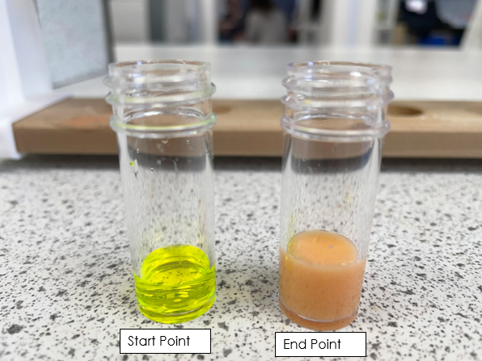
- Repeat until you have concordant results.

Safety
0.05 moll⁻¹ silver nitrate and 0.1% fluorescein solutions are both low hazard, so there is no need for eye protection for this experiment.
Recycling: It is common, where possible, to collect silver residues to reclaim.
Results
Average number of drops in 1cm³: ________________
Titre | Number of drops of silver nitrate | Volume of silver nitrate (number of drops/number of drops in 1cm³) (cm³)
1
2
3

Calculation
As the silver ions react in a 1:1 ratio with the chloride ions, the concentration of chloride ions can be calculated using this method.
Average volume of silver nitrate used: ___________cm³
Number of moles of silver nitrate reacting:
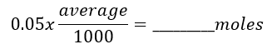
Concentration of chloride ions:
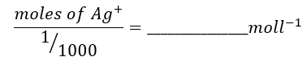
Phosphate content in water
Aim: To determine the phosphate content of different samples of water.
Background: Organic phosphates are important in nature. Their occurrence may result form the breakdown of organic pesticides which contain phosphates. They may exist in solution, as particles, loose fragments, or in the bodies of aquatic organisms.
You will need:
Potassium antimony tartrate solution# | Distilled water
Ammonium molybdate solution# | 3cm³ pipette
Ascorbic acid solution# | 100cm³ beaker
5 bijoux containing 5cm³ 1ppm, 2ppm, 3ppm, 4ppm and 5ppm standard phosphate solutions. | 10cm³ Measuring cylinder
1 x bijou containing 5cm³ water sample | Cuvettes
2.5 moll⁻¹ sulfuric acid | Colorimeter
# see technician notes at the end for preparation.
To do
- Make up the combined reagent: Mix the reagents in a beaker in the following proportions (and order) for 20cm³ of the combined reagent.
  - 10cm³ 2.5 moll⁻¹ sulfuric acid.
  - 1cm³ potassium antimony tartrate solution.
  - 3cm³ ammonium molybdate solution.
  - 6cm³ ascorbic acid solution.
If turbidity forms in the combined reagent, shake, and let stand for a few minutes. This reagent is stable for four hours.
- Add 1cm³ of combined reagent to the bijou containing 1ppm phosphate standard solution. Replace lid and shake.
- Repeat for the other four standard solutions, and the water sample provided.
- Leave the solution for 15 minutes.
- Place a cuvette containing deionised water into the colorimeter and calibrate.
- Transfer some of the coloured solution to a cuvette and read the absorbance at 590nm (or red filter).
- Repeat with the other reference samples, and the test sample.
- Using the readings from the reference samples, plot the figures on the calibration graph.
- Using the reading for the test sample, read the absorbance off the graph to determine the concentration.
Safety
0.00844 mol⁻¹potassium antimony tartrate solution, ammonium molybdate, phosphate and ascorbic acid have no significant hazards.
2.5 moll⁻¹ sulfuric acid is corrosive, and the combined reagent is a skin/eye irritant, so eye protection should be worn.

Results
Standard phosphate solution concentration (ppm) | Absorbance
0 | 0.00
1
2
3
4
5

Test sample absorbance:______________
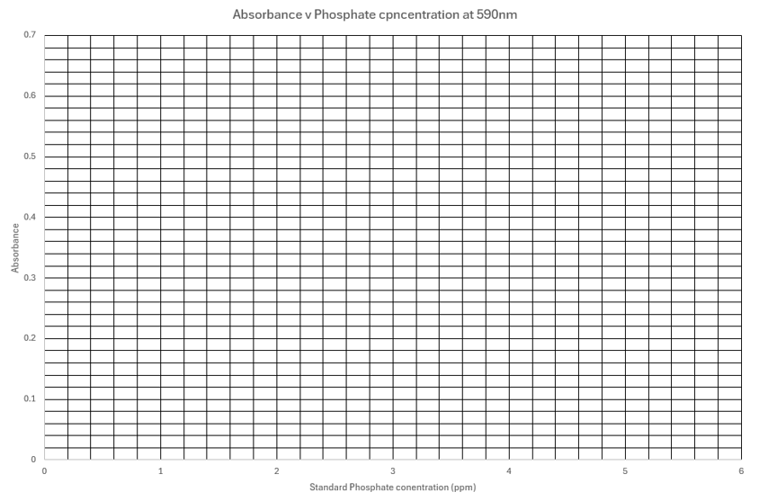
Test sample concentration:________ppm
Example calibration graph.
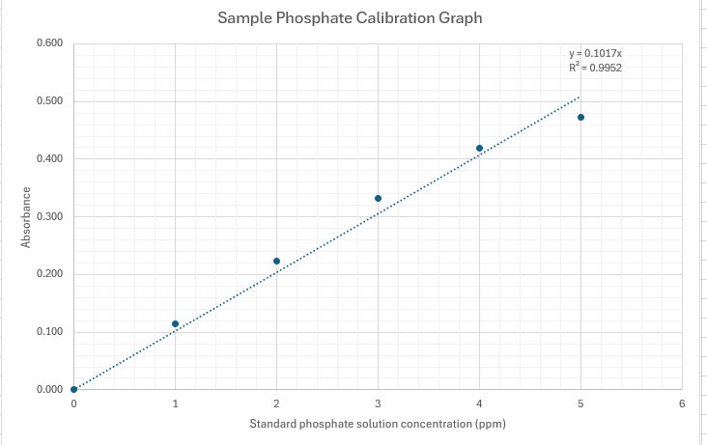

Technician Notes
Equipment and materials required for each group
50cm³ 2.5M sulphuric acid | Colorimeter and Cuvettes
5cm³ potassium antimony tartrate | Distilled water
15cm³ ammonium molybdate solution | Beaker/bottle for combined reagent
30cm³ ascorbic acid | Test tubes
15cm³ 10ppm (PO₄³⁻) Phosphate standard solution | Measuring cylinder
A standard stock 10ppm phosphate solution:
A 10ppm solution of phosphate = 14.3ppm solution of potassium dihydrogen phosphate.
(10ppm = 10mg/l)
To ensure accuracy it is better to make a more concentrated solution and then dilute it.
1000ppm (PO₄³⁻) phosphate stock solution: Dissolve 1.43g of potassium dihydrogen phosphate in distilled water in a 1000cm³ volumetric flask and make up to the mark.
10ppm (PO₄³⁻) phosphate solution: Transfer 10cm³ of 1000ppm stock solution to a 1000cm³ volumetric flask and make up to the mark.
Potassium antimony tartrate: Dissolve 1.371g K(SbO)C₄H₄O₆. ½H₂O in 400cm³ distilled water in a 500cm³ volumetric flask and dilute to volume.
Ammonium molybdate solution: Dissolve 20g (NH₄)₆Mo₇O₂₄. 4H₂O in 500cm³ distilled water.
0.1M Ascorbic Acid: Dissolve 1.76g ascorbic acid in 100cm³ distilled water

