Factors that affect pectinase activity
Aim: To investigate the effect of [IV] on pectinase activity.
Background:
Extracting juice from a wide variety of fruits can be done by manual squeezing or, more efficiently (in terms of speed and volume), using enzymes. These enzymes, which include pectinase, amylase and cellulase, break down plant cell walls to release liquids and sugars.

Plant cell walls are complex molecular structures and to get the maximum breakdown of the compounds found in them, industry use different treatments to maximise their yields. Fruit is made up of cells linked by middle lamellae which contain insoluble proto-pectin. Pectinase breaks down the pectin chains.

Cell walls are composed largely of cellulose and hemicellulose; cellulases weaken the cell walls, which makes it easier to extract juice.

A variety of polysaccharides are found within the juice extract which make the juice to cloudy and reduce its market value. Pectinases and amylases degrade these insoluble compounds releasing soluble sugars, which clarify the juice producing a clearer, sweeter product.

Enzymes are expensive products and juice manufacturers aim to minimise their costs by using the enzymes at their optimum conditions and therefore maximising their effectiveness, re-using the enzymes where possible.

Possible independent variables to investigate in this session:
Temperature | pH | Substrate concentration | Fruit type

Materials available per pair:
40 cm³ pectinase | Stirring rod
1x Knife | Stopwatch
1x Chopping board | 4x 100 cm³ beakers
1x Balance | Spoon
2x 5 cm³ syringe (enzyme & buffer) | Weigh boats
4x filter funnel | Blender
160 cm³ water | 4x filter paper
4x 100 cm³ measuring cylinders | Waterbath at 55 °C
1x 25 cm³ measuring cylinder | 160 g Granny Smith apple

Additional materials available for specific aims:
25 cm³ pH buffers 2, 4, 7, 10 | 100 g fruit - pineapple, pear, melon
Water baths at 40 °C, 55 °C, 80 °C.

Aim 1 Method – Temperature
- Blend 4 separate pieces of apple, each 20 g, with 20 cm³ water to achieve a “finely chopped” consistency.
- To four separate beakers, add the finely chopped apple to 5 cm³ pectinase. Mix well.
- Incubate at the appropriate temperature for 5 minutes (10 minutes would be preferable but if time is limited, 5 minutes will do).
- Transfer the contents of the beakers to separate filter funnels (with filter paper) and collect the filtrate in a 100 cm³ measuring cylinder. Record the volume of juice collected.
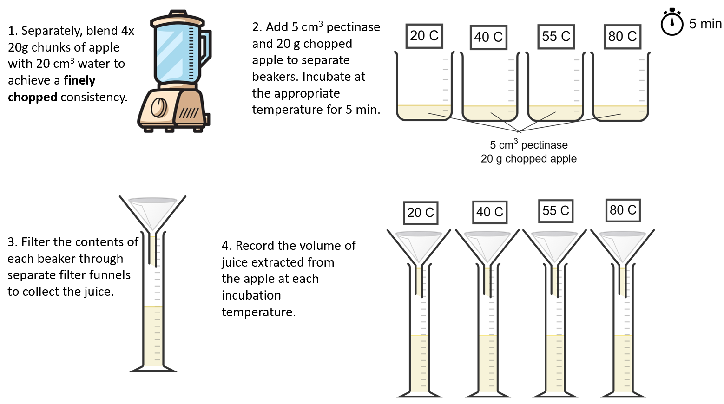

Aim 1 Results:
Incubation temperature (°C) | Volume of juice extracted from apple (cm³)
20
40
55
80

Aim 2 Method – pH
- Blend 4 separate pieces of apple, each 20 g, with 20 cm³ water to achieve a “finely chopped” consistency.
- To four separate beakers, add the finely chopped apple to 5 cm³ pectinase and 5 cm³ of the appropriate pH buffer. Mix well.
- Incubate at 55 ºC for 5 minutes.
- Transfer the contents of the beakers to separate filter funnels (with filter paper) and collect the filtrate in a 100 cm³ measuring cylinder. Record the volume of juice collected.

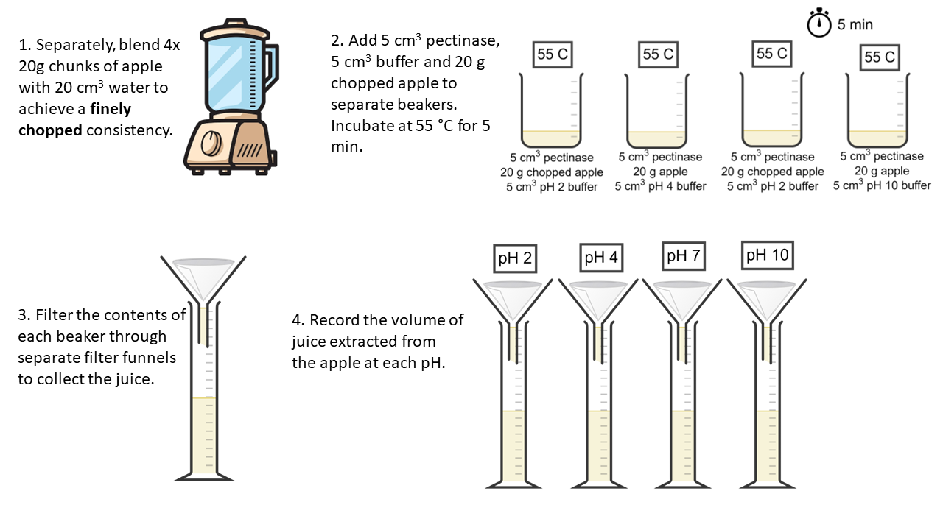

Aim 2 Results:
pH | Volume of juice extracted from apple (cm³)
2
4
7
10

Aim 3 Method – Substrate concentration
- Blend 4 separate pieces of apple (5 g, 10 g, 20 g or 30 g) with 20 cm³ water.
- To four separate beakers, add the apple to 5 cm³ pectinase. Mix well.
- Incubate at 55 ºC for 5 minutes.
- Transfer the contents of the beakers to separate filter funnels (with filter paper) and collect the filtrate in a 100 cm³ measuring cylinder. Record the volume of juice collected.

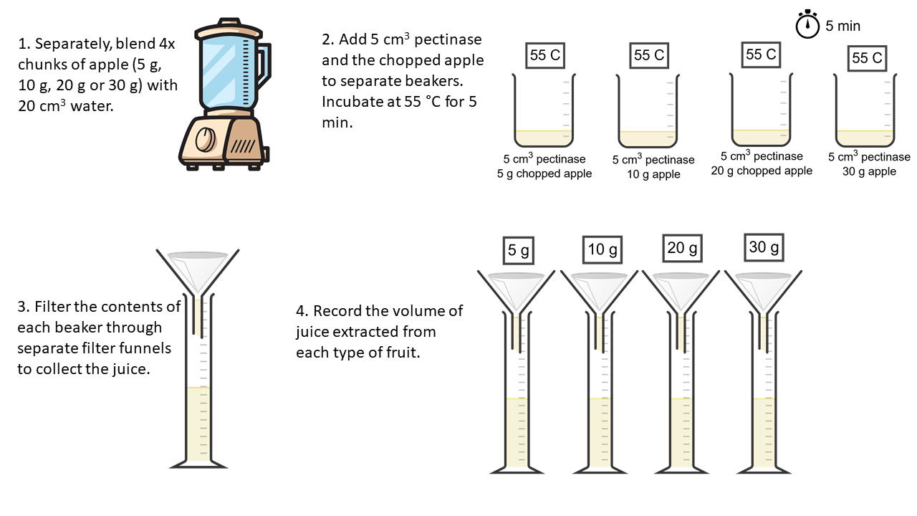

Aim 3 Results:
Mass of apple (g) | Volume of juice extracted from apple (cm³)
5
10
20
30

Aim 4 Method – Type of fruit
- Blend 4 separate pieces of fruit (apple, pear, pineapple or melon), each 20 g, with 20 cm³ water to achieve a “finely chopped” consistency.
- To four separate beakers, add the fruit to 5 cm³ pectinase. Mix well.
- Incubate at 55 ºC for 5 minutes.
- Transfer the contents of the beakers to separate filter funnels (with filter paper) and collect the filtrate in a 100 cm³ measuring cylinder. Record the volume of juice collected.

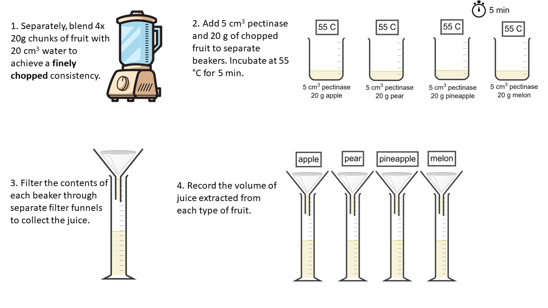
Aim 4 Results
Type of fruit | Volume of juice extracted from fruit (cm³)
Apple
Pear
Pineapple
Melon

