Photosynthesis
In this session, photosynthesis will be explored. Experiment 1 will look at using seaweed, bicarbonate indicator and colorimetry to quantify the consumption of atmospheric carbon dioxide through photosynthesis. Experiment 2 will look at the ability of green plants, including algae, to photosynthesise and respire. In experiment 3 and 4, a couple of simple experiments will be used to demonstration the impact of “human activity” on ocean acidification and the restorative potential of plants.

Experiment 1 – Using colorimetry
Aim: To investigate the effect of light intensity on photosynthesis in seaweed
Materials required (per pair):
5x bijou bottles | Neutral density filters (filter number 209 and 210 to allow 51% and 24% light transmission, respectively)
Bladderwrack seaweed | Black paper
2x Universals of bicarbonate indicator (air-saturated) | Colorimeter
Scissors | 5x cuvettes
Forceps | 3 cm³ dropping pipettes
Access to a balance | Marker pen
Weigh boat | Access to fluorescent tube light
50 cm³ beaker (1/2 full of distilled water) | Stopwatch
Bicarbonate indicator colour chart

Method - in pairs
- Cut 4 pieces of seaweed of same length, avoiding air bladders.

- Store the seaweed samples in distilled water until they are used in Step 4 below.

- Line up 5 empty Bijou bottles (each bottle has a volume of approximately 7 cm³). Rinse the first bottle with approximately 2 - 3 cm³ of bicarbonate indicator and transfer the indicator to the second bottle. Repeat until all 5 bottles have been rinsed.

- Place a sample of seaweed into 4 of the rinsed Bijou bottles.

- Fill all 5 Bijou bottles with bicarbonate indicator and write your initials on the lid.

- You are provided with 3 pre-formed filter sleeves which will allow either 50%, 25% or 0% of light to be transmitted. Place these filters over 3 of your Bijou bottles containing seaweed.

- The 2 remaining bottles – one containing seaweed & indicator and one containing just indicator - will not be covered.

- Line all 5 bottles under one of the fluorescent tubes and note the time.

- Leave the samples in front of the lamp for a period of 25 min.

- Thoroughly mix the contents of each Bijou bottle.

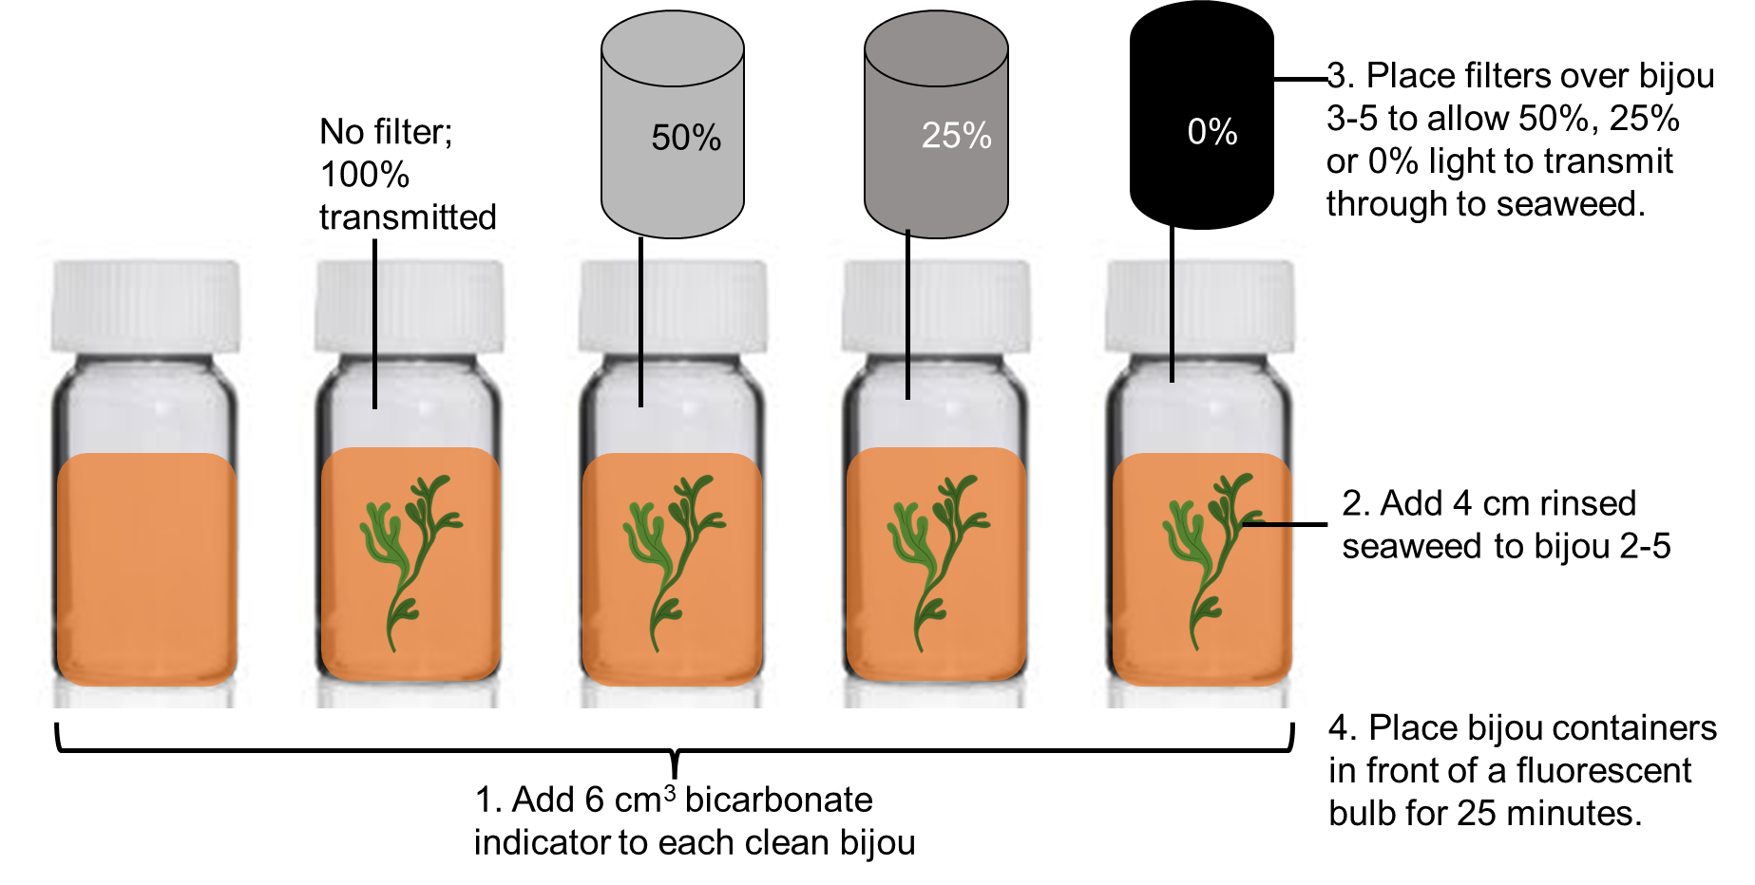

- You are going to use the colorimeter to record the absorbance values of your solutions.

The controls for the colorimeter are relatively simple:

 | Power switch turns the unit on. The unit switches off after about 2 minutes to conserve battery power.
CAL | Calibrates the unit to 0.000 absorbance or 100.0% transmittance
RGB | Switches between the red, green and blue light sources
A/T | Switches display between absorbance and transmittance

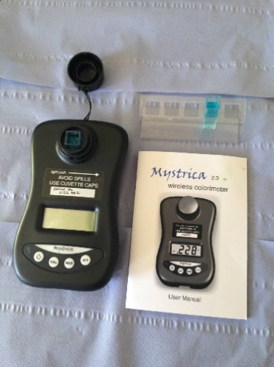
- Switch on the colorimeter.

- Select the green diode by pressing RGB until ‘G’ appears in the top left-hand side of the display screen.

- Select absorbance by pressing A/T until A appears in the top right-hand side of the display screen.

- Place a cuvette containing distilled water into the sample holder and press ‘CAL’ to zero the colorimeter. Note the direction of the light beam - ensure the cuvette is in the correct orientation. Record the absorbance (it should read 0.00

- Empty the cuvette and replace with the indicator from the Bijou bottle which did not contain any seaweed and measure the absorbance.

- Measure and record the absorbance of the 4 remaining Bijou bottles starting with 0% light transmitted.

Results

Light intensity (%) | Absorbance of light by indicator
 | 1 | 2 | 3 | Mean | Corrected mean
0
24
51
100

Absorbance of indicator on its own (bijou 1):______________________

This must be subtracted from all mean values to account for the initial absorbance of the indicator in the absence of biochemical reactions by the plant.

Alternatives to using colorimetry
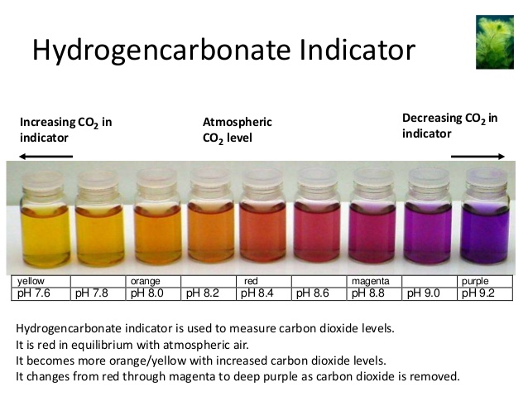

Light intensity (%) | pH of indicator
 | Trial 1 | Trial 2 | Trial 3 | Average
0
24
51
100
Experiment 2: Observing photosynthesis and respiration using algae
Aim: To investigate the effect of light on photosynthesis and respiration in algae

Materials required (per pair):
50 cm³ bicarbonate indicator | Filter funnel
5 cm³ concentrated suspension of Scenedesmus quadricauda | 20 cm x 6 cm length of black bin bag
50 cm length of glass tubing (internal diameter ~1cm) with 2 rubber bungs | Access to a light source (preferably fluorescent)
100 cm³ beaker | 2x retort stands / or suitable alternative
Stirring rod | Ruler
Scissors | Sellotape

Method:
- Check the size of the black bin bag. The material should fit snugly around half of the glass tube, without being too tight – this will need to be removed tomorrow without disturbing the contents.

- Firmly stopper one end of the glass tube.

- Add 5 cm³ algae to a beaker and add sufficient bicarbonate indicator to give a final volume of 50 cm³.

- Stir the mixture and add to the glass tube as quickly as possible. Top up the tube with indicator leaving about 1 cm³. Add the second stopper.

- Give the tube a thorough mix to ensure the algal suspension is uniformly distributed.

- Wrap the bin bag cutting around the left half of the tube and secure with Sellotape.

- Place the tube under a light bank, resting in the wooden support provided. Alternatively, the tube could be clamped between two retort stands.
- Leave for a couple of hours (or up to 24 hours) and observe the results. Carefully, without disturbing the contents of the tube, remove the black material to observe the effect of respiration in the “dark zone” and photosynthesis where the algae accessed light fully.

