 | Photosynthesis and Respiration

[Taken, with minor modifications, from Redding, K. & Masterman, D. (2007), Biology with Vernier, Vernier Software & Technology, Beaverton, OR 97005-2886, USA.
ISBN 978-1-929075-43-0. Aspects of this protocol can be downloaded at: http://www.vernier.com/files/sample_labs/BWV-31B-COMP-photosynthesis_respiration_CO2.pdf].

BACKGROUND

Plants make sugar, storing the energy of the sun in the form of chemical energy, by the process of photosynthesis. When they require energy, plants can tap the energy stored in the sugars through cellular respiration.

The process of photosynthesis is often summarised as:

Cellular respiration refers to the process of converting the chemical energy of organic molecules into a form immediately usable by organisms. Glucose may be oxidised completely if sufficient oxygen is available by the following equation:

All organisms, including plants and animals, oxidise glucose for energy.

Objectives

In this experiment, you will:

- Use a CO₂ gas sensor to measure the volume of carbon dioxide consumed or produced by a plant during respiration and photosynthesis.

- Determine the rate of respiration and photosynthesis of a plant.

MATERIALS

- computer | - 250 cm³ respiration chamber
- Go!Link | - plant leaves
- Logger Lite software | - tissue culture flask or similar
- Vernier CO₂ gas sensor | - lamp
- aluminum foil | - tweezers

PROCEDURE
 | - Set the sensor to its low setting (0-10 000 ppm). Connect the CO₂ sensor to the Go!Link interface and connect to the computer.  - Obtain several leaves and, if they are damp, blot them dry with a paper towel.  - Place the leaves into the respiration chamber, using tweezers if necessary. Wrap the respiration chamber in aluminum foil so that no light reaches the leaves.  - Place the CO₂ sensor into the bottle as shown in Figure 1. Wait 3 minutes before proceeding to Step 5.  - Click  to begin data collection. Data will be collected for approximately 5 minutes. | 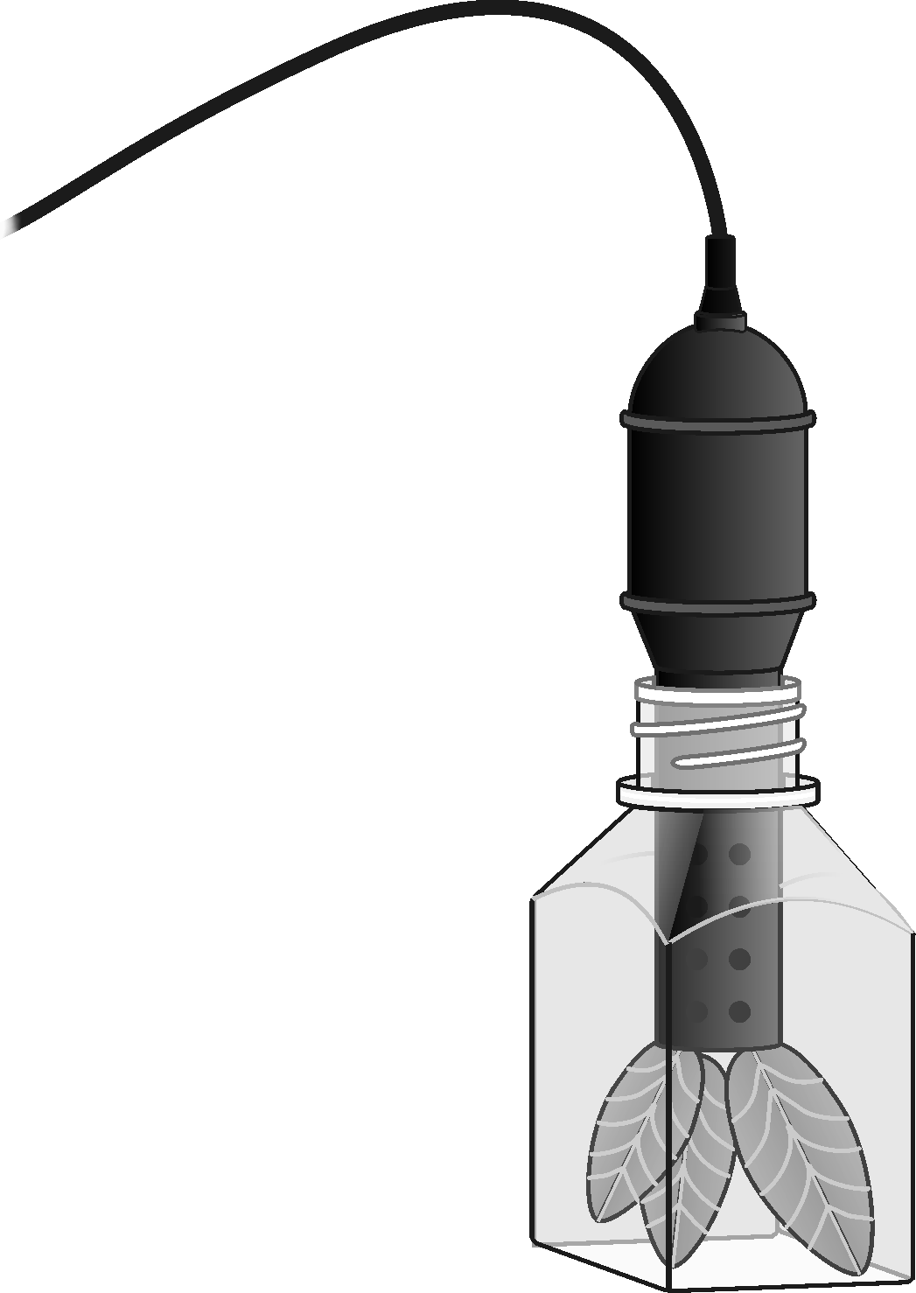  Figure 1
- When data collection has finished, determine the rate of respiration:
- Move the mouse pointer to the point where the data values begin to increase. Hold down the left mouse button. Drag the pointer to the point where the data ceases to rise and release the mouse button.
- From the ‘Analyze’ menu select ‘Linear Fit’ to perform a linear regression. A floating box will appear with the formula for a best fit line.
- Record the slope of the line, m, as the rate of respiration in Table 1.
- Save your data.

- Remove the aluminium foil from around the respiration chamber.
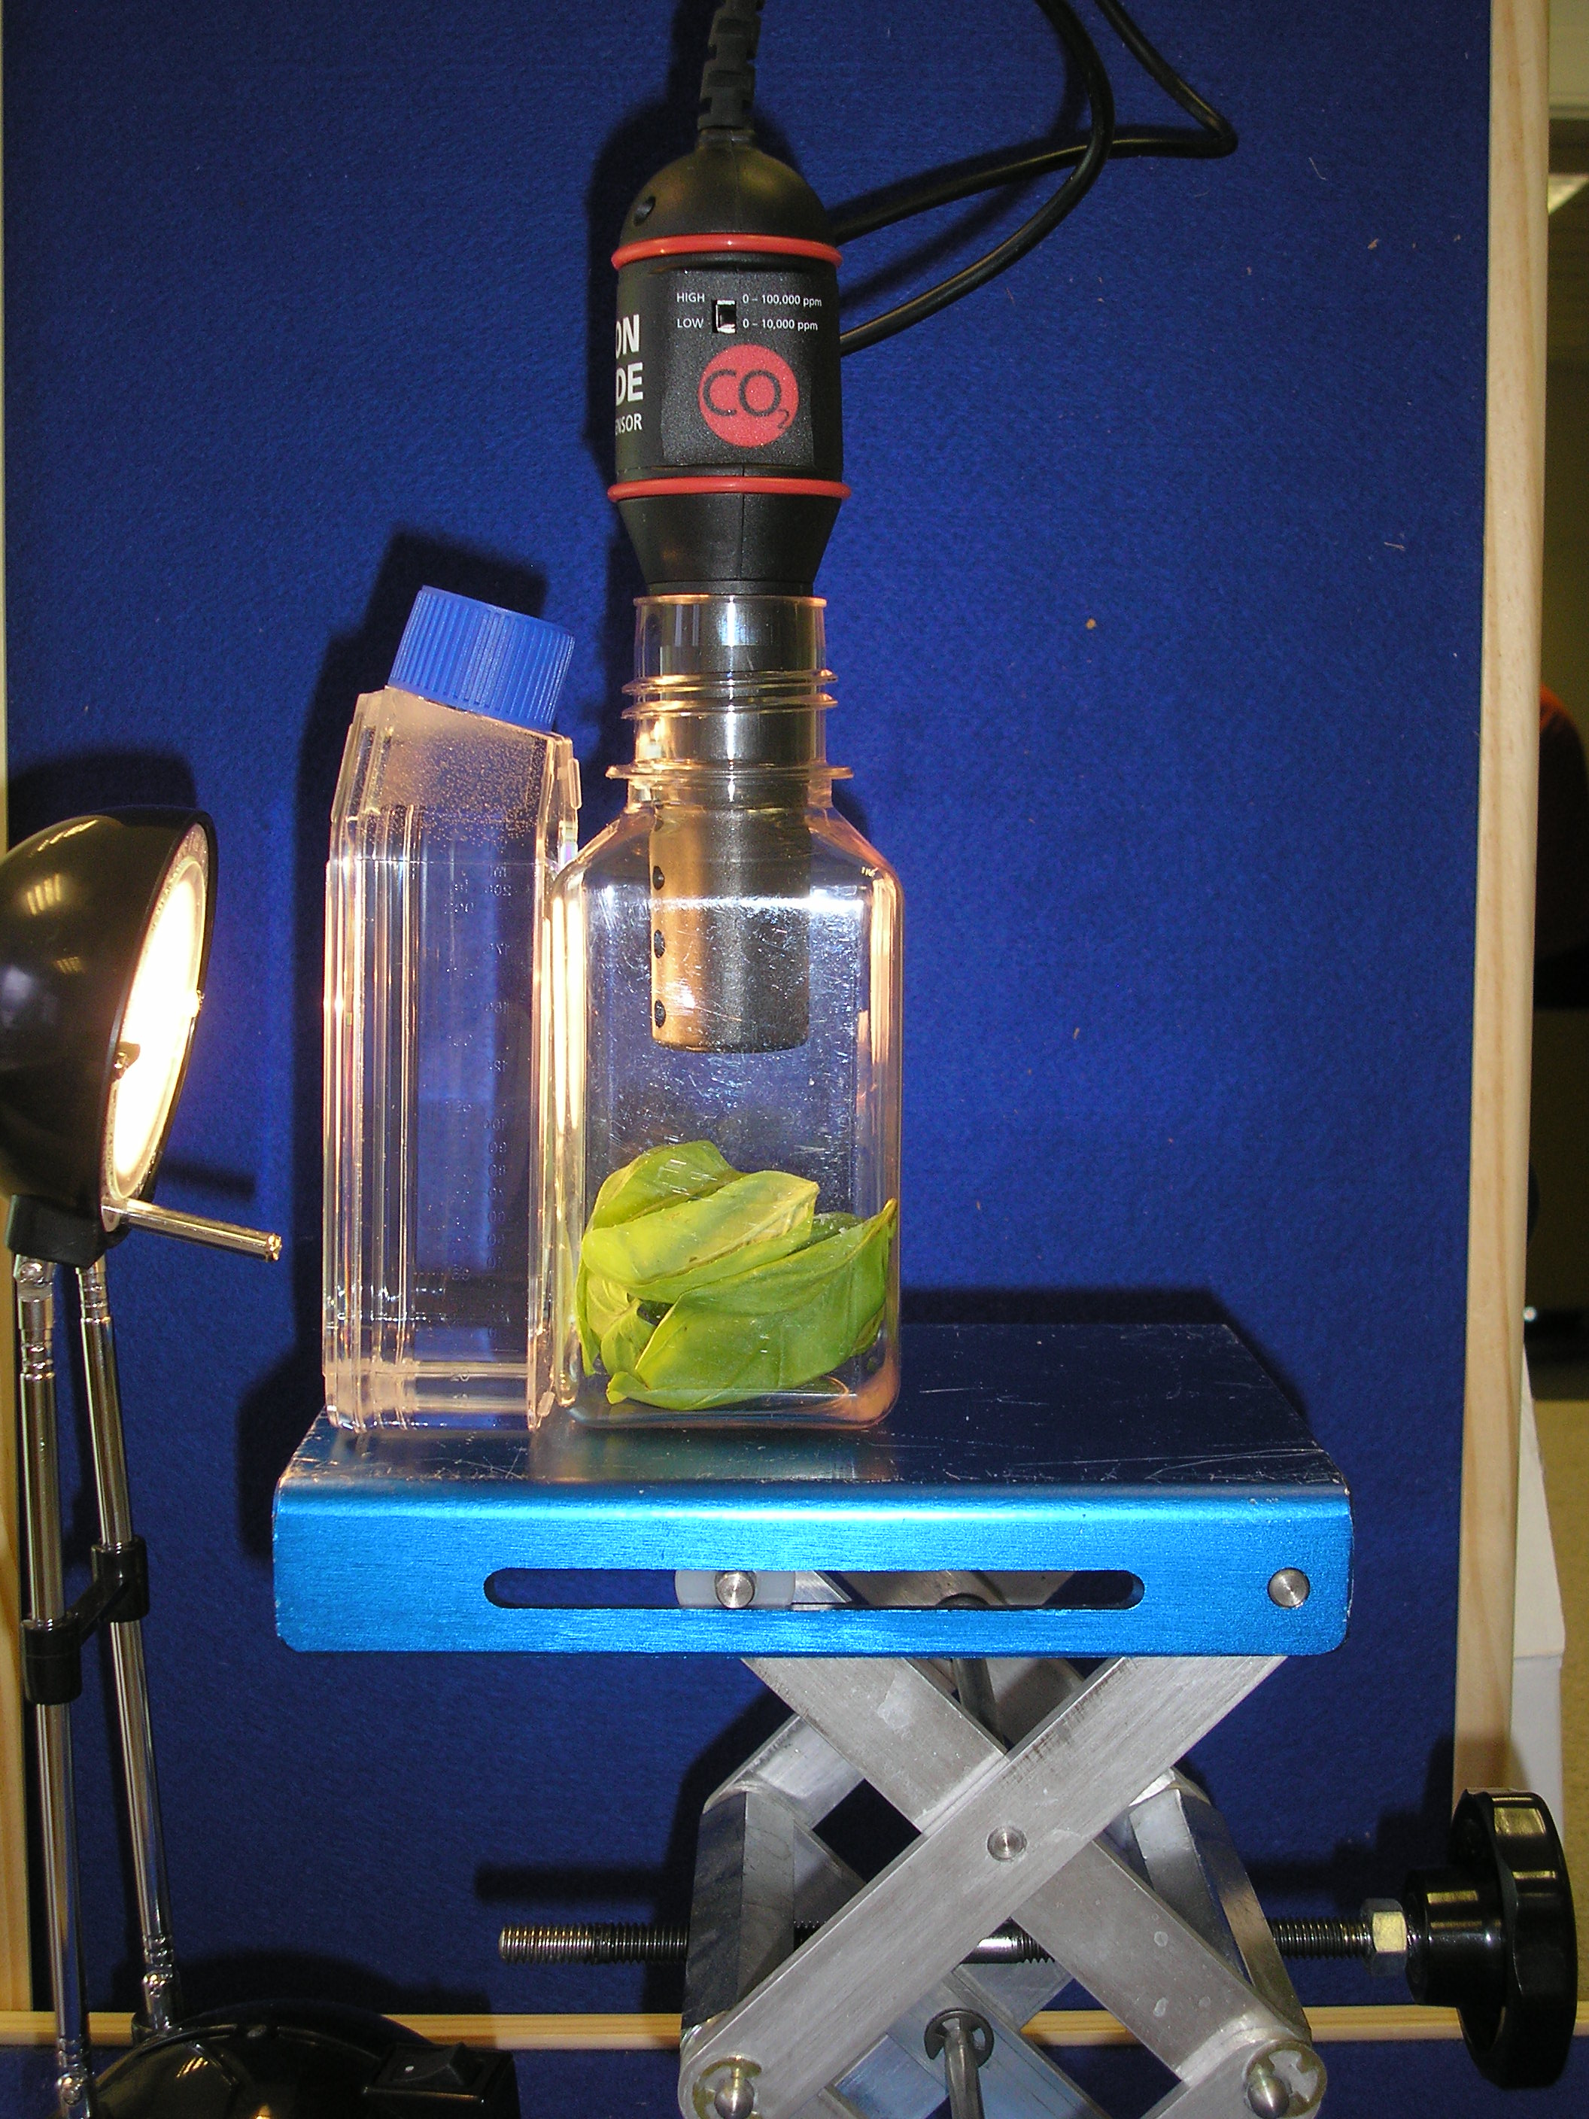  Figure 2 | - Fill the tissue culture flask with water (not the respiration chamber) and place it between the lamp and the respiration chamber (see Figure 2). The flask will act as a heat shield to protect the plant leaves.  - Turn the lamp on. Place the lamp as close to the leaves as reasonable. Do not let the lamp touch the tissue culture flask. Note the time. The lamp should be on for 3 minutes prior to beginning data collection.  - After the three-minute time period is up, click to begin data collection. Data will be collected for approximately 10 minutes.

- When data collection has finished, determine the rate of photosynthesis:
- Move the mouse pointer to the point where the data values begin to increase. Hold down the left mouse button. Drag the pointer to the point where the data ceases to rise and release the mouse button.
- From the ‘Analyse’ menu select ‘Linear Fit’ to perform a linear regression. A floating box will appear with the formula for a best fit line.
- Record the slope of the line, m, as the rate of photosynthesis in Table 1.

- Print a graph showing your photosynthesis and respiration data.
- Label each curve by choosing Text Annotation from the Insert menu. Enter “Photosynthesis” in the edit box. Repeat to create an annotation for the “Respiration” data. Place each box to a position near its respective curve (hold down LH button and shift key at the same time).
- Remove the plant leaves from the respiration chamber, using forceps if necessary. Clean and dry the respiration chamber.

DATA
Table 1
Leaves | Rate of respiration / photosynthesis (ppm min⁻¹)
In the dark
In light

Questions
1. Was either of the rates positive? If so, what is the biological significance of this?
2. Was either of the rates negative? If so, what is the biological significance of this?
3. Do you have evidence that cellular respiration occurred in leaves? Explain.
4. Do you have evidence that photosynthesis occurred in leaves? Explain.
5. List five factors that might influence the rate of carbon dioxide production or consumption in leaves. Explain how you think each will affect the rate?

extension work

1. Design and perform an experiment to test one of the factors that might influence the rate of carbon dioxide production or consumption in Question 5.

2. Compare the rates of photosynthesis and respiration among various types of plants.

