Session 5: Trypsin activity
Aim: To investigate the effect of [IV] on trypsin activity.

Background:
Trypsin is secreted by the pancreas as trypsinogen and activated in the small intestine. It hydrolyses proteins to smaller, soluble peptides and amino acids. Casein, a protein found in milk, is broken down by trypsin to form small peptides. In this protocol, a powdered milk suspension is combined with trypsin; the milk suspension becomes clear because of trypsin activity.

Possible independent variables to investigate during this session:
Temperature | pH | Substrate concentration | Inhibitor type
Each pair will investigate one independent variable but share data for all.
Materials available for each pair:
40 cm³ 3% milk | 3 cm³ plastic pipettes
8 cm³ 1% trypsin | Stopwatch
1x 10 cm³ syringe | Marker pen
Test tube rack | 5 test tubes
thermometer | Thermotube block (40 ºC)

Pair | Independent variable
1 | Temperature
2 | pH
3 | Substrate concentration
4 | Inhibitor type
5 | Temperature
6 | pH
7 | Substrate concentration
8 | Inhibitor type
9 | Substrate concentration
10 | pH

Materials available per bench (group of 4):
Water baths at 40 °C, 60 °C + crushed ice | 8 cm³ of 1%, 5% and 10% milk
2 cm³ of pH 2, 4, 7 & 10 buffer | 2 cm³ green tea
4 cm³ water | 2 cm³ black tea

Alternative method for determining the dependent variable
Instead of measuring “time taken for the X to become visible” through the suspension, a colorimeter can be used to measure light transmission through the suspension.

Aim 1 Method – Temperature
    - Place 5 test tubes in a test tube rack. Draw an X about 4 cm from the bottom on the glass, using a marker pen.
    - Using a syringe, add 8 cm³ 3% milk suspension to each test tube.
    - Incubate the test tubes at the appropriate temperature, as shown on the diagram below. Equilibrate for 5 minutes. Use a thermometer to record the room temperature and the temperature of the ice bath. Insert these values into the results table.
    - Add 2 cm³ 1% trypsin to four of the test tubes to initiate the reaction. Leave the 5th test tube at room temperature without trypsin. Start the stopwatch.
    - Record the time it takes for the X on the test tube to become visible through the suspension.
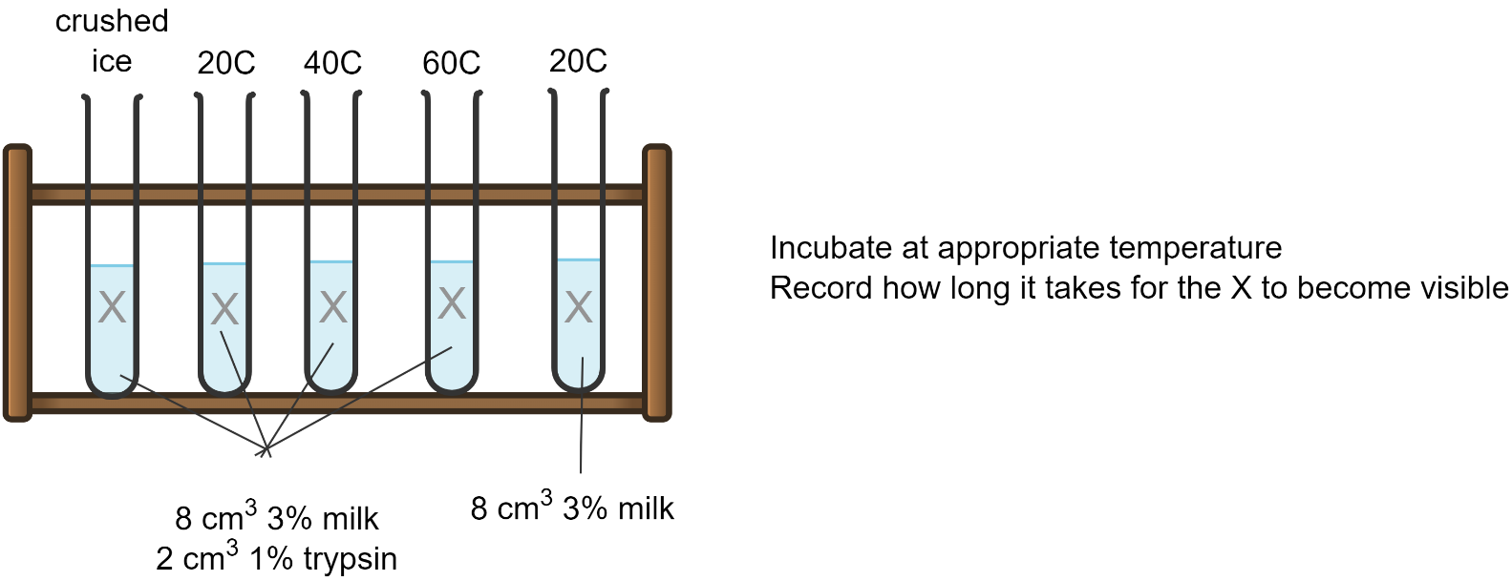

Results
The initial rate of reaction is proportional to the reciprocal of the time taken for the reaction to be complete, i.e. 1/t. This allows values for the rate of reaction to be calculated.
Temperature (°C) | Time taken for the writing to become visible (s) | Rate of reaction (s⁻¹)
20
40
60

Aim 2 Method – pH
    - Place 5 test tubes in a test tube rack. Draw an X about 4 cm from the bottom on the glass, using a marker pen.
    - Using a syringe, add 6 cm³ 3% milk suspension to five test tubes.
    - Using a plastic pipette, add 2 cm³ buffer of the appropriate pH. Add any buffer to the 5th test tube.
    - Add 2 cm³ 1% trypsin to four of the test tubes to initiate the reaction. Leave the 5th test tube without trypsin. Start the stopwatch.
    - Record the time it takes for the X on the test tube to become visible through the suspension.
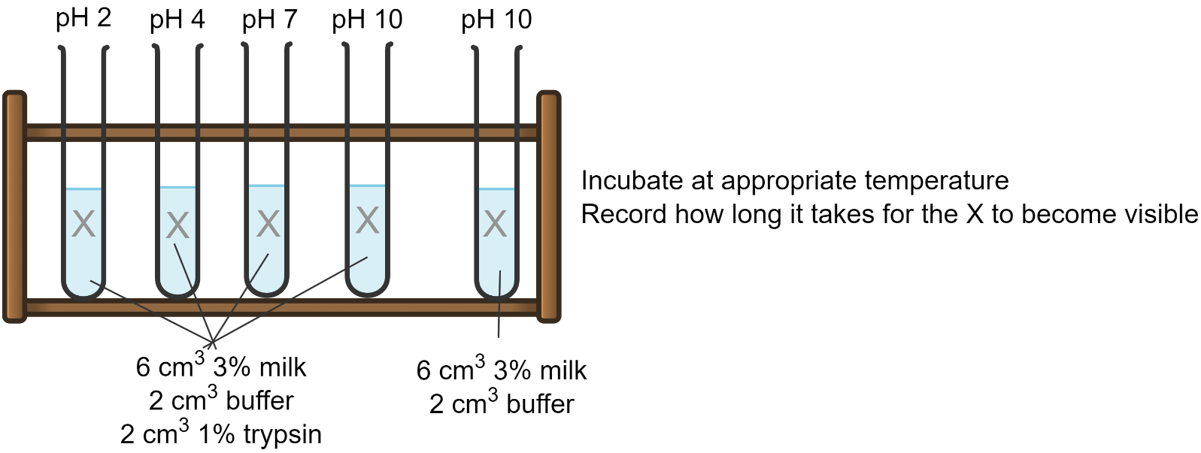
Results
pH | Time taken for the writing to become visible (s) | Rate of reaction (s⁻¹)
2
4
7
10

Aim 3 Method – Substrate concentration
    - Place 5 test tubes in a test tube rack. Draw an X about 4 cm from the bottom on the glass, using a marker pen.
    - Using a syringe, add 8 cm³ milk suspension (of the appropriate concentration) to each test tube. Add any concentration to the 5th test tube (control).
    - Add 2 cm³ 1% trypsin to 4 test tubes to initiate the reaction. Do not add trypsin to the 5th test tube. Start the stopwatch.
    - Record the time it takes for the X on the test tube to become visible through the suspension.

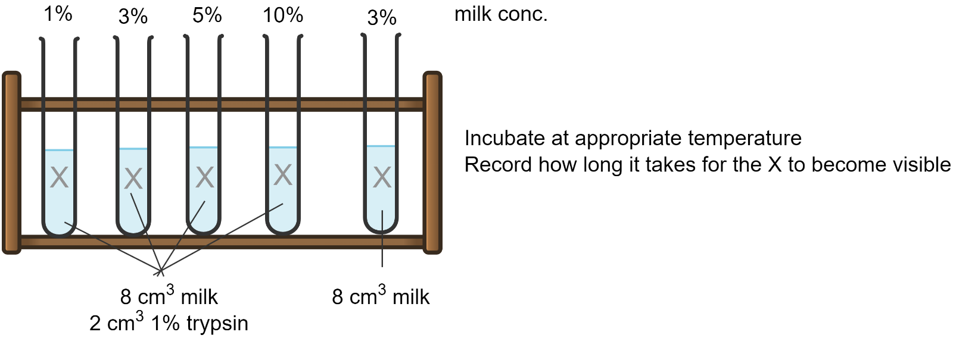

Results
Substrate concentration (%) | Time taken for the writing to become visible (s) | Rate of reaction (s⁻¹)
1
3
5
10

Aim 4 Method – Inhibitor type
Aim: To investigate the effect of tea as an inhibitor of trypsin activity.

Background: Beverages, such as tea, containing milk offer good flavour and nutrition. Tea also has numerous positive health effects, mainly due to the presence of catchins, such as antioxidant activity and free radical scavenging activity that reduce the risk of cancers, CVD, inflammation, Alzheimer’s disease and diabetes. Research [1] has suggested that the availability of nutrients in milk and tea can be limited by their potential inhibitory effect on digestive enzymes, including trypsin. In this experiment, learners can explore the potential inhibitory effect of compounds found in green tea and black tea on the breakdown of milk proteins by trypsin in the small intestine.

Method
    - Place 4 test tubes in a test tube rack. Draw an X about 4 cm from the bottom on the glass, using a marker pen.
Test tube 1 | Test tube 2 | Test tube 3 | Test tube 4
Negative control – trypsin + milk | Presence of green tea | Presence of black tea | Milk only

    - Enzyme first: Add 2 cm³ 1% trypsin to test tube 1, 2 and 3 only.

    - Add treatment: Using a plastic pipette, add:
      - 2 cm³ water to test tube 1
      - 2 cm³ green tea to test tube 3
      - 2 cm³ black tea to test tube 4

    - Mix well and leave to incubate at 40 ºC for 2 minutes.

    - Using a syringe, add 6 cm³ 3% milk suspension to each test tube.

    - Record the time it takes for the X on the test tube to become visible through the suspension.
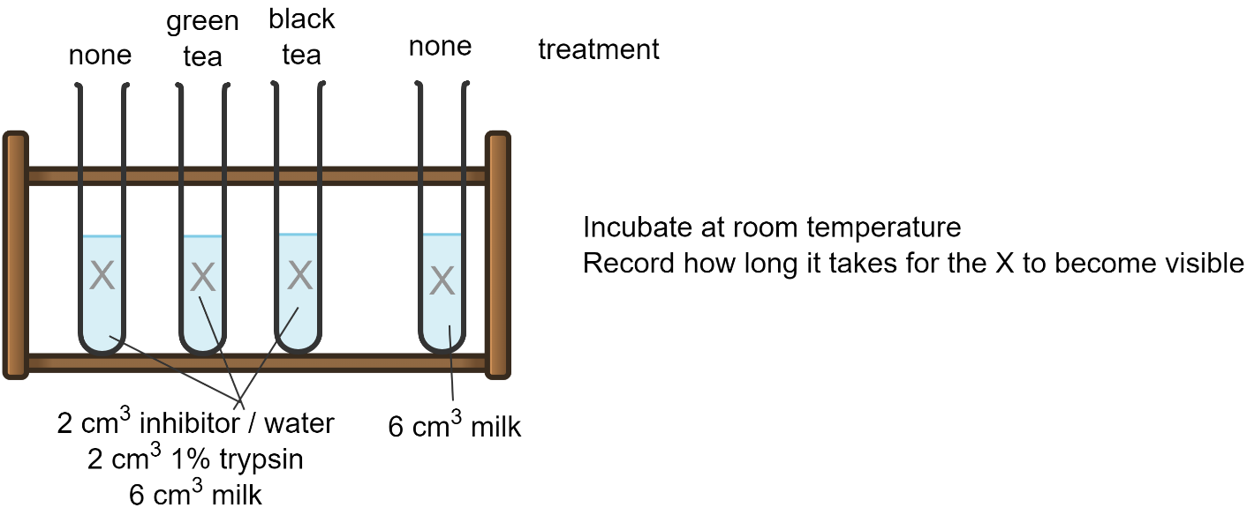

Results
Treatment | Time taken for the writing to become visible (s) | Rate of reaction (s⁻¹)
None
Green tea
Black tea

Technical notes for Aim 4:
To prepare the tea solutions, add 1 tea bag to 80 cm³ boiling water and steep for about 10 minutes. Remove the tea bag prior to use.

References
[1] Qie, X., et al. (2021), Competitive interactions among tea catechins, proteins, and digestive enzymes modulate in vitro protein digestibility, catechin bioaccessibility, and antioxidant activity of milk tea beverage model systems, Food Research International, vol. 140. https://doi.org/10.1016/j.foodres.2020.110050

