

|  |
| --- |
| Chemistry Experiment |
| Synthesis of ethyl ethanoate |
| Learner Guide |

# The Best Nail Polish Remover Pads, According to Our Editors | Makeup.comIntroduction

Ethyl ethanoate (ethyl acetate) is a common solvent with many uses: most particularly as an alternative to propanone (acetone) in nail-polish removers and as a solvent to remove caffeine from tea and coffee.

Its popularity as a solvent is due to its low toxicity and not unpleasant odour as well as the fact that it is cheap to make. The reason for the low cost is that it is synthesised from ethanol and ethanoic acid, both of which can be easily and cheaply made themselves.

The reaction is catalysed by concentrated sulphuric acid.

The reaction is slow and also reversible.

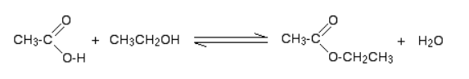

To reduce the chances of the reverse reaction happening, the ester is distilled off as soon as it is formed.

The reaction mechanism is complex but taken as a whole, this is a dehydration reaction.

A by-product of the reaction is ethoxyethane (diethyl ether).

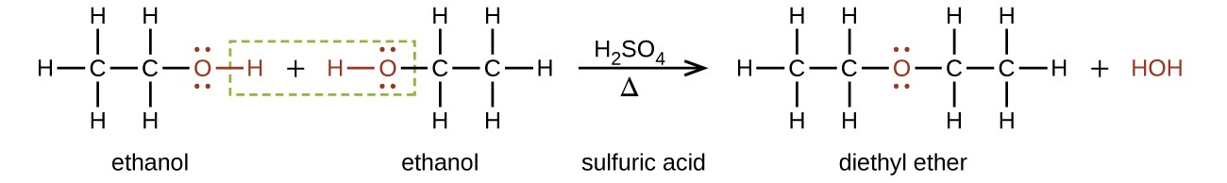

This is removed by the final distillation as it has a boiling point much lower than the ester.

## Step 1 - Reflux & first distillation

**You will need**

|  |  |
| --- | --- |
| 50 cm3 measuring cylinder* | Bottles of Ethanol and Ethanoic acid (~60 cm3) |
| 10 cm3 measuring cylinder | Small bottle of sulphuric acid |
| 3 cm3 Pasteur pipette | 250 cm3 round-bottomed flask |
| Heating mantle | Leibig condenser (& hoses) |
| Clamp and stand | Small ice bath |
| Still head & thermometer stopper | 100 cm3 conical flask |
| Anti-bump granules | Thermometer 0 - 100 |
| Keck Clips (optional) |  |

* This can be used for both the ethanol and ethanoic acid

**To do**

Wear goggles (BS EN166 3) and gloves for handling the sulphuric acid.

1. Mix 50cm3 of ethanol and 50cm3 of *glacial* ethanoic acid thoroughly in a 250cm3 round-bottomed flask.
2. **Slowly** add *(*with cooling and shaking) 10cm3 of concentrated sulphuric acid. Keep mixing until you have a homogenous mixture.

*Concentrated sulphuric acid is much denser than any of the other reagents. If it is not properly mixed, the solution may overheat and boil uncontrollably later in the reaction*

1. Ensure that the mixture is fully mixed and add a few anti-bumping granules.

*If you forget, do not just add them into the top of the hot mixture as it can boil violently and spray out of the top – wait until it is cool.*

1. Fit a condenser to the flask, arranged vertically for reflux (see diagram overleaf), place flask in the heating mantle and bring to the boil.
2. 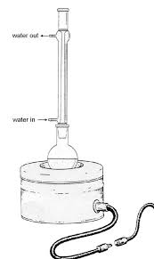Boil the mixture gently under reflux for 10 minutes.
3. Remove the flask setup from the heating mantle, allow to cool slightly for a minute or two and rearrange the apparatus so that it is set up for distillation.

*It is often best to switch the water off at this point in case the pipe pulls out of the sink and water goes everywhere – remember to turn it back on.*

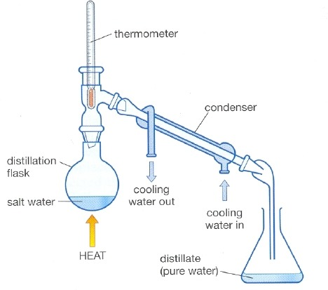

mixture

distillate

1. Replace the apparatus in the heating mantle and bring back to the boil.
2. Distil off about two-thirds of the mixture (70 – 75 cm3).
3. Switch off heating mantle and water and remove flask from the heat.

## Step 2 – Separating and drying the crude ethyl ethanoate

**You will need**

|  |  |
| --- | --- |
| 25 cm3 measuring cylinder | Bottle of 30% sodium carbonate (~ 30 cm3) |
| Clamp, stand & ring | 250 cm3 separating funnel |
| 100 cm3 conical flask | 25 cm3 of saturated calcium chloride solution |
| 100 cm3 round bottomed flask | 250 cm3 beaker (for waste) |
| Sodium sulphate (anhydrous) | spatula |

**To do**

1. Transfer the distillate to a separating funnel
2. Add about 25 cm3 of 30% sodium carbonate solution.

*The sodium carbonate will neutralise any remaining ethanoic or sulphuric acids.*

1. Stopper the funnel, invert it, and shake, opening the tap from time to time. To release any pressure build-up.
2. Place in the stand and allow the two layers to separate
3. Carefully run off the lower layer into a beaker, being careful not to leave any sodium carbonate solution behind. (this will be disposed of later).
4. Add about 25 cm3 calcium chloride to the crude ethyl ethanoate in the funnel and shake vigorously.

*The calcium chloride solution removes any remaining ethanol since it forms a complex with the alcohol.*

1. Place in the stand and allow the two layers to separate
2. Run off the lower aqueous layer, again making sure none is left behind
3. Run the ethyl ethanoate into a 100 cm3 conical flask,
4. Add a spatula or two of anhydrous sodium sulphate and shake occasionally until the liquid is clear (it may not be perfectly clear but it will be very close).

## Step 3 – Fractional distillation of pure(ish) ethyl ethanoate

**You will need**

|  |  |
| --- | --- |
| Heating mantle | Leibig condenser (& hoses) |
| Clamp and stand | Keck Clips (optional) |
| Still head & thermometer stopper | Thermometer 0 - 100°C |
| 100 cm3 conical flask | 100 cm3 beaker |

**To do**

1. Decant the liquid into a clean, dry 100 cm3 round-bottom flask.
2. Add some anti-bumping granules,
3. Arrange the apparatus for distillation including a 0-100oC thermometer in the apparatus. (This may well still be set up from earlier). Place the beaker to collect the distillate.
4. Start heating, The ether that is always formed in this reaction will distil off at 35-40°C, and may be discarded.
5. Continue to heat, allowing the distillate to continue to drop into the beaker.
6. When the thermometer reaches 74°C, switch to the conical flask.
7. Collect the fraction that boils between 74°C and 79°C.
8. Once the thermometer reaches 79°C, switch off the heat, remove the flask and replace with the beaker again to collect any drips.