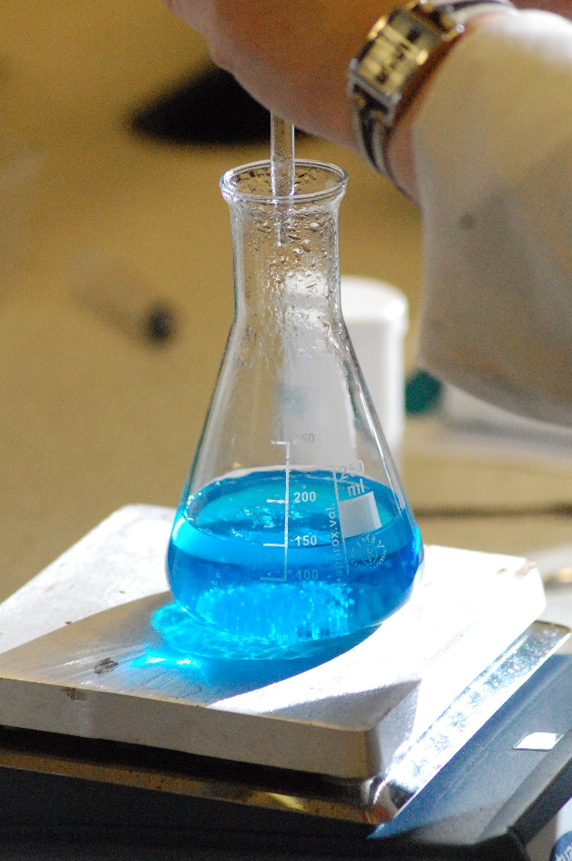

Chromatography,

Distillation

&

Titration,

Distillation is an important technique that allows you to separate mixtures of substances that have different boiling points.

The mixture is heated to a temperature at which one of the components will vapourise (or vapourise significantly more than the others) and the vapour is cooled back into a liquid by a condenser.

As usual, there are various ways to carry this out.

The easiest way to demonstrate the process is simply to use a solution of a dye in water – food dyes are perfectly acceptable. The distillation carried the water over, leaving the dye behind so it is easy to see the result in that you start with a coloured liquid and end up with a clear one.

## Simple distillation

While distillation usually requires more complex glassware, it can be done quite simply as shown below.

### Each group will need

|  |  |
| --- | --- |
| Boiling tube | Delivery tube fitted through a bung |
| Beaker of iced water | Anti-bump granules |
| Tissue/paper towel | Dye mixture |
| Test tube to collect distillate | Clamp and stand (optional) |
| Access to Bunsen/spirit burner |  |

#### Method

Set the apparatus up as shown below.

*Using a clamp and stand to hold the boiling tube is much the easiest method but as the experiment only takes a few minutes, it is possible to hold it with a pair of tongs instead.*

1. Put a small amount of your mixture in a boiling tube and add a couple of anti-bump granules.
2. Fit a delivery tube and bung in the top.
3. Hold the boiling tube at an angle in a clamp.
4. Wrap some damp tissue paper round the delivery tube, to cool it a little more.
5. Place a test tube, for collecting the distillate, in a beaker of ice or iced/water and position it so that the delivery tube goes well down into it.
6. Heat the bottom of the boiling tube gently. It is very easy to overheat the liquid so it boils too vigorously which will cause it to overflow down the delivery tube.

*You should hold the Bunsen burner in your hand (by the base!) and play it backwards and forwards over the bottom of the tube. (Or move the tube a little if you are holding it with tongs).*

1. Once you see signs of boiling, be even more careful, keep taking the heat away and allowing the bubbling to die down a little before giving it another few seconds.
2. The vapour will go up and into the delivery tube where contact with the cooled sides of the tube cause it to condense and trickle down into the test tube.
3. After a short time, the hot vapour will heat up the glass so little condensation occurs here but there will still be a significant amount happening in the tube that is being cooled by the ice.

This is not an efficient process, in that quite a lot of vapour escapes, but it can allow for the collection of small quantities of distillate quite easily.

NB Heating with a Bunsen burner is only suitable for a **non-flammable solvent** such as water. For flammables like ethanol or propanone, the heating is best carried out in a water bath.

## ‘Standard’ distillation

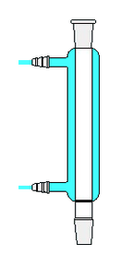This is the ‘normal’ method of distillation that is carried out in the classroom. The principle is exactly the same as for simple distillation but a specialised condenser is used so as to be able to capture all of the vapours that evaporate, making it a much more efficient process.

### Condensers

There are various different types of condenser but the one most commonly encountered is the Leibig condenser. In this device, the glass delivery tube is surrounded by another tube which can be filled with cold water. The condenser is connected to the cold tap so water is constantly flowing in and out and this keeps the walls of the delivery tube cold enough for the fumes to condense and trickle down to be collected.

While it is possible to use bungs or corks and glass tubing, it is much preferable to use ‘quickfit’ type glassware, which has ground glass joints that ‘lock’ together..

All the components have ground glass fittings which allow them to fit snugly together with no leakage. They come in different sizes but adaptors are available to step up or down.

Although quickfit joints are firm, they are not strong enough to support any load on their own. A flask attached to a still head, for instance must be supported by a separate clamp or it is likely to fall off and spill potentially hazardous substances.

Clips are available to help hold the apparatus together. These are a good idea but are not a substitute for holding any load (as above) – though the load from a 25 cm3 receiving flask should not be a problem.

**Heating**

Aqueous solutions can be heated, **carefully**, with a Bunsen burner but anything flammable should be heated by another method. Most commonly a water/oil or sand bath or a heating mantle or hotplate.

**You will need**

|  |  |
| --- | --- |
| Bunsen burner | Bottles of coloured water |
| Round-bottomed flask | Leibig condenser (& hoses) |
| Still head & thermometer stopper | Clamp and stand |
| Receiving adaptor | Keck Clips |
| conical flask | Antibumping granules |
|  |  |

**Method**

The apparatus is set up (more or less) as in the diagram below.

For most distillation the delivery tube is likely to be optional or, if used, it will be a much simpler type. The one shown has an adaptor for vacuum distillation.

1. Set up the apparatus as shown in the diagram
2. Connect the water so that cold water flows in at the bottom and out at the top. Be careful not to turn on the water too forcefully as it might force the hose off and spray all round the lab!
3. Make sure that the flask and the condenser are **both** supported by clamps. Make sure the height of the apparatus is suitable so that you can fit whatever heating apparatus you are using under the flask.
4. Disconnect the flask and put the solution to be distilled in it along with a few anti-bump granules. Don’t over fill – no more than about half way.
5. Replace the flask in the apparatus and make sure the joints are tight. Put clips on if you are using them.
6. Make sure the water is switched on to the condenser.
7. Heat the solution. If using a Bunsen burner, be careful not to overheat it. (be particularly careful as you get close to the boiling point.

After a while you will start to see condensation on the inside walls of the condenser.

1. Keep an eye on the thermometer. Its positioning will let you know what substance is coming over.

*For instance. If you are distilling ethanol from home made wine, initially you will get some other components coming over such as volatile esters and aldehydes. When the temperature gets up to about 78°C you will be getting ethanol* and once the temperature rises above that you will be getting more and more water.*

*\* In fact you get an azeotropic mixture of 95.6% ethanol and 4.4% water but the principle still holds.*

1. When you have sufficient distillate or the temperature rises to the point at which you think no more of your desired product is coming over. Stop heating.