Soil Sampling
Activity 1
Aim: To take in situ measurements of pH, moisture, and temperature.
Background: These properties vary with depth.
You will need:
Soil auger (or trowel) | Metre stick
pH meter | Moisture meter
Thermometer

To do
If needs be, clear the surface of the soil so you can access the bare soil.
- Use the meters to record pH, moisture content and temperature.
- Use an auger or trowel to dig down into the soil to a depth of 20cm.
- Clear debris and repeat measurements of pH, moisture, and temperature.
- Dig down another 20 cm and repeat measurements again.
- Repeat the above steps in another location.

Results
Location 1
Depth (cm) | pH | Moisture | Temperature
0
20
40

Location 2
Depth (cm) | pH | Moisture | Temperature
0
20
40

Activity 2
Aim: To take in situ measurements of permeability.
Background: Permeability is the rate at which water will soak into the soil. This is affected by the structure of the soil and compaction. The more compact the soil, the less air/water spaces in the bulk soil. This will reduce the permeability. If you are investigating the effect of compaction, chose two sites (at least), one on a path and the one off it.

You will need:
Access to a trowel (possibly) | Timer
Plastic measuring jug | Sample of water
Tin can, open at both ends

To do
- If needs be, clear the surface of the soil so you can access the bare soil.
- Take you can and press into the soil. Not too far, but a centimetre or two, enough so that your water sample can’t escape under the rim.
- Use you jug to measure out 250cm³ of water.
- Pour the water into the tin and start your timer.
- As soon as the water has soaked into the soil, stop your timer, and record your result.
- Move to a different site and repeat the above steps.
Results
Site number | Description | Time taken for water to soak into soil (s)
1
2
3

Activity 3
Aim: To take in situ measurements of porosity.
Background: The porosity of a material is a measurement of how much of its volume is open space. This is related to permeability and is also affected by compaction.
You will need:
Soil samples | 250 cm³ beaker
100 cm³ measuring cylinder | Water

To do
- Take a 250 cm³ beaker and fill with soil up to the 100 cm³ line.
- Measure 100 cm³ of water in the measuring cylinder and slowly (and carefully) pour it into the beaker until the water reaches the top of the sample.
- Write the volume of water remaining in the measuring cylinder into the results table below.
- Subtract the water remaining from the start volume, this is the volume of water added to the sample. Record this value in the results table.
- To determine the porosity, divide the volume added by the total volume at the star, and multiply the result by 100.
- Repeat for two more samples.

Results
Sample number | Volume of water remaining, R, (cm³) | Volume of water added, A, (cm³) | Porosity  (A/(R+A))x100
1
2
3

Activity 4
Aim: To determine the pH of various soil samples in the lab.
Background: The pH of soils can have a great effect. Although there are exceptions, soil will generally have a pH value between approximately five and eight. Pants such as heather grow best on acidic soils, while cabbage grows well on alkaline soil.
You will need:
Soil samples | 3cm³ pipette
6 bijoux | Filter funnel and filter paper
Universal indicator solution | 3 test tubes
Aquarium indicator

To do
- Add some water to the first soil sample and mix well.
- Place the filter paper in the funnel and sit in a test tube. Pour some of the mixture in.
- Allow the test tube to half fill with filtrate.
- Add 2cm³ of the filtrate to two bijoux.
- Into one, add two drops of universal indicator, compare with a pH chart and record results in table below.
- Into the other, add two drops of aquarium indicator, compare with the colour chart and record results in the table below.
- Repeat with two more soil samples.

Results
Sample number | pH (Universal indicator) | pH (Aquarium indicator)
1
2
3

Activity 5
Aim: To determine the type of soil you have based on particle size.
Background: The inorganic matter in soil can be divided into three main categories depending on size: sand, silt, and clay. The exact composition will have various effects on soil, such as its rate of drainage.
You will need:
2 soil samples | 2 measuring cylinders
Timer | Ruler
10cm³ of 0.4% Iron(III) chloride solution

To do
- Take your two soil samples and add to the measuring cylinders – roughly half full.
- Fill one to 2-3 centimetres from the top with water. To the other, add the iron(III) chloride solution, then add water to make it the same level as the other.
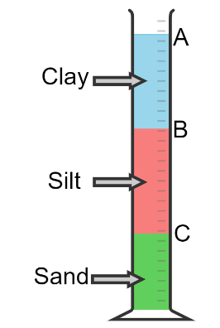
- Shake the two measuring cylinders until all the soil is suspended. Place down and start the timer.
- After two minutes, measure the heigh. This is height C.

As this experiment takes a long time to finish (24 hours), we are not going to proceed any further. In class, measurements are taken after 2 minutes (height C), 2 hours for silt (height B) and 24 hours for clay (height A).

Results
 | Measurements in these columns |  |  | Calculate these values
Soil Sample | A  Clay | B  Silt | C  Sand | D  Sand % | E  Silt | F  Silt % | G  Clay | H  Clay %
 |  |  |  | (C/A) x 100 | B - C | (E/A) x 100 | A - B | (G/A) x 100
1
2

Use this diagram to find out what type of soil you have.

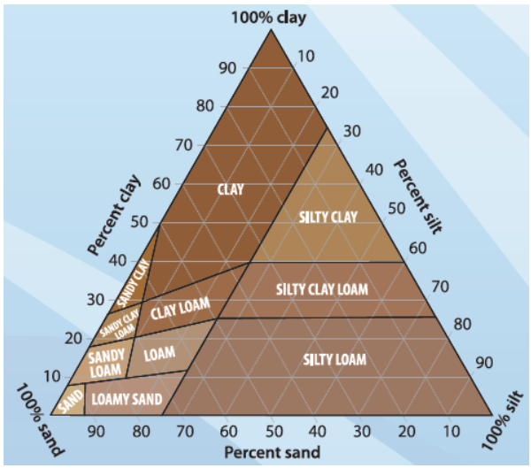

Activity 6
Aim: To determine the moisture content of soil samples.
Background: Moisture content will vary from sample to sample. It is obviously dependent on rainfall, but also on other factors. For example, a high concentration of organic matter retains more moisture, while a sandy soil is more free draining and will dry out more quickly.
To save time, we have done part of this for you.
You will need:
1 x pre-dried soil sample | Balance

To do
- Copy the values for column B, C and D from the label of your sample.
- Weigh the sample and record the value.
- Find the original mass of the soil before drying.
- Work out the difference in mass.
- Work out this as a percentage of the initial mass.

Results
A | B | C | D | E | F | G
Sample number | Mass of jar (g) | Mass of jar + wet soil (g) | Mass of wet soil (g) | Mass of jar + dried soil (g) | Dry soil mass  (E – B)  (g) | Mas of water  (D – F)  (g) | % water (G/D) x 100
1
2
3

Activity 7
Aim: To determine the density of soil samples.
Background: Less of a factor for the environment, but the density of a soil can tell you much about its composition.
You will need:
Pre-dried soil sample – from previous experiment | Balance
100 cm³ beaker

To do
- Weigh the beaker and record the value in the table below.
- Fill the beaker to the 50cm³ line with the dry soil. Weigh again and record the value.
- Work out the difference in mass. Divide the mass by the volume to calculate the density of the soil sample.
Results
Sample number | Mass of beaker (g) | Mass of beaker + soil (g) | Mass of soil (g) | Volume of soil (cm³) | Density of soil (g/cm³)
1
2
3

Activity 8
Aim: To determine the organic matter content of soil samples.
Background: Dry soil can be roughly divided into two components: inorganic matter (sand, silt, etc) and organic matter (humus from decay/decaying plant and animal matter).
You will need:
Pre-dried soil sample from previous experiment | Balance
Bunsen burner | Crucible
Tripod | Pipe-clay triangle
Tongs

To do
- Weigh the crucible and record the mass in the table below.
- Add a few grams of soil and re-weigh and record the mass.
- Put the crucible over the Bunsen burner and heat strongly.
- When the soil stops smoking, keep heating for a few more minutes and then switch off the Bunsen burner.
- Allow to cool for a little while, then re-weigh.
- Record the new mass and work out the difference, and then the percentage that has been lost.
Results
Sample number | Mass of crucible (g) | Mass of crucible + soil (g) | Mass of soil (g) | Mass of soil after heating (g) | Loss of mass (g) | % loss
1
2
3

