2024/25 Delegate EDI Survey.
SSERC collects data on equality, diversity, and inclusion from delegates who attend SSERC professional learning activities. This data is collected voluntarily and is used so that we can develop a better understanding of how different groups are affected by our policies, processes, decisions, products, and services and, by doing so, identify and take action to address any potential discrimination, harassment, and/or unconscious/conscious bias. We are grateful to the 639 delegates who completed the survey.

- 639 responses.
- This survey is anonymous and not mandatory.
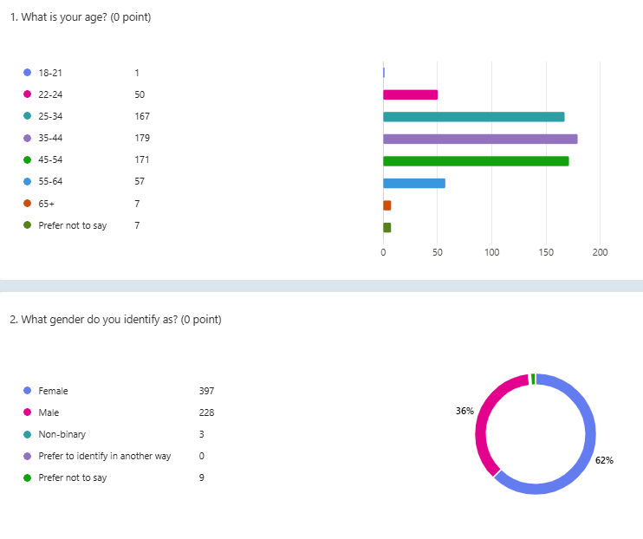
- Average time to complete – 1 min and 50 seconds




