Air Pollution and the role of Trees

**Aim**: To investigate the effect of distance from road on fine particulate matter deposits on tree trunks.

Fine particulate matter (PM) is a common air pollutant that represents a major threat to public health. PM can arise from vehicle diesel exhaust, brake dust and rubber tyre particles, which can then be deposited onto the surface of vegetation, including trees, reducing its concentration in the air. Research has shown that urban tree planting significantly lowers the concentration of PM in the atmosphere, particularly during rush hour, and improves air quality by 126% [1].

This investigation, adapted from the Field Studies Council, is well-suited to a site where there is an environmental gradient, with trees planted at increasing distance from a busy road into a green space. Ideally, trees will be regularly spaced, of the same age and species. This protocol could also be extended to look at the effect of air pollution on lichen growth.

**References:**

[1] Riondato, E., *et al.* (2020), *Investigating the effect of trees on urban quality in Dublin by combining air monitoring with i-Tree Eco model*, Sustainable Cities and Society, 61, 102356.

**Materials required (per pair):**

|  |  |
| --- | --- |
| 5 m tape measure | Hand lens |
| Flexible measuring tape | Scissors |
| Sellotape | Results table |
| Device with sound sensor |  |

**Method – choosing a fieldwork site**

Criteria for this fieldwork site ideally will include:

* trees of same age and species
* trees close to a busy road
* trees planted a considerable distance from a busy road for comparison.

**Method - taking measurements**

1. Identify a sampling zone of trees, of the same species. Carry out a tree count. Use random sampling to identify four trees within this zone to sample.

1. Cut 7 cm of sellotape and stick it to the tree on the aspect facing the road. Position the tape 1.4 m from the ground. Leave the sellotape for 10 seconds, then remove it.
2. Transfer the sellotape to the data collection sheet (Site 1: Tree 1-4).

1. Repeat steps 2-3 on three additional trees identified at this “road-side” location.

1. Move to a sampling site further away from the road. Measure the distance from the road. Estimate the number of trees at this distance and carry out random sampling to select 4 trees. Repeat Steps 2-3 (Site 2: Tree 1-4).

1. How many squares (out of 18) contain fine particular matter (these should be black and not green; green marks will be moss/lichen)? Record this number in the Results table below. Compare to the reference square at the top – this shows carbon deposits.

**Results - Raw**

|  |  |  |  |  |  |
| --- | --- | --- | --- | --- | --- |
| **Distance of tree from road (m)** | **Abundance of fine particulate matter**  **(number of quadrat squares containing soot / 18)** | | | | |
| **1** | **2** | **3** | **4** | **Mean** |
| 5 | 16 | 12 | 10 | 17 | 14 |
| 50 | 4 | 3 | 3 | 2 | 3 |

**Results - Processed**

|  |  |
| --- | --- |
| **Distance of tree from road (m)** | **Mean abundance of fine particulate matter (%)** |
| 5 | 78 |
| 50 | 17 |

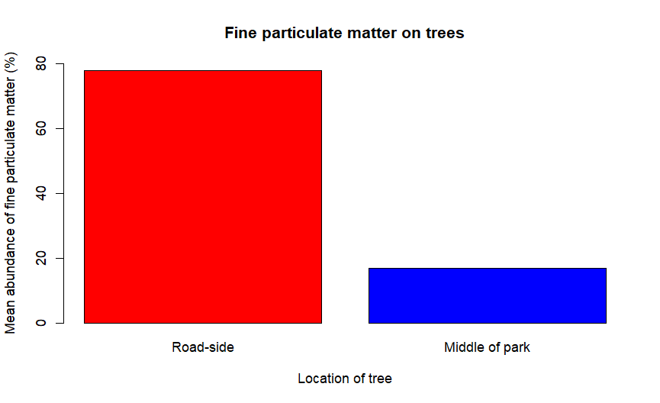

*This data was collected at the Helix Park, in Falkirk, home of The Kelpies. This site was chosen because heavily used roads surrounded the park. Trees close to the road were selected for sampling (5 m from road) and then compared to a representative sample more central to the park.*

*Cities are looking at research data that suggest that tree planting in busy city centres will reduce air pollution, and thus improve human health, since the fine particulate matter will rest of the surfaces (trunk and leaves). The referenced research paper will provide a suitable context for this work.*