The Honey Lab
Reference: T. Scheuber (2023), To bee or not to bee: the chemistry of honey, Science in School, Issue 65.

Aim: To investigate the difference between adulterated honey and unadulterated honey.

This session will involve 4 parts:
- Production of artificial honey
- Carry out the Fehlings test on artificial and natural honey
- Carry out an amylase test with artificial and natural honey
- Using microscopy to identify pollen found in natural honey

Part 1: Production of artificial honey
Materials:
50 cm³ glass beaker | Water
14 g sucrose | Thermometer
1 cm³ lemon juice | Glass rod
Magnetic stirrer and hotplate | Balance
Magnetic flea | Weigh boat
Spatula | 1 cm³ syringe
Test tube and rack | Marker pen

Method:
- To a beaker, add:
  - 8 cm³ water
  - 14 g sucrose.
  - 1 cm³ fresh lemon juice

- Heat the mixture, stirring regularly – use a hot plate rather than a Bunsen to allow control of the temperature. Collect a 2 cm³ sample of the “honey” at this point – this will be used in Part 2.

- Reduce the heat before boiling point and continue heating, without stirring, until the solution boils. Leave the glass rod in the beaker to act as a boiling chip.

- Continue boiling until about 1/3 of the water has evaporated.
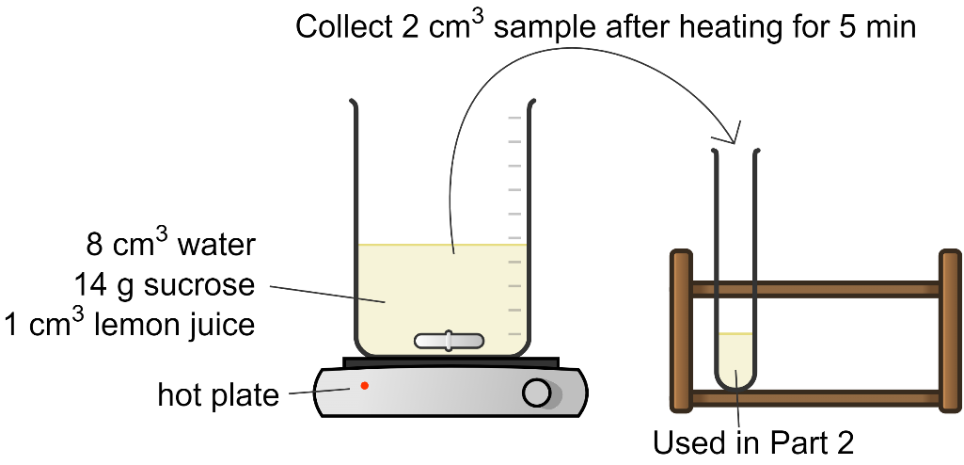

Part 2: Fehling test
Materials
1 cm³ of artificial honey | 3 test tubes
1 cm³ real honey | Test tube rack
6 cm³ Fehling I | 3x 1 cm³ syringes
6 cm³ Fehling II | 3 cm³ plastic pipettes
Heat-proof mat | Bunsen burner
Tongs to hold a test tube

Method:
- Collect 3 test tubes and label appropriately.

- Add 2 cm³ Fehling I and 2 cm³ Fehling II to each test tube.

- Using a 1 cm³ syringe, add the following to each test tube:
  - Test tube 1: 1 cm³ artificial honey mixture (from step 3 in Part 1 above)
  - Test tube 2: 1 cm³ artificial honey mixture (from step 7).
  - Test tube 3: 1 cm³ real honey.
- Using the tongs, hold each test tube in a Bunsen burner flame for about 20 s. Record the colour of each sample.
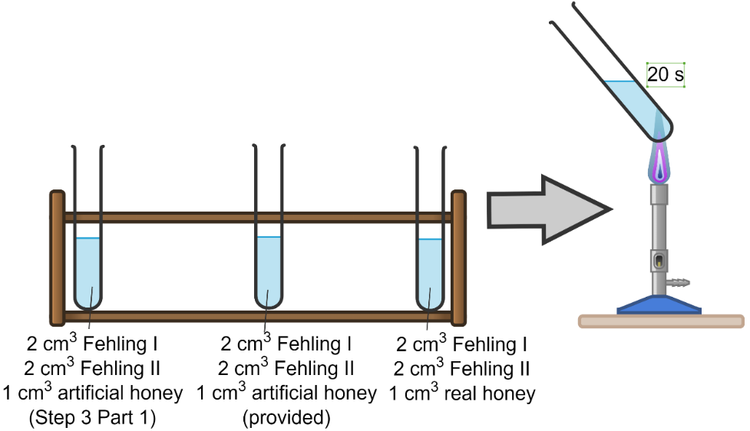

Results
Sample | Colour of Fehling solution | Conclusion
Artificial honey (step 3)
Artificial honey (step 7)
Real honey

Fehling test turns orange in the presence of mono- and disaccharide carbohydrates. If the Fehling solution stays blue, none of these sugars are present. Sucrose is an exception – although sucrose is a disaccharide, the potential reactive aldehyde group of the molecule is “hidden” in the bond between glucose and fructose.

The Fehling test is negative at the start when sucrose is the only sugar.

The catalytically active protons of lemon juice cause the hydrolytic cleavage of sucrose into glucose and fructose. This results in a subsequent positive Fehling test.

Real honey contains a mixture of different sugars and should provide a positive Fehling test.

Part 3: Amylase activity – a test for adulterated honey
Honey contains about 80% sugar. Water, another main ingredient, contributes about 17%. In addition, there are over 100 other components, e.g. amino acids, minerals, vitamins, and small amounts of fatty acids, flavouring and enzymes. The last of these can be used to distinguish real honey from artificial honey. This investigation reveals the enzyme activity of amylase in real honey.

Materials:
1 cm³ real honey | 4x test tubes and rack
1 cm³ artificial honey from Part 1 | 3 cm³ Pipettes
4 cm³ 1% starch suspension | Glass rod
2 cm³ 0.01 M iodine | 21 cm³ water
Thermotube block at 37 °C | 1 cm³ alpha-amylase

Method:
- Label 4 test tubes: “amylase”, “real”, “artificial”, “control”.

- To each test tube, add:
  - 1 cm³ 1% starch suspension
  - 5 cm³ water
- Add the following:
  - To test tube 1, add 1 cm³ alpha-amylase
  - To test tube 2, add 1 cm³ real honey.
  - To test tube 3, add 1 cm³ artificial honey
  - To test tube 4, add 1 cm³ water (control).

- Mix the contents of each test tube very well. Incubate in the waterbath at 37 °C for 30 minutes.

- Add 3-4 drops of 0.01M iodine to each tube.

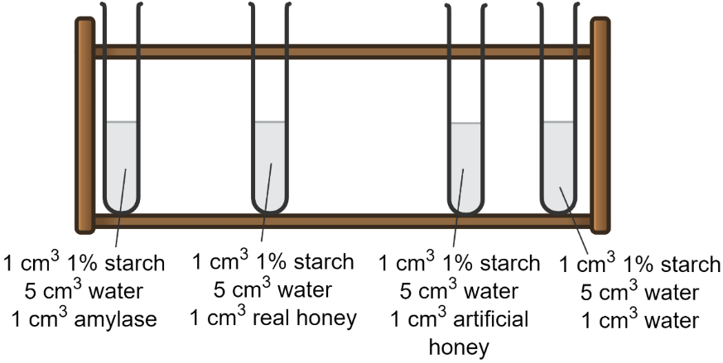
Results:
Solution | Colour of iodine | Presence/absence of active amylase
Amylase
Real honey
Artificial honey
Water (control)

Part 4: Pollen Identification
Aim: To explore the pollen diversity found in honey.

Materials:
Microscope | Centrifuge
Microscope slide + coverslip | Centrifuge tube
Sample of real honey | Water
Pollen identification guide | Pipette
Test tube and rack | Spatula

Method:
- Add 10 cm³ water to a test tube.

- Add a spatula of honey to the test tube and mix well to dissolve in the water.
- Transfer the contents of the test tube to a centrifuge tube. Centrifuge at 6000 rpm for 5 minutes.
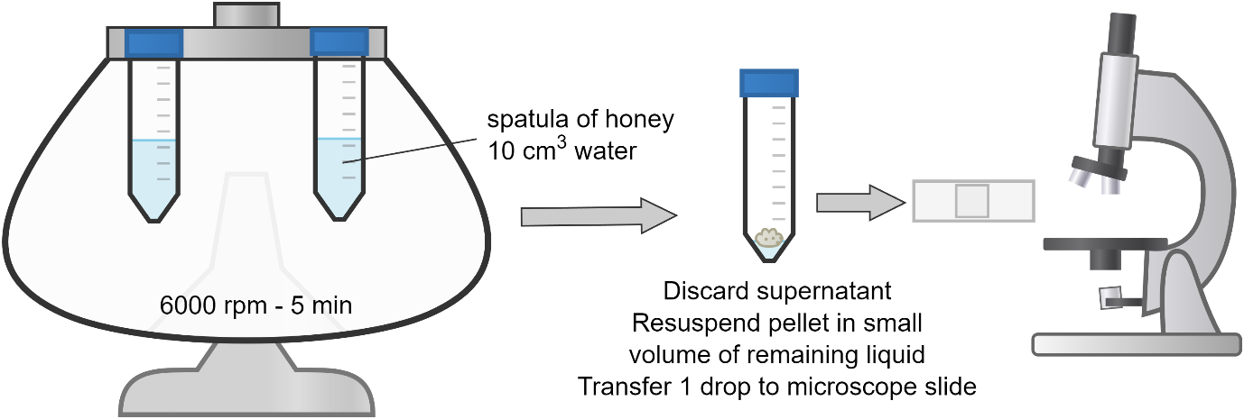
- Discard most of the supernatant using a pipette. Resuspend any pellet in the remaining volume of supernatant.

- Transfer a drop of the material to a microscope slide and add a coverslip.

- Use a microscope to identify any pollen grains found in the honey. This will vary based on type of honey, season and location in which the honey was produced.

