

|  |
| --- |
| Chemical Demonstrations |
| Sugar Snake |

***Background***

This reaction can be applied to curriculum for excellence.

SCN 4-19 a

…*analyse experimental data on chemical reactions that result in an obvious change in energy.*

National 4 – Chemical change and structure

*Energy changes of chemical reactions*

Image by [Capaccio](https://commons.wikimedia.org/wiki/User:Capaccio) from Wikipedia under a [Creative Commons license](https://creativecommons.org/licenses/by-sa/3.0/deed.en)

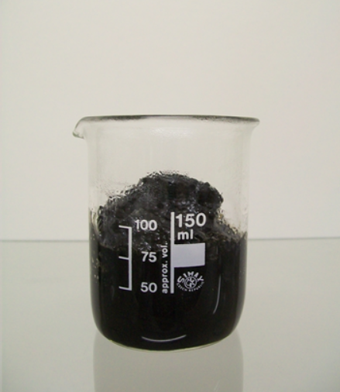

Sulphuric acid is well known for its ability to act in three distinct ways: as an acid, as an oxidising agent, and as a dehydrating agent

This demonstration shows the third of these.

The concentrated sulphuric acid removes ‘water’ from the sucrose leaving carbon. The generic formula for carbohydrates is C(H2O)n

**You will need**

|  |  |
| --- | --- |
| Access to a fume cupboard with good all-round visibility | Beaker, 100 cm3 |
| Large watch glass or tile | Measuring cylinder, 25 cm3 |
| Measuring cylinder, 10 cm3 or 5 cm3 | Sucrose (table sugar), 50 g |
| Concentrated sulphuric acid approximately 20 cm3 | Cobalt chloride paper (optional) |

**What you do**

1. Weigh about 50 g of sucrose (ordinary table sugar) and add to the 100 cm3 beaker.
2. Stand the beaker on a large watch glass (or white tile) in a fume cupboard.

Clamp the beaker if needed.

1. Pour onto the sugar about 20 cm3 of concentrated sulphuric acid.

The sugar will turn yellow, then brown. After about a minute, the sugar will start to blacken. A spongy mass of carbon will begin to rise up the beaker, and steam will be evolved. The carbon will eventually rise to two or three times the height of the beaker.

The steam can be tested with cobalt chloride paper. This will turn from blue to pink.

**Safety**

Sulphuric acid is highly corrosive. Wear goggles (BSED 166 3).

The reaction gives off sulphur dioxide gas that is toxic and can trigger asthma. It also produces carbon monoxide which is not captured by most filtered fume cupboards. Carry out the reaction in a fume cupboard. And if it is a filtered one have the windows open if possible.

The reaction produces a significant amount of heat. Allow to call before handling.

**It is the responsibility of teachers doing this demonstration to carry out an appropriate risk assessment.**

**Extensions**

Test for SO2 - Sulphur dioxide will turn the potassium dichromate paper from orange to blue-green.

The reaction is very exothermic – Squirt one drop of water from a wash bottle on to the outside of the beaker and it will steam.

**What is happening?**

The reaction is usually written as:

C12H22O11 🡪 12C + 11H2O

However, this is an oversimplification.

Some of the carbon is oxidised to carbon monoxide and carbon dioxide and some of the sulphur is reduced from an oxidation state of +6 in sulfuric acid to +4 in sulphur dioxide.