Experimental Data Sets
The following data sets are useful when exploring fermentation to make a dough. During fermentation with yeast, a sugar substrate is mixed with a yeast suspension and carbon dioxide and ethanol are produced. The carbon dioxide gas causes the dough to rise. The height of the dough can be measured as an indirect measure of carbon dioxide production as a result of fermentation.
In this document, we look at the following independent variables:
- Type of flour
- Mass of yeast
- Type of sugar
- Mass of sugar
- Incubation temperature
- Incubation time
The basic recipe for each of the investigations below was:
- 1 teaspoon sugar
- 0.5 teaspoon yeast
- 80 cm³ warm water
  - Leave for 5 minutes
- 100 g flour
  - Mix all ingredients together
  - Measure the height of the dough using a ruler
  - Incubate at 40 °C for 60 minutes
  - Measure the height of the dough after 60 minutes.

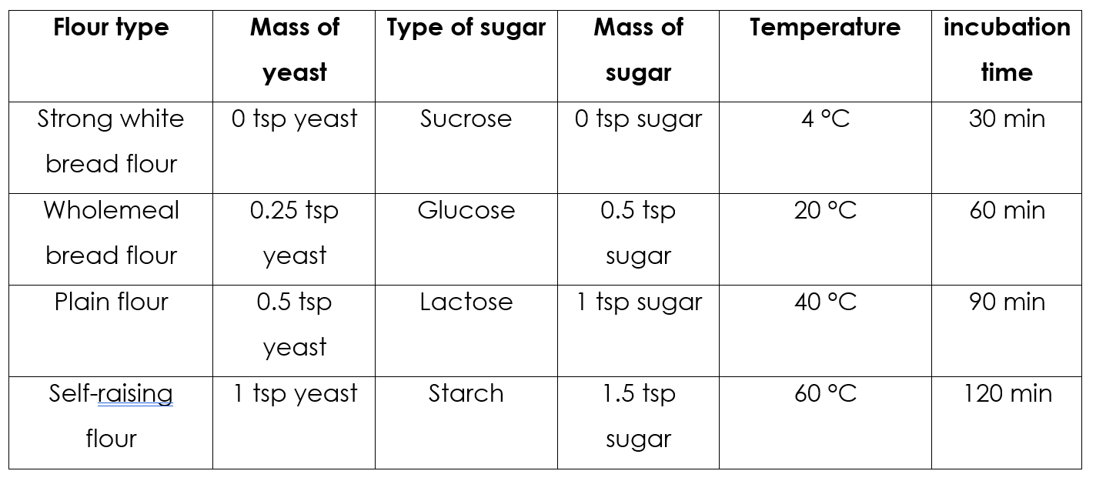

Effect of FLOUR TYPE
Brief overview of the method
Sugar (sucrose), yeast and warm water were mixed in 4 Ziploc bags and left for 5 minutes. A different type of flour was added to each bag and mixed inside the bag. A ruler was used to measure the height of dough at the start of the experiment. The bag of dough was left at 40 C for 60 minutes and then the height of the dough was measured again. The change in dough height in one hour was calculated.
Trial 1
Type of flour | Height of dough at start (mm) | Height of dough after 60 min (mm) | Change in dough height (mm/hr)
Strong white bread flour
Wholemeal bread flour | 21 | 26 | 4
Plain flour
Self-raising flour | 23 | 69 | 46

Trial 2
Type of flour | Height of dough at start (mm) | Height of dough after 60 min (mm) | Change in dough height (mm/hr)
Strong white bread flour
Wholemeal bread flour | 22 | 30 | 8
Plain flour
Self-raising flour | 25 | 67 | 42

Trial 3
Type of flour | Height of dough at start (mm) | Height of dough after 60 min (mm) | Change in dough height (mm/hr)
Strong white bread flour
Wholemeal bread flour | 23 | 30 | 7
Plain flour
Self-raising flour | 25 | 72 | 47

Average
Type of flour | Change in dough mm/hr
 | Trial 1 | Trial 2 | Trial 3 | Average
Strong white bread flour
Wholemeal bread flour | 4 | 8 | 7 | 6
Plain flour
Self-raising flour | 46 | 42 | 47 | 45

Effect of YEAST MASS
Brief overview of the method
Sugar (sucrose), different masses of yeast and warm water were mixed in 4 Ziploc bags and left for 5 minutes. Self-raising flour was added to each bag and mixed inside the bag. A ruler was used to measure the height of dough at the start of the experiment. The bag of dough was left at 40 C for 60 minutes and then the height of the dough was measured again. The change in dough height in one hour was calculated.
Trial 1
Mass of yeast (tsp) | Height of dough at start (mm) | Height of dough after 60 min (mm) | Change in dough height (mm/hr)
0
0.25
0.5
1

Trial 2
Mass of yeast (tsp) | Height of dough at start (mm) | Height of dough after 60 min (mm) | Change in dough height (mm/hr)
0
0.25
0.5
1

Trial 3
Mass of yeast (tsp) | Height of dough at start (mm) | Height of dough after 60 min (mm) | Change in dough height (mm/hr)
0
0.25
0.5
1

Average
Mass of yeast (tsp) | Change in dough mm/hr
 | Trial 1 | Trial 2 | Trial 3 | Average
0
0.25
0.5
1

Effect of TYPE OF SUGAR
Brief overview of the method
Different types of sugar (glucose, sucrose, lactose or starch), yeast and warm water were mixed in 4 Ziploc bags and left for 5 minutes. Self-raising flour was added to each bag and mixed inside the bag. A ruler was used to measure the height of dough at the start of the experiment. The bag of dough was left at 40 C for 60 minutes and then the height of the dough was measured again. The change in dough height in one hour was calculated.
Trial 1
Type of sugar | Height of dough at start (mm) | Height of dough after 60 min (mm) | Change in dough height (mm/hr)
Glucose | 26 | 80 | 54
Sucrose | 23 | 69 | 46
Lactose | 20 | 40 | 20
Starch | 20 | 34 | 14

Trial 2
Type of sugar | Height of dough at start (mm) | Height of dough after 60 min (mm) | Change in dough height (mm/hr)
Glucose | 25 | 75 | 50
Sucrose | 24 | 65 | 41
Lactose | 20 | 39 | 19
Starch | 20 | 30 | 10

Trial 3
Type of sugar | Height of dough at start (mm) | Height of dough after 60 min (mm) | Change in dough height (mm/hr)
Glucose | 24 | 76 | 52
Sucrose | 24 | 62 | 38
Lactose | 21 | 37 | 16
Starch | 22 | 29 | 7

Average
Type of sugar | Change in dough mm/hr
 | Trial 1 | Trial 2 | Trial 3 | Average
Glucose | 54 | 50 | 52 | 52
Sucrose | 46 | 41 | 38 | 42
Lactose | 20 | 19 | 16 | 18
Starch | 14 | 10 | 7 | 10

Effect of MASS OF SUGAR
Brief overview of the method
Different mass of sugar (sucrose), yeast and warm water were mixed in 4 Ziploc bags and left for 5 minutes. Self-raising flour was added to each bag and mixed inside the bag. A ruler was used to measure the height of dough at the start of the experiment. The bag of dough was left at 40 C for 60 minutes and then the height of the dough was measured again. The change in dough height in one hour was calculated.
Trial 1
Mass of sugar (tsp) | Height of dough at start (mm) | Height of dough after 60 min (mm) | Change in dough height (mm/hr)
0
0.5
1
1.5

Trial 2
Mass of sugar (tsp) | Height of dough at start (mm) | Height of dough after 60 min (mm) | Change in dough height (mm/hr)
0
0.5
1
1.5

Trial 3
Mass of sugar (tsp) | Height of dough at start (mm) | Height of dough after 60 min (mm) | Change in dough height (mm/hr)
0
0.5
1
1.5

Average
Mass of sugar (tsp) | Change in dough mm/hr
 | Trial 1 | Trial 2 | Trial 3 | Average
0
0.5
1
1.5

Effect of INCUBATION TEMPERATURE
Brief overview of the method
Sugar (sucrose), yeast and warm water were mixed in 4 Ziploc bags and left for 5 minutes. Self-raising flour was added to each bag and mixed inside the bag. A ruler was used to measure the height of dough at the start of the experiment. The bag of dough was incubated at various temperatures for 60 minutes and then the height of the dough was measured again. The change in dough height in one hour was calculated.
Trial 1
Incubation temperature (°C) | Height of dough at start (mm) | Height of dough after 60 min (mm) | Change in dough height (mm/hr)
4 | 23 | 23 | 0
20 | 25 | 34 | 10
40 | 26 | 69 | 37
60

Trial 2
Incubation temperature (°C) | Height of dough at start (mm) | Height of dough after 60 min (mm) | Change in dough height (mm/hr)
4
20
40
60

Trial 3
Incubation temperature (°C) | Height of dough at start (mm) | Height of dough after 60 min (mm) | Change in dough height (mm/hr)
4
20
40
60

Average
Incubation temperature (°C) | Change in dough mm/hr
 | Trial 1 | Trial 2 | Trial 3 | Average
4
20
40
60

Effect of INCUBATION TIME
Brief overview of the method
Sugar (sucrose), yeast and warm water were mixed in 4 Ziploc bags and left for 5 minutes. Self-raising flour was added to each bag and mixed inside the bag. A ruler was used to measure the height of dough at the start of the experiment. The bag of dough was incubated at 40 °C for various durations and then the height of the dough was measured again. The change in dough height in one hour was calculated.
Trial 1
Incubation duration (min) | Height of dough at start (mm) | Height of dough after 60 min (mm) | Change in dough height (mm/hr)
30
60 | 23 | 69 | 46
90
120

Trial 2
Incubation duration (min) | Height of dough at start (mm) | Height of dough after 60 min (mm) | Change in dough height (mm/hr)
30
60
90
120

Trial 3
Incubation duration (min) | Height of dough at start (mm) | Height of dough after 60 min (mm) | Change in dough height (mm/hr)
30
60
90
120

Average
Incubation duration (min) | Change in dough mm/hr
 | Trial 1 | Trial 2 | Trial 3 | Average
30
60
90
120

