Chemical Experiments
Extraction of paracetamol

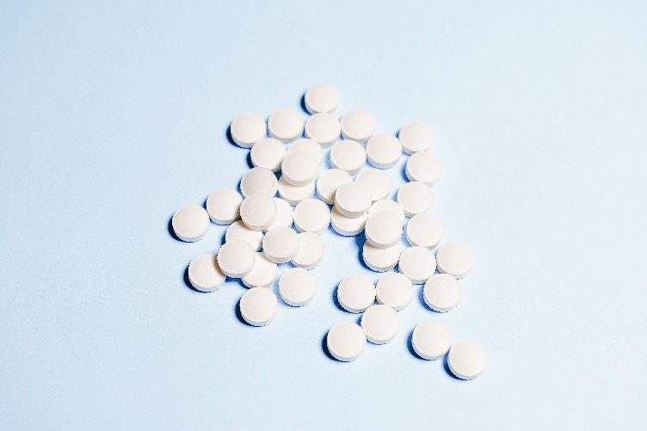

Introduction
Paracetamol is one of the most widely used drugs in the world, being prescribed or available over the counter for pain relief.
In the UK, standard paracetamol tablets contain 500mg (0.5g) of paracetomol.
It is easy to extract this as follows.

You will need.
2 paracetamol tablets | propanone
25cm³ measuring cylinder | Small conical flask x 2
Access to water bath | Stirring rod (optional)
Access to fume cupboard | Funnel and filter paper
Evaporating basin (or similar) | Access to a balance

Method
Extraction
- Place two paracetamol tablets in a small conical flask
- Add 20 cm³ of propanone and place the flask in a warm water bath.
(Propanone boils at 56°C so around 50°C is fine)
- The tablets will break up on their own but you can speed it up with a stirring rod.
- Set up your filtration apparatus and pour the suspension of the tablets in propanone into the filter paper, washing out the flask with a few cm³ of extra propanone.
- Pour the clear filtrate into a weighed evaporating basin (or other container) and allow to evaporate in a fume cupboard. You can speed up the process by using a warm water bath in the fume cupboard.
- The white solid is crude paracetamol.
- Once it is completely dry, reweigh the container to determine the mass of paracetamol you have extracted.
- To determine the percentage yield, divide the amount you have (your new mass – the mass of the container without the paracetamol) in g by 1.
(2 x 500mg tablets = 1000mg = 1 g)
- Keep a small amount of the solid to determine its melting point later.

Recrystallisation
- The material can be purified by recrystallisation from water.
- Add your solid to about 10 cm³ of water to dissolve it.
- Filter off any insoluble material through a very small piece of cotton wool in a warm glass funnel.
(Pour hot water through the funnel and cotton wool first.)
- Cool the filtrate, in an ice-water bath and filter off the crystals that form.
- Dry the pure paracetamol by either pressing with filter papers or gently warming in an oven.
- Again, you can reweigh and work out the yield. This time compared to both the initial tablet and the first extraction.

If you are determining melting points, you can take the melting point now, and compare it with that of your crude sample and the quoted literature value for the melting point of pure paracetamol.
This process relies on the fact that paracetamol is not very soluble in cold water (1.4 g/100 cm³) but much more soluble in hot water (5 g/100 cm³).

