Fermentation & Respiration
Background:
Fermentation involves the breakdown of a substrate, typically glucose, in the absence of oxygen within the cell cytoplasm. In yeast cells, glucose is broken down to pyruvate molecules, which are then irreversibly converted to ethanol and carbon dioxide. The breakdown of each glucose molecule via the fermentation pathway yields only two molecules of ATP.

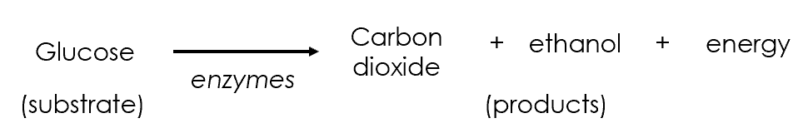

Investigations to try today:
Investigation 1: To investigate the effect of substrate concentration on rate of fermentation (microscale dehydrogenase).
Investigation 2: To investigate the effect of substrate concentration on fermentation rate in yeast (microscale).
Investigation 3: To investigate the effect of substrate type on fermentation rate in yeast (displacement).
Investigation 4: To investigate the effect of substrate type on fermentation rate in yeast (gas syringe).

Investigation 1: Microscale dehydrogenase
Aim: To investigate the effect of substrate type on dehydrogenase activity in yeast.

Materials (per pair)
Basin of warm water | Dimple tile
50 immobilised yeast beads* | 1 cm³ 10% sugar (glucose, sucrose, lactose, starch) - at 40 °C
Resazurin (1 tablet in 25 cm³) | P1000 pipette + tips
Smartphone with RGB detector app | Resazurin colour chart
Kettle for boiled water | forceps
spoon | Wash bottle of distilled water
1 cm³ plastic pipettes | Beaker/bijou of distilled water
5x cuvettes | Retort stand
White tile

*Note: Immobilised yeast beads made by combining 10% Baker’s yeast with 2% sodium alginate in a 1:1 ratio.

Method
  - Using a spoon and forceps, add 10 immobilised yeast beads to 4 wells of a dimple tile.
  - Add 0.25 cm³ resazurin to each well.
  - Add 0.25 cm³ of a different sugar to each well. To well 5, add 0.25 cm³ water instead.
  - Float the dimple tile in the basin of warm water from the kettle.
  - Incubate for 15 minutes.
  - Transfer the supernatant from each reaction into a cuvette.
  - Interpret the colour using one of the following methods:
    - Use the colour chart to assign a colour rating for each of the reactions.
    - Transfer the supernatant of each well of the dimple tile to a cuvette. Place the cuvette in front a white tile (secured with a retort stand). Take a photo of the solution in the cuvette and use the RGB detector to determine the intensity of R/G/B colours.
  - Use the distilled water in the wash bottle to wash the beads at least three times. Set up the reaction again by following the instructions from step 2. This will demonstrate that the same beads can be re-used for fast triplicate results.
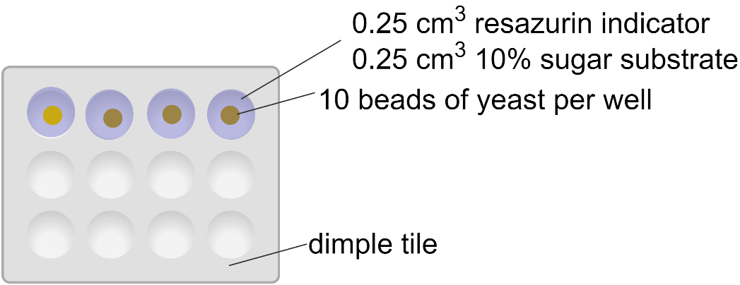
In the diagram above, from left to right well, the sugar substrate that should be added is glucose, sucrose, lactose and then starch. The dimple tile should be floated in a basin of warm water (~ 40 °C) to maximise yeast activity. The same yeast beads can be rinsed and reused several times for quick and straight-forward replication.

Results
Substrate | Colour rating from colour chart | RGB values of suspension
 |  | R | G | B
Glucose
Sucrose
Lactose
Starch

Investigation 2: Microscale fermentation
Aim: To investigate the effect of substrate concentration on rate of fermentation.

In this experiment, a yeast suspension is incubated with a sugar substrate within the bulb of a plastic pipette. A standard 1 cm³ plastic pipette can be converted into a micropipette using a simple procedure. The micropipette, containing yeast and sugar, is immersed in universal indicator. The progress of fermentation is observed in 2 ways:

- The production of carbon dioxide can be observed as bubbles of gas produced from the end of the micropipette, which can be counted to determine a rate.

- The production of carbon dioxide changes the colour of the universal indicator from green to yellow because of increasingly acidic conditions.

Using microscale approaches reduces the volume of reagents required, minimising costs and waste.

Materials (per pair) – each pair will set up one microscale fermenter

Universal indicator | 2 cm³ 10% yeast
30 cm³ water | 5 test tubes
Test tube rack | Paraffin oil
2x 200 µl plastic pipettes | 2x weigh boats
2 cm³ 10% glucose | Thermotube block at 35 °C
2 small nuts that fit around the pipette | 100 cm³ beaker of warm water
thermometer | Blue roll

Method

- Everyone: Prepare the yeast/sugar mixtures and incubate at 35 °C.

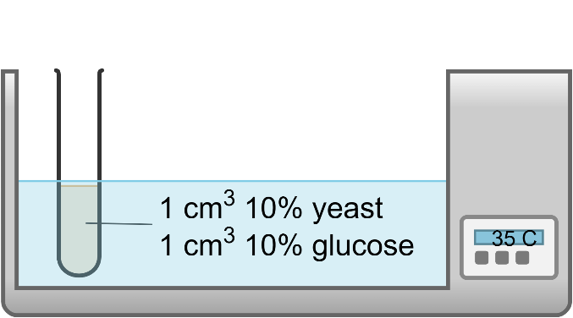

- In your pairs: Prepare 3 test tubes of universal indicator. Add water until the test tube is about 2/3 full and then universal indicator to achieve a dark green colour.

- Everyone: Transfer the yeast/sugar suspension to a weigh boat. Draw up ~ 1 cm³ yeast / glucose mixture into the bulb of a micropipette – you want the bulb to be full of the mixture but no mixture should extend into the stem of the pipette.

- Everyone: Place two small nuts over the end of the micropipette. Place the micropipette into the test tube of universal indicator.
- Everyone: Add a small layer of paraffin oil to the top of the indicator solution to exclude oxygen from the reaction.

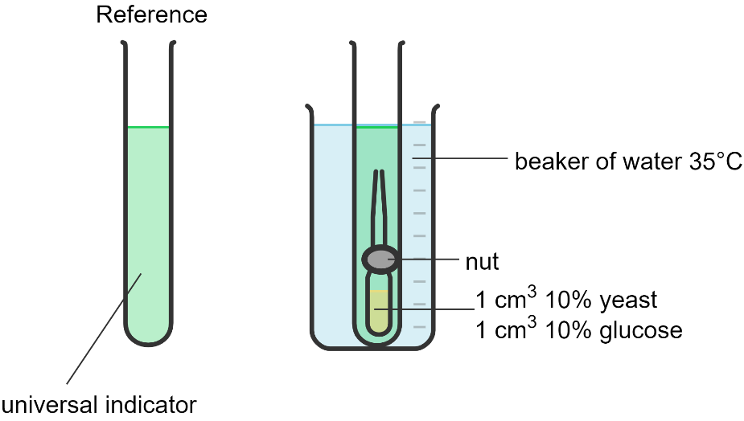

- Everyone: Start the stopwatch and record how long it takes for the universal indicator to change from green to yellow.

- Everyone: Allow one minute for equilibration and then count the number of carbon dioxide gas bubbles produced in one minute.

Results

Glucose concentration (%) | Time taken for indicator to change from green to yellow (s) |  | Number of CO₂ bubbles / min
 | Trial 1 | Trial 2 | Trial 1 | Trial 2
10

Investigation 3: Displacement
Aim: To investigate the effect of substrate type on fermentation rate in yeast.

Materials – per pair
25 cm³ burette | 250 cm³ conical flask – 1 armed
Clamp stand | 2x pieces of silicone tubing
2L ice cream tub with 40 ᴼC water | Magnetic stirrer and flea
thermometer | 20 cm³ syringe
stopwatch | Beehive
Kettle for warm water | Bung to fit conical flask
Plastic trough of water

Materials – per group of 4 – incubated at 40 °C
50 cm³ 10% sugar (glucose, sucrose, lactose, starch) | 200 cm³ 10% Baker’s yeast suspension

Method – Each pair will test two sugars (Pair 1: glucose + starch; Pair 2: sucrose + lactose)
  - Use the syringe to draw water up into the burette until the water level reaches beyond the 25 cm³ mark. Turn the burette tap to the closed position. Remove the syringe. Use the tap to adjust the position of the water to the 25 cm³ mark.

  - To the conical flask, add 50 cm³ sugar and 50 cm³ yeast, giving a final concentration of 5% sugar and 5% yeast. Add the flea and use the magnetic stirrer to form a suspension. Insert the rubber bung into the neck of the conical flask.

  - Attach the second piece of silicone tubing (wider diameter) to the conical flask side arm. Weave the tubing through the beehive and into the submerged end of the burette.

  - Continue mixing the yeast/sugar suspension, maintaining the temperature of the water in the “waterbath” at around 40 ᴼC.

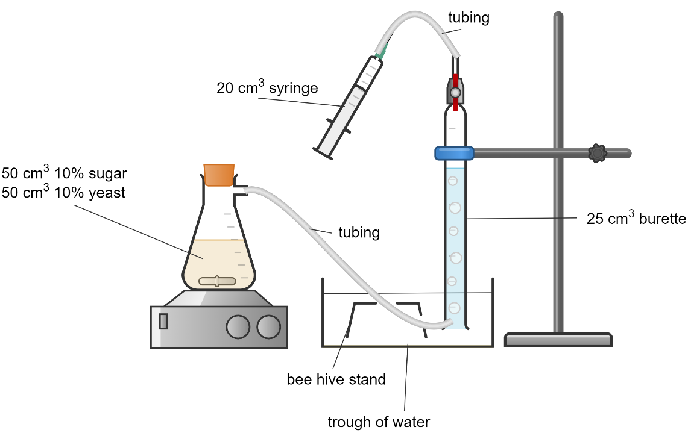
Image: Fermentation of yeast with different substrates using a burette

  - When the first bubble of carbon dioxide gas is observed, start the stop clock.

  - Note the volume of carbon dioxide collected each 3 minutes for 15 minutes.

  - Repeat these steps for a second sugar. Share results to complete the table below.

Results:
Substrate | Volume of carbon dioxide gas collected (cm³)
 | 3 min | 6 min | 9 min | 12 min | 15 min
Glucose
Sucrose
Lactose
Starch

Investigation 4: Gas syringe
Aim: To investigate the effect of substrate type on fermentation rate in S. cerevisiae.

Materials – per pair
Beaker of water for rinsing | 500 cm³ side-armed conical flask
Retort stand with clamp | Rubber bung for flask
100 cm³ gas syringe | 1L tub
2x 10 cm³ syringes | Silicone tubing to connect gas syringe to flask
Access to hot water | Magnetic stirrer and flea
Stopwatch

Materials – per group of 4 – incubated at 40 °C
120 cm³ 10% yeast suspension | 30 cm³ 10% glucose / sucrose / lactose / starch

Method - Each pair will test two sugars (Pair 1: glucose + starch; Pair 2: sucrose + lactose)
- Pre-incubate the yeast suspension and sugar solutions. The yeast suspension should be foamy, showing the active fermentation is going on.

- Mount the gas syringe in the retort stand.

- Add warm water to the 1L tub and place on top of the magnetic stirrer.

- Add a magnetic flea to the conical flask and sit the flask inside the 1L tub of warm water on top of the magnetic stirrer.

- Attach the silicone tubing to the conical flask and gas syringe.

- Using a 10 cm³ syringe, add 30 cm³ sugar to the conical flask.

- Set the magnetic stirrer to a slow speed. Reset the plunger in the gas syringe.

- Reset the stopwatch. Use the second 10 cm³ syringe to add 30 cm³ 10% yeast to the conical flask, immediately start the stopwatch and insert the rubber bung into the neck of the conical flask.

- Record the volume of carbon dioxide gas collected in the gas syringe every minute for 5 minutes.

- Rinse out the conical flask and repeat the experiment with a second sugar solution. Share results with other groups to complete the Results table.

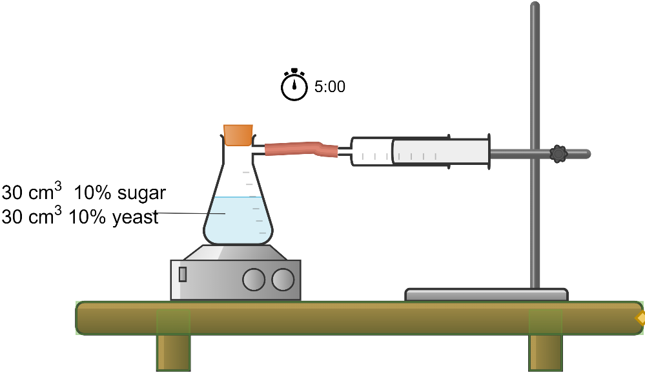
Yeast fermentation with different sugar substrates to release carbon dioxide gas, measured using a gas syringe.

Results

Substrate type | Volume of carbon dioxide gas collected (cm³)
 | 1 min | 2 min | 3 min | 4 min | 5 min
Glucose
Sucrose
Lactose
Starch

Conclusion: Fermentation in yeast was most active in the presence of _____________, followed by ________________, and least active in the presence of _________________.

