Session 9: Fertilisers
Aim: To investigate the effect of fertilisers on plant growth.

Background
In this session, 4 different experiments will be explored to investigate the effect of fertilisers on crop growth. Within Key Area 5 (Food Production) of Life on Earth at National 5 level, the course outlines strategies used in farming for a secure food supply, including the use of fertilisers. The course also highlights the impact of fertilisers on the growth of algae and the subsequent impact on aquatic biodiversity. This is explored again in the Higher course specification within Sustainability and Interdependence. Depending on available resources and approach used in the classroom, various experiments can be tried.
In part 1, you will investigate hydroponics as relatively new approach to growing plants. Published advantages of this method include the requirement for less space, higher crop yields, shorter growing times and greater control of growing conditions. In this protocol (from the RSC), learners will investigate the effect of a complete-nutrient solution and a nutrient-deficient solution. There will be 7 different nutrients to investigate. In part 2, radish plantlets will be grown in compostable pots using low-nutrient growth medium, measuring stem growth over time. Part 3 and 4 require algae to be cultured in the presence or absence of a fertiliser, such as Babybio, over a period of 3-4 weeks. The cultures can be visually inspected and then further examined by microscope. A haemocytometer can be used to perform a direct cell count or colorimetry can be used to quantify plant growth.

Part 1: Nutrient-deficient growth conditions
Aim: To investigate the effect of nutrient-deficiency on plant growth.
Reference: RSC (2020), Effect of nutrient solutions on plant growth (hydroponics), Advancing the Chemical Sciences, https://edu.rsc.org/download?ac=12634

Materials (per pair) – finished experiment provided for you to look at in groups of 4
8x test tubes | Cotton wool
8x healthy germinated mung bean or barley seedlings | 15 cm³ complete-nutrient solution
15 cm³ nutrient-deficient solution (choice of 7 available) | test tube rack
Marker pen | Blue roll
balance | Weigh boat
Method
  - Shake the containers of complete-nutrient and nutrient-deficiency solution to mix contents well and aerate them.

  - Add about 15 cm³ complete-nutrient solution to test tube 1 and 15 cm³ of each nutrient-deficient solution to test tubes 2-8. Label the test tubes appropriately.

  - To each test tube, insert a small cotton wool plug, ensuring it is in contact with the solution.

  - Make a small groove for the germinated mung bean/barley seedling in each cotton wool plug. Position the seedling in the groove.

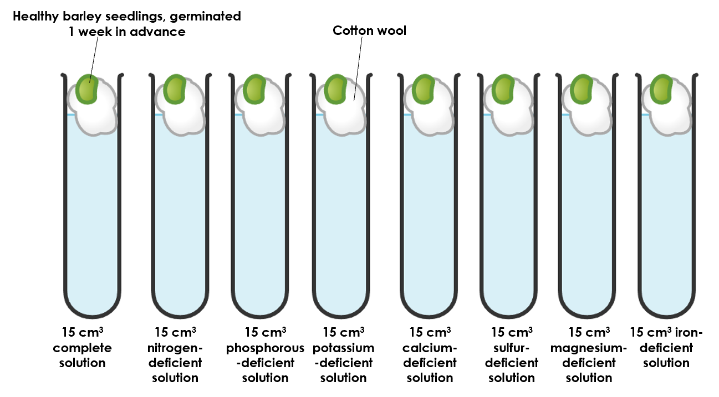
  - Leave the seedling to grow for 4 weeks. Refresh the solution every couple of days.

  - Monitor growth once a week, noting any observations about plant growth.

  - After 4 weeks, remove the seedling and blot its roots dry. Measure its mass.

  - Place the seedling in an oven at 90 ºC to dry. Measure its mass every day until 3 consecutive readings are constant. Record the dry mass of the plant material.

Results
Nutrient-deficiency | Wet mass (g) | Dry mass (g) | Observations about growth
None
Nitrogen
Phosphorus
Potassium
Calcium
Sulfur
Magnesium
Iron

Technical notes:
Preparation of the fertiliser solutions – these can be purchased from Timstar. Alternatively, the Teacher and Technician guide from RSC can be used to produce the complete- and deficient-nutrient solutions (https://edu.rsc.org/download?ac=12634).

Part 2: Concentration of fertiliser
Aim: To investigate the effect of fertiliser concentration on plant growth.

Materials (per pair):
8x radish seeds | 1x 100 cm³ glass beaker
4x sheets of newspaper | 1x 1L ice cream container / equivalent
1x template of capillary matting | Potting mix (½ perlite, ½ seed potting compost)
30x fertiliser beads | Weigh boats / cupcake cases
Balance | Plastic spoon
Scissors | Marker pen

Method:
- Fold the newspaper in half, lengthwise.

- Roll it around the 50 cm³ glass beaker to create a sustainable plant pot.
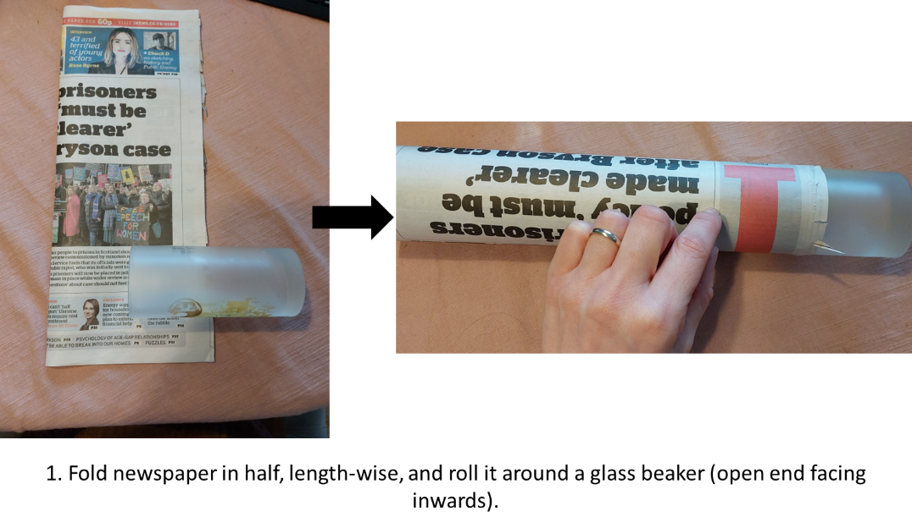

- Fold one end of the newspaper into the glass beaker to create the base of the plant pot.

- Remove the newspaper plant pot from the glass beaker. Repeat to make 4 pots.

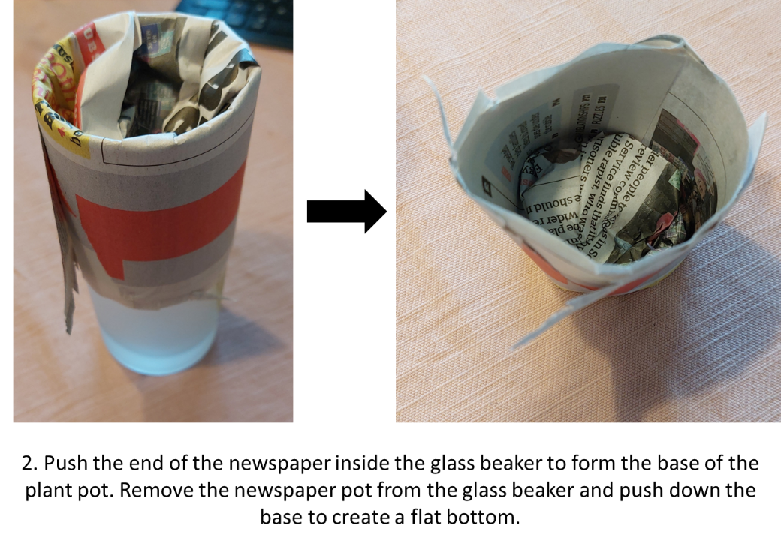

- Fill the plant pot with 12 g low-nutrient potting mix.

- Add 2 radish seeds to each pot.

- Add 0, 5, 10 or 15 fertiliser beads to each pot. Use a marker pen to label the newspaper pots.

- Add a small handful of potting mix to cover the fertiliser beads and radish seeds.

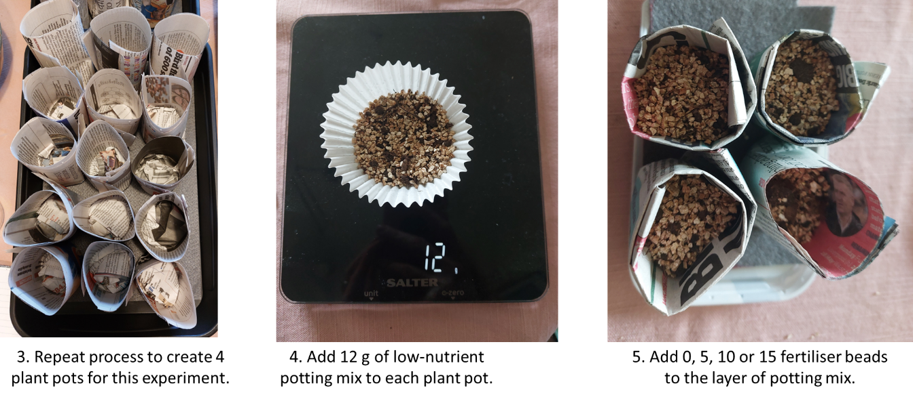

- To prepare the watering system, slice a slit into the ice cream container close to the base.

- Use the template to cut a base from capillary matting and push the “wick” through the cut slit of the ice cream tub. The wick should sit in the ice cream container lid.

- Place the plant pots into the base of the ice cream container.

- Add water to the lid. This will allow consistent watering of each plant pot during the growth period.

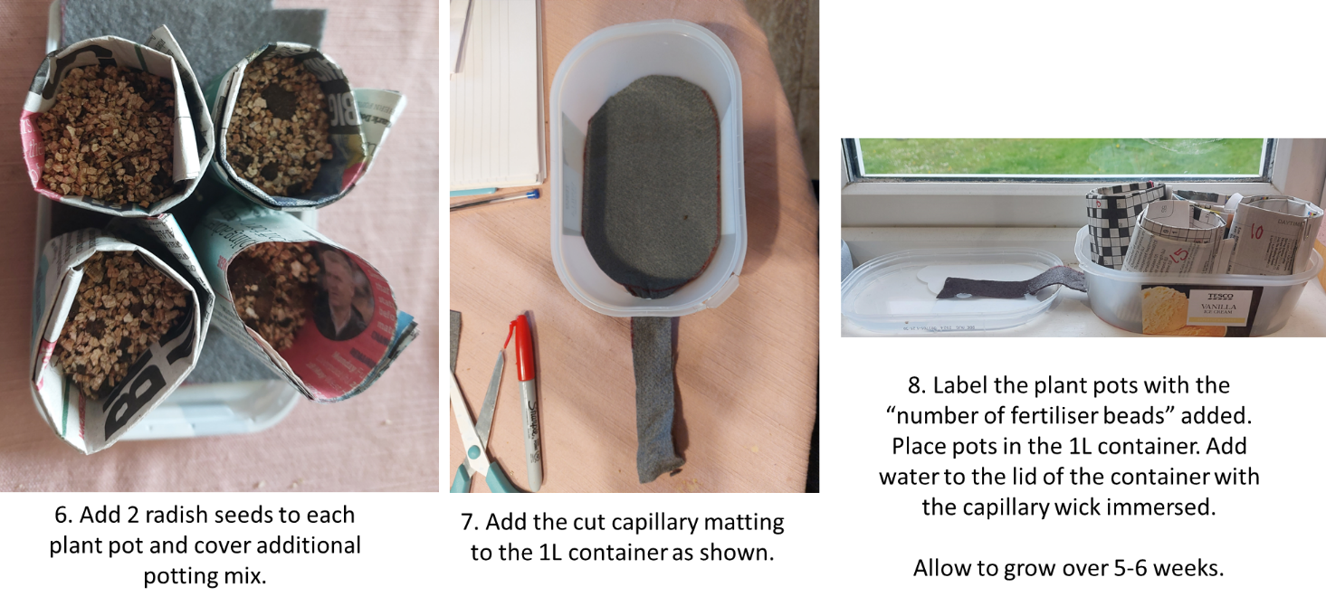

- Every week, measure the length of the stem and record in the table below. Continue recording these measurements for approximately 6 weeks.

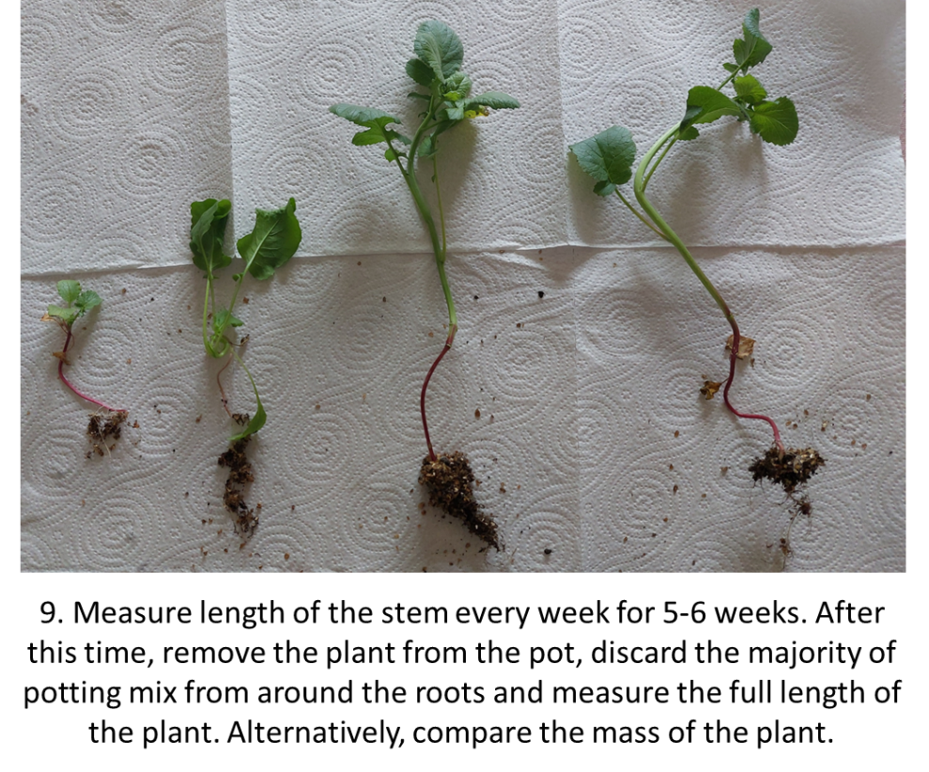

Number of fertiliser beads | Height of stem (mm)
 | 1 | 2 | 3 | 4 | 5 | 6
0
5
10
15

Part 3: Colorimetric approach
Materials (per pair):
Bijou containing algae (Chlorella vulgaris) grown ± fertiliser. | Colorimeter (red diode)
Beaker of distilled water | 3x cuvettes
3x 3 cm³ plastic pipettes | Access to a discard jar of Virkon.

Method:
- Collect a colorimeter and set to the red diode and to measure absorbance.

- To cuvette 1, add ~ 3 cm³ water using a plastic pipette. Calibrate the colorimeter using this sample.

- To cuvette 2, add ~ 3 cm³ algae (absence of fertiliser) using a plastic pipette. Measure and record the absorbance in the table below.

- To cuvette 3, add ~ 3 cm³ algae (presence of fertiliser) using a plastic pipette. Measure and record the absorbance in the table below.

- Discard cuvette and contents in the Virkon.

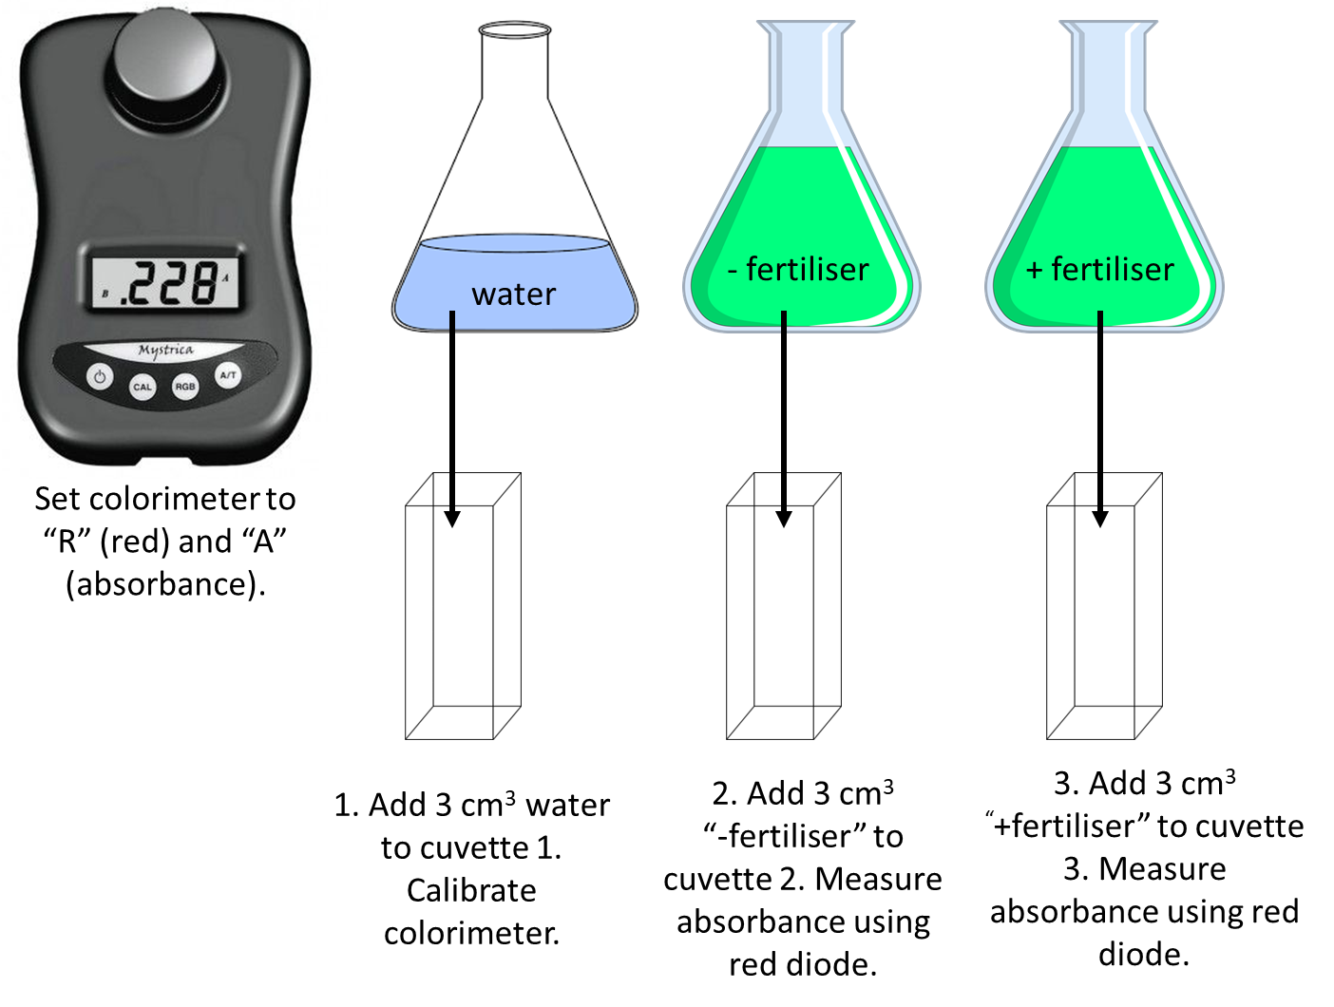

Treatment | Absorbance of culture
None
Babybio fertiliser

Alternative option to Part 3 – vary concentration of fertiliser, as shown in the image below.
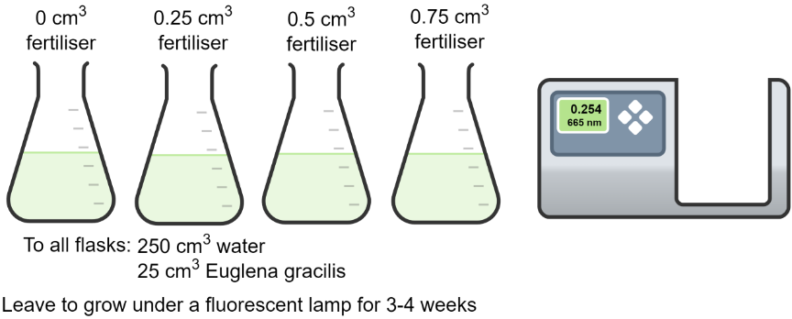

Part 4: Using haemocytometers

Materials (per pair):
Bijou containing algae grown ± fertiliser. | Microscope
Haemocytometer | 4x 1 cm³ plastic pipettes
Access to a discard jar of Virkon. | Methylene blue

Method:
- Collect a C-chip haemocytometer. Swirl your cultures to redistribute the algae. Using a plastic pipette, load the “A” chamber with the algae culture grown in the absence of fertiliser. Put the pipette in the discard jar.

- Observe using the microscope – count how many cells there are within the 5 boxes of the haemocytometer grid, as shown in the image below.

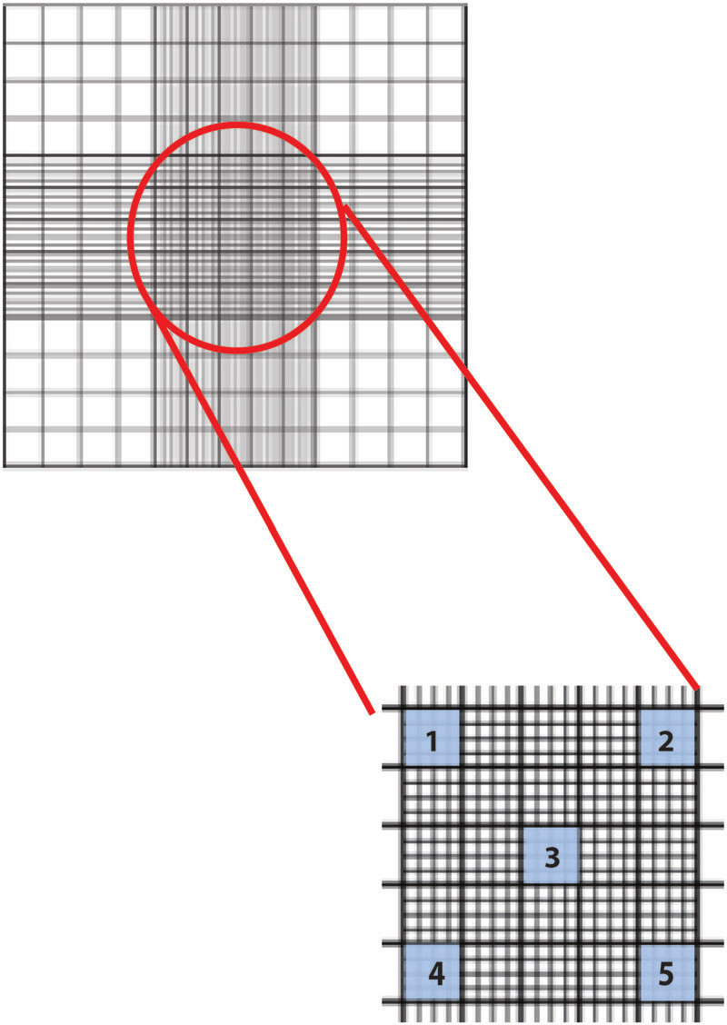
- Repeat step 5-7 for the algae grown in the presence of fertiliser, this time loading the culture into chamber B.

- When the number of cells within the 5 boxes of the haemocytometer grid has been recorded, place the haemocytometer in the discard jar.

- Determine the number of algae cells in 1 cm³ of the original culture provided.

Results
Calculation of haemocytometer volume:
Dimensions (25 boxes) = 1 mm x 1 mm x 0.1 mm à 0.1 mm³
Vol. of 5 boxes = 5/25 x 0.1 mm³ à 0.02 mm³

Treatment | Number of cells present |  |  |  |  | No. of cells / 0.02mm³ | No. of cells / 1 mm³ | No. of cells / 1cm³
 | Box 1 | Box 2 | Box 3 | Box 4 | Box 5
None
Fertiliser

Haemocytometer dimensions: 1 mm x 1 mm x 0.1 mm

Volume of haemocytometer counting chamber (25 squares):

Volume of haemocytometer chamber (5 squares):

Number of cells in 5 squares (0.02 mm³):

Number of cells in 1 mm³ (x50):

Number of cells in 1 cm³ (x1000):

Safety guidance
In terms of Safety in Microbiology: A Code of Practice for Scottish Schools and Colleges (SSERC, 2012), working with algae as set out in the Student Activity Guide has little, if any, known risk; it is work at level 1. However, hands should be washed prior to and on completion of the activities involved in this practical work. Similarly, benches should be swabbed with 1% bleach prior to and on completion of the work.

Discard jars containing the appropriate concentration of VirkonTM should be made available for sterilising used pipettes, cuvettes and microscope slides.
Used algal cultures should be sterilised by autoclaving before they are discarded. Or, VirkonTM (an equal volume of 1% solution) can be added to cultures and left for 24 hours prior to disposal as liquid waste to the sink.
http://www.sserc.org.uk/images/Publications/Biology/SSERC-Safety_in_Microbiology_Code_of_Practice.pdf

Suitable algal cultures
If students are going to carry out direct counts using a haemocytometer, non-motile species such as Chlorella vulgaris, or Scenedesmus quadricauda are appropriate to use.

