

Chemical Experiments
Oxidation of alcohols
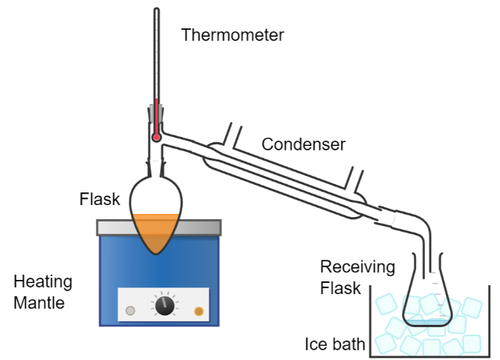
This reaction can be applied to curriculum for excellence.
CfE Higher Chemistry
Nature’s Chemistry
Chemistry of Cooking (Aldehydes), Oxidation of food
Chemistry in Society
Getting the most from reactants, Oxidising or reducing agents
CfE Advanced Higher Chemistry
Organic Chemistry
The preparation, properties and reactions of alcohols

Introduction
In this activity, a primary alcohol (ethanol) is oxidised to an aldehyde (ethanal) using a solution of acidified sodium dichromate Vl a powerful oxidising agent.
Qualitative tests on the organic product are also described.

You will need
Beaker with ice/water (perhaps 2) | Boiling tube
Sulphuric acid (2 mol l⁻¹ ) | Sodium dichromate
Ethanol (IMS is OK) | Small funnel
Apparatus for distillation | Receiving flask (or test tube) with stopper
Access to a balance | Measuring cylinder, to measure 25cm³
Dropping / Pasteur pipette(s) | Thermometer

Carrying out the reaction
- Measure 20 cm³ of 2 mol l⁻¹ sulphuric acid into a boiling tube.
- Place the tube in a beaker filled ⅔ – ¾ with an ice-water mixture.
- Add 1.7 g of sodium dichromate Vl-2-water (or 1.5 g of the anhydrous salt) to the boiling tube containing the acid. Stir until the solid has completely dissolved.
- Check that the acidified dichromate Vl solution has cooled to below 10°C before proceeding further.
- Use a Pasteur pipette to draw up 1 cm³ of ethanol.
- Add 2-3 drops of ethanol to the cold acidified sodium dichromate Vl solution and stir/agitate the mixture.
- Continue adding drops of ethanol (with stirring) to the boiling tube – still in the ice bath. This should be done slowly enough to ensure the temperature of the reaction mixture stays below 20°.
On addition of drops of ethanol, the reaction mixture will change colour (from orange to green) and the temperature rise as this is an exothermic reaction). Allow the temperature to drop a little each time - before adding further drops of ethanol.

Distillation
It is possible to carry out the distillation using a Bunsen burner but great care needs to be taken and we think it preferable to use an alternative heat source as ethanal is extremely flammable.
- Set up your apparatus for distillation as shown in the diagram (overleaf) using a 50 cm³ pear-shaped or round-bottomed flask.
- Add a few anti-bumping granules to the flask.
- Transfer the cold reaction mixture to the flask, carefully, using a small funnel (to avoid contamination of the neck of the flask).
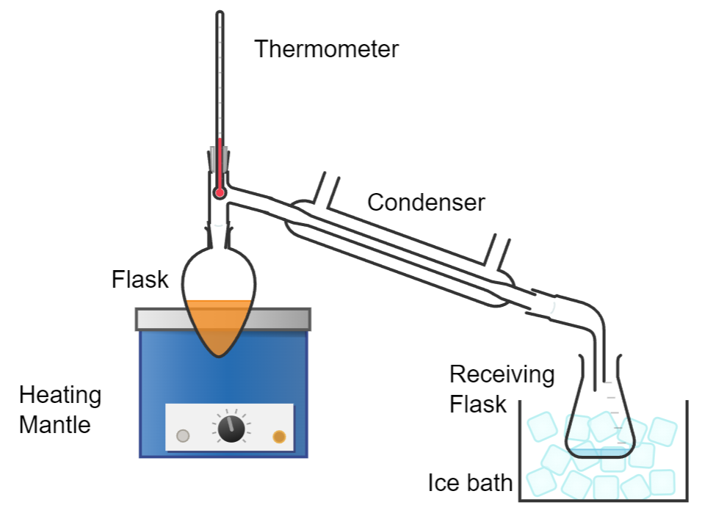
- Leave the reaction mixture in the flask for a few minutes to warm to room temperature before proceeding. This should be quite rapid as the exothermic alcohol - dichromate reaction is proceeding.
- Switch on your heat source and gently heat the mixture in the flask, maintaining a gentle simmer, until 4 cm³ of clear colourless liquid has distilled over and collected in the receiving flask (or test tube).
As ethanal is very volatile, and the vapour is irritating and carcinogenic, collect the distillate in a flask or test tube in and ice or cold-water bath
- Stop heating, remove the distillate and stopper the container.
- Stopper the test tube.

Safety
Wear indirect-vent goggles (BS EN166 3)
Use sodium dichromate Vl not potassium dichromate. This is essential as the potassium salt is much less soluble and the presence of solid dichromate Vl in the reaction mixture may lead to excessive 'bumping' and cause hot, corrosive liquid to splash out of the flask, possibly quite forcefully.
(Older methods using concentrated acid and carrying out the reaction in one step rather than cooling the initial reaction mixture makes such an eruption more likely)

Disposal
After completing the distillation, allow the apparatus to cool. This can be speeded up by cooling the reaction flask in a beaker of cold water for 30 seconds or so.
Disconnect the flask and pour the green contents into a bowl of bucket of water (5 litres or so) - in a fume cupboard to contain the fumes.
The green chromium III mixture is of relatively low hazard and once added to water, can be safely washed to waste with plenty of fresh water.

The chemistry
The dichromate ion is a powerful oxidiser but not quite to the same degree as potassium manganate VII and so it only oxidises the ethanol ‘part-way’ to the aldehyde rather than fully to the carboxylic acid.
The equation for the reaction (state symbols not included) is
3C₂H₅OH + 8H⁺ + Cr₂O₇ ²⁻ 3CH₃CHO + 2Cr³⁺ + 7H₂O
orange green
While oxidising the ethanol to ethanal, the dichromate is reduced from orange Cr ⁶⁺ to green Cr ³⁺.
Stoichiometry
20 cm of 2 mol l⁻¹ sulphuric acid = 0.04 moles of H₂SO₄ (= 0.08 moles of H⁺)
1 cm³ of ethanol has a mass of 0.79 g = 0.0171 moles.
1.7 g of sodium dichromate-2-water (gfm 297.99) = 0.0057 moles.
So the ethanol : dichromate ratio is 3 : 1(as required in the equation) with excess H⁺ ions (actually nearly 15 rather than the 8 required).
The distillate is not pure ethanal, rather a mixture of ethanal, ethanol and some acetals but there is sufficient aldehyde for any qualitative tests to give positive results.
Purifying the ethanal is possible but it is complex and time-consuming.

Extensions
Other alcohols
This preparation can also be carried out with propan-l-ol to form propanal. The reaction equation and quantities of reagents will need to be adjusted appropriately and you will need to check the hazards and adjust the risk assessment if required.
Tests
It is possible to test the distillate for the presence of a carbonyl group using Fehling’s solution or Tollen’s reagent (the silver mirror test).

