
Membership Information
Additional information:
Membership
All 32 Local Authorities, all the leading independent schools, most Scottish colleges, and some Scottish universities are members of SSERC, meaning that we have access to all education practitioners in Scotland.
Website
Website reach (2024 figures)- our resources were downloaded over 250,000 times.
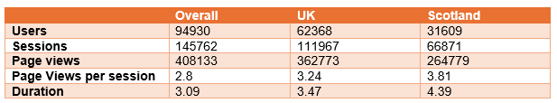
The UK may account for the majority of our website users, but we are proud to have a significant and diverse international user profile. You'll be part of a global community when you join us.
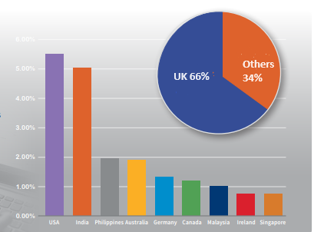
Certain parts of the website are restricted, i.e., only available to members. This includes:
- Access to the SSERC digital publications (see below)
- Access to all health and safety resources and information, including risk assessment templates and guidance.
While education practitioners account for a significant readership, learners, parents, community learning and development practitioners, and those interested in STEM education and training also have access to the open part of the website.

Bulletin
We have three corporate digital publications, each with its own ISSN, published twice a year. These are available to members via the website:
- STEM Bulletin is targeted at secondary school and college practitioners.
- The Early Years and Primary STEM Bulletin is targeted at early years practitioners and primary school teachers
- The School STEM Technician is targeted at school and college technicians
Publications - SSERC
Ongoing support
You have ongoing access to our specialist team, which includes biology, chemistry, digital skills and computer science, environmental science, physics, STEM engagement, health and safety, and early years and primary education, who can provide support related to STEM education and training in Scotland.
Website feature
The company logo, website link, and Company bio (limited to 150 words) will be featured in the corporate membership section of the SSERC website, accessible in the open section of the SSERC website.
Annual Meeting
You will be invited to an annual meeting (virtual or in-person) with our National Partnership Manager to discuss your ongoing relationship with SSERC.
Product support
We offer a range of STEM engagement products and services that link the industry to the education community. These are managed by specialist staff who can provide ongoing advice and support.
STEM Engagement - SSERC
Product testing
We have experience testing equipment used in educational settings to support STEM education, providing guidance on curricular use, and, where applicable, offering health and safety advice for use in these settings.

