Experimental Data Sets
The following data sets are useful when exploring factors that affect fermentation rate. At SSERC, we have used several procedures to measure fermentation rate, often using yeast as a model organism.
In this document, we look at the following procedures:
- Microscale dehydrogenase
- Microscale fermentation bubbler
- Displacement of buffer by gas
- Collection of carbon dioxide gas in a gas syringe
Microscale dehydrogenase methodology
Brief overview of the method
In this experiment, immobilised yeast beads were added to separate wells in a dimple tile with resazurin indicator and a different sugar substrate. The dimple tile was floated in a basin of warm water and left for 15 minutes. The colour of the resazurin indicator was quantified by measuring the intensity of the red pigment in each reaction product, using an RGB detector app.
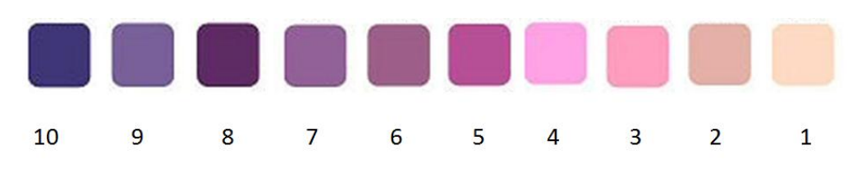
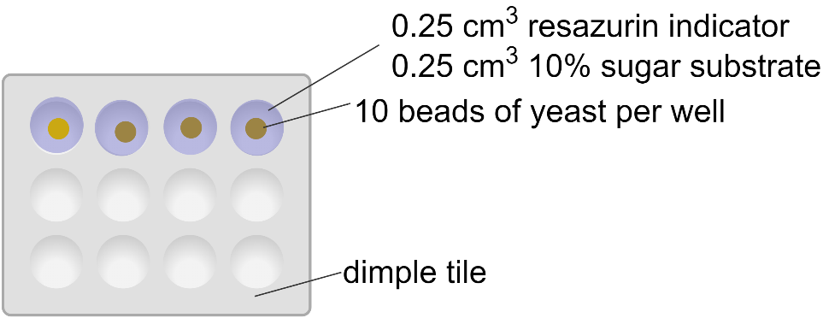
Sugar substrate | Intensity of red colour of resazurin indicator
 | Trial 1 | Trial 2 | Trial 3 | Average
Glucose | 155 | 150 | 165 | 157
Sucrose | 136 | 142 | 163 | 147
Lactose | 95 | 97 | 85 | 92
Starch | 83 | 107 | 75 | 88

Microscale fermentation bubbler methodology
Brief overview of the method
In this experiment, a 200 µl plastic pipette was filled with a yeast/sugar suspension. The sugar used was varied in each experiment. The pipette was submerged in a test tube containing universal indicator, maintained in a waterbath at 40 °C. The number of bubbles of carbon dioxide gas produced per minute, from the end of the pipette, was recorded. The time taken for the indicator to turn from green to yellow was also recorded.
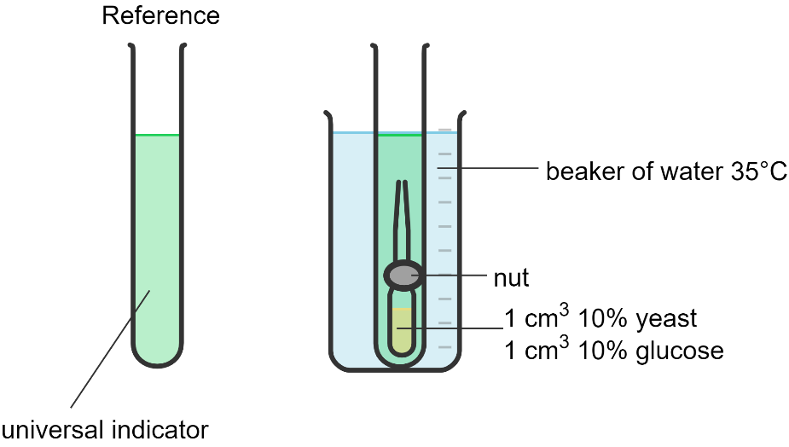

Results
Glucose concentration (%) | Time taken for indicator to change from green to yellow (s) | Number of CO₂ bubbles / min
1 | 630 | 2
8 | 385 | 8
10 | 346 | 12
20 | 225 | 32

Measuring fermentation using the displacement method
Brief overview of the method
In this experiment, yeast was mixed with different types of sugar in a side-armed conical flask, one type of sugar per experiment. The side-arm of the flask was connected to an inverted measuring cylinder filled with water, positioned in a basin of water. As carbon dioxide was produced as a result of fermentation, the water in the measuring cylinder was displaced and the volume of gas produced was measured after 10 minutes.
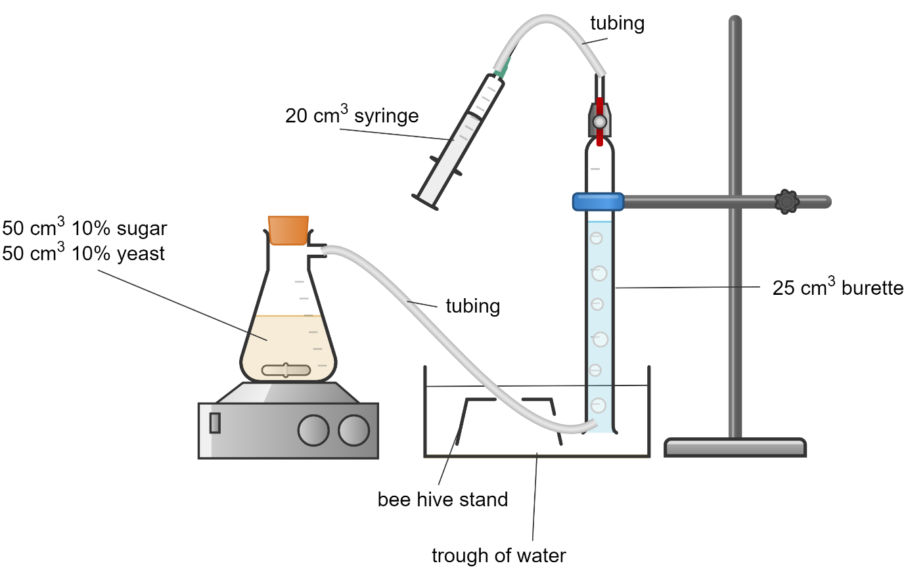

Substrate | Volume of carbon dioxide gas collected after 10 minutes (cm³)
 | Trial 1 | Trial 2 | Trial 3 | Average
Glucose | 12 | 11.5 | 14.8 | 12.8
Sucrose | 12.2 | 15.6 | 12.3 | 13.4
Lactose | 2 | 1.8 | 3.2 | 2.3
Starch | 3.6 | 3.1 | 4.6 | 3.8

Measuring fermentation using a gas syringe
Brief overview of the method
In this experiment, yeast was mixed with different types of sugar in a side-armed conical flask, one type of sugar per experiment. The side-arm of the flask was connected to a gas syringe, positioned using a retort stand. The volume of carbon dioxide gas produced in the presence of different types of sugar substrates was measured using the gas syringe.
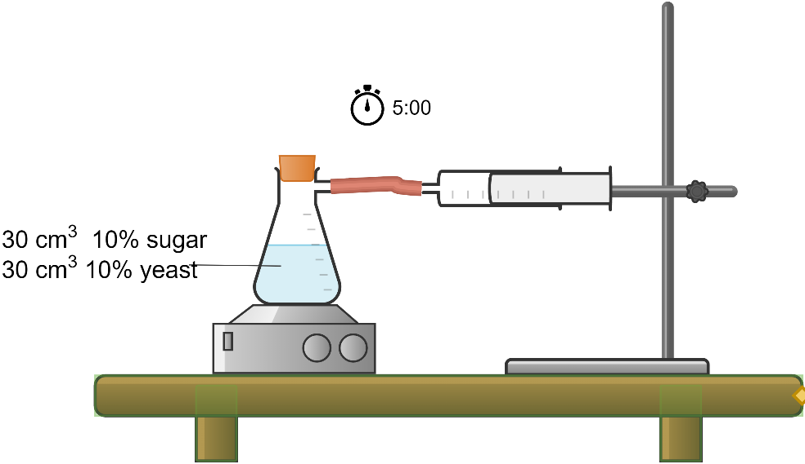

Substrate | Volume of carbon dioxide gas collected after 5 minutes (cm³)
 | Trial 1 | Trial 2 | Trial 3 | Average
Glucose | 26 | 32 | 28 | 29
Sucrose | 25 | 27 | 24 | 25
Lactose | 2 | 4 | 0 | 2
Starch | 11 | 10 | 5 | 9

